Quality of Service (QoS) Monitoring of Cellular Mobile Voice Services- Upper West Region
[May 2016]
[Communications for Development]


NATIONAL COMMUNICATIONS AUTHORITY

Table of Contents
1. Background 2
2. What we measure 2
3. Findings 2-7
4. Remedies 7
5. Coverage and Speech Maps 8-29

Background
In pursuance of Annexure D1 and D2 of the Cellular Mobile Licence of Telecommunication Operators, the user perspective of the quality of voice services are tested to ensure the compliance of Operators to the obligations on service quality to the user.
The report is based on findings on quality of service in Upper West Region from 5th to 10th May, 2016 for all Operators except for Expresso due to technical challenges.

What we measure
As per the Cellular Mobile licence obligations, the QoS indicators and their respective threshold for compliance under assessment considering the user’s perspective are;
• Stand-alone Dedicated Control Channel (SDCCH) Congestion Rate
• Call Setup Time (CST)
• Call Congestion Rate
• Call Drop Rate (CDR)
• Call Completion Rate (CCR)
• Voice Call Audio Quality
• Coverage

Findings
The results for the District Capitals within Upper West Region tested during the period are as below:
- Stand-alone Dedicated Control Channel (SDCCH) Congestion Rate
SDCCH Congestion is defined as the probability of failure of accessing a stand-alone dedicated control channel during call set up.
For analysis and calculations,
$\text{SDCCH Congestion }\left[\text{\%}\right]=\frac{\text{Number of connect fails due to Immediate Assignment Failures }}{\text{ MOC call attempts }}×\text{100\%}$
SDCCH Congestion Rate should be equal or less than one per cent (1%).
The results for the cities and towns tested in February are as below:
Table 1 Signalling Congestion Rate Cellular Mobile Voice Service, May 2016
Month | Town | MTN | Vodafone | Tigo | Airtel | Glo
May | Funsi | 0.00% | No Network | No Network | 0.00% | No Network
May | Gwollu | 0.00% | 0.00% | 0.00% | 0.00% | No Network
May | Jirapa | 0.00% | 0.00% | 0.00% | 0.00% | No Network
May | Lambussie | 0.00% | 0.00% | 0.00% | 0.00% | No Network
May | Lawra | 0.00% | 0.00% | 0.00% | 0.00% | No Network
May | Nadowli | 0.00% | 0.00% | 0.00% | 0.00% | No Network
May | Tumu | 0.00% | 0.00% | 0.00% | 0.00% | No Network
May | Wa | 0.00% | 0.00% | 0.27% | 0.00% | 0.00%
May | Wechiau | 0.00% | 0.00% | 0.00% | 0.00% | 0.00%

REMARKS:
- All Operators were in compliance with the Signalling Congestion Rate licence threshold of less than one percent (1%) in all available localities tested.

- Call Setup Time (CST)

Call Setup Time is the period of time elapsing from the sending of a complete destination address (target telephone number) to the setting up of a call to the receiving terminal;
$$\text{Call set-up time }\left[s\right]=t_{\text{alerting}−\text{signal}}−t_{\text{address}−\text{sending}}$$
$t_{\text{alerting}\text{signal}}$– Moment when an alerting signal is sent to the called terminal
$t_{\text{address}\text{sending}}$– Moment user presses the SEND button on the calling terminal
CST should be less than ten seconds (<10secs) in 95% of cases.
Table 2 Call Setup Time of Cellular Mobile Voice Service, May 2016
Month | Town | MTN | Vodafone | Tigo | Airtel | Glo
May | Funsi | 7.14secs | No Network | No Network | 5.10secs | No Network
May | Gwollu | 6.12secs | 3.09secs | 5.69secs | 13.65secs | No Network
May | Jirapa | 8.57secs | 4.73secs | 6.32secs | 15.68secs | No Network
May | Lambussie | 6.93secs | 3.62secs | 9.60secs | 13.92secs | No Network
May | Lawra | 6.14secs | 4.15secs | 8.14secs | 6.13secs | No Network
May | Nadowli | 6.62secs | 15.79secs | 6.40secs | 13.56secs | No Network
May | Tumu | 6.40secs | 4.82secs | 9.73secs | 9.76secs | No Network
May | Wa | 8.44secs | 6.06secs | 8.32secs | 15.66secs | 9.92secs
May | Wechiau | 9.30secs | 3.72secs | 5.09secs | 5.75secs | 4.92secs

REMARKS:
- All Operators except Vodafone and Airtel were in compliance with the Call Setup Time licence threshold of less than ten seconds (<10secs) in all available locations tested.
- Vodafone had Call Setup Time delays in Nadowli.
- Airtel had Call Setup Time delays in Gwollu, Jirapa, Lambussie, Nadowli and Wa.

- Call Congestion Rate

Call Congestion Rate is the probability of failure of accessing a traffic channel during call setup;
$$\text{Call Congestion }\left[\text{\%}\right]=\frac{\text{Number of Connect failed calls}}{\text{Total number of call attempts}}×\text{100\%}$$
Traffic Channel Congestion should be equal or less than one per cent (1%).
Table 3 Call Congestion Rate Cellular Mobile Voice Service, May 2016
Month | Town | MTN | Vodafone | Tigo | Airtel | Glo
May | Funsi | 0.00% | No Network | No Network | 0.00% | No Network
May | Gwollu | 0.00% | 0.00% | 0.00% | 0.00% | No Network
May | Jirapa | 0.00% | 0.00% | 0.00% | 0.00% | No Network
May | Lambussie | 0.00% | 0.00% | 0.00% | 0.00% | No Network
May | Lawra | 0.00% | 0.00% | 0.00% | 0.00% | No Network
May | Nadowli | 0.00% | 0.00% | 0.00% | 0.00% | No Network
May | Tumu | 0.00% | 0.00% | 0.00% | 0.00% | No Network
May | Wa | 0.00% | 0.00% | 0.00% | 0.00% | 1.00%
May | Wechiau | 0.00% | 0.00% | 0.00% | 0.00% | 40.00%

REMARKS:
- All Operators except Glo were compliant with the licence threshold of less than one percent (1%) in all available locations tested.
- Glo recorded high Call Congestion Rate at Wechiau.

- Call Drop Rate ( CDR)

Voice Call Drop Rate is the probability of a call terminating without any of the users’ will;
$$\text{Drop Rate }\left[\text{\%}\right]=\frac{\text{Number of calls terminated unwillingly}}{\text{Total number of call attempts}}×\text{100\%}$$
Call drop rate should be equal or less than three per cent (3%).
Table 4 Call Drop Rate Cellular Mobile Voice Service, May 2016
Month | Town | MTN | Vodafone | Tigo | Airtel | Glo
May | Funsi | 0.00% | No Network | No Network | 0.00% | No Network
May | Gwollu | 0.00% | 0.00% | 0.00% | 0.00% | No Network
May | Jirapa | 0.00% | 0.00% | 0.00% | 0.00% | No Network
May | Lambussie | 0.00% | 0.00% | 0.00% | 0.00% | No Network
May | Lawra | 0.00% | 0.00% | 0.00% | 0.00% | No Network
May | Nadowli | 0.00% | 0.00% | 0.00% | 0.00% | No Network
May | Tumu | 0.00% | 0.00% | 0.00% | 0.00% | No Network
May | Wa | 0.00% | 0.00% | 0.00% | 0.00% | 0.00%
May | Wechiau | 0.00% | 0.00% | 0.00% | 0.00% | 0.00%
REMARK:
- All Operators were in compliance with the Call Drop Rate licence threshold of less than three percent (3%) in all localities tested.

- Call Completion Rate ( CCR)

Call Completion Rate is defined as the probability that a call has, after being successfully set up, be maintained during a period of time and ending normally.
$$\text{Call Completion }\left[\text{\%}\right]=\frac{\text{Number of normally ended calls}}{\text{Total number of call attempts}}×\text{100\%}$$
Call Completion Rate should be equal or better than seventy percent (70%).
Table 5 Call Completion Rate Cellular Mobile Voice Service, May 2016
Month | Town | MTN | Vodafone | Tigo | Airtel | Glo
May | Funsi | 100.00% | No Network | No Network | 100.00% | No Network
May | Gwollu | 100.00% | 100.00% | 94.12% | 76.92% | No Network
May | Jirapa | 100.00% | 100.00% | 98.63% | 12.50% | No Network
May | Lambussie | 94.87% | 100.00% | 97.37% | 92.11% | No Network
May | Lawra | 100.00% | 98.18% | 100.00% | 98.04% | No Network
May | Nadowli | 100.00% | 100.00% | 100.00% | 59.52% | No Network
May | Tumu | 98.82% | 98.88% | 100.00% | 100.00% | No Network
May | Wa | 100.00% | 99.49% | 97.07% | 83.75% | 88.96
May | Wechiau | 100.00% | 100.00% | 92.00% | 100.00% | 40.00%

REMARKS:
- MTN, Vodafone and Tigo were in compliance with the Call Completion Rate licence threshold of less than seventy percent (70%) in all available localities tested.
- Airtel failed the Call Completion Rate obligation in Jirapa and Nadowli.
- Glo failed the Call Completion Rate obligation in Wechiau.

- Voice Call Audio Quality
It is the perceptibility of the conversation during a call. Voice Call Audio Quality is measured by a parameter called the Mean Opinion Score (MOS) which categorizes speech samples in ranges from 0 to 5.
Range | Colour Code | Rating
[0 – 2.5) |  | Poor
[2.5 – 3.5) |  | Fair
[3.5 – 4) |  | Good
[4.1 – 5) |  | Excellent

Table 6 Speech Quality Mean Opinion Score Upper West Region, May 2016
Upper West | MTN | Vodafone | Tigo | Airtel | Glo
MOS | 3.39 | 3.75 | 3.75 | 3.63 | 3.90

REMARK:
- All Operators except MTN were assessed to give GOOD speech quality
- MTN was assessed to give FAIR speech quality.

REMEDIES
- The NCA has notified Operators of these findings and has directed all Operators to improve their coverage in some localities by December 2016.
- Airtel has been granted moratorium till July 2016 to resolve the persistent Call Setup Time delays which has been acute since 2015.
- Glo has also been sanctioned for failing in TCH Congestion Rate in the Upper West Region.

APPENDICES

COVERAGE AND SPEECH MAPS

The Maps below show the coverage level and speech quality in the various towns where monitoring was performed. The coverage map is a combination of both 2G and 3G network signal strength. In each plot is a legend to indicate definitions of signal strength and quality range attained by Operators during measurement. Coverage levels in green falls in the rage of -85dBm and above, and are considered good. Those between -85 and -95dBm are considered average and are indicated in yellow. The red samples represent worse coverage in the range of -95 to -105dBm. The black samples represent areas with no coverage. The speech quality was assessed with Mean Opinion Score (MOS) which ranges from 5 to 1.

APPENDIX I

COVERAGE AT FUNSI
Fig. 1- MTN Coverage Map, Funsi – May, 2016
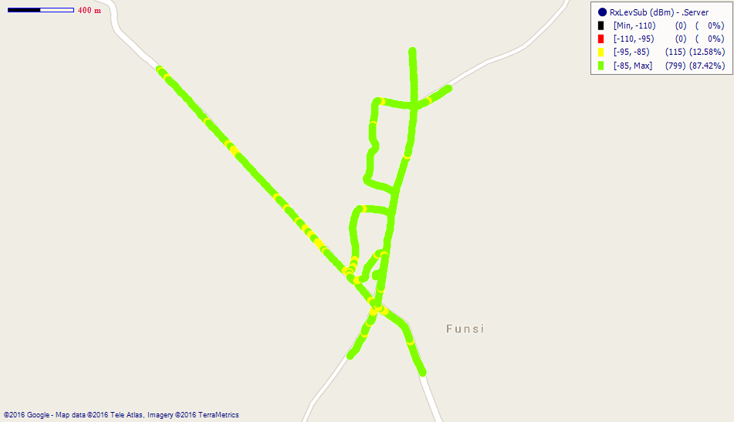
Remarks: Good 2G network coverage.

Fig. 2 - Vodafone Coverage Map, Funsi – May, 2016
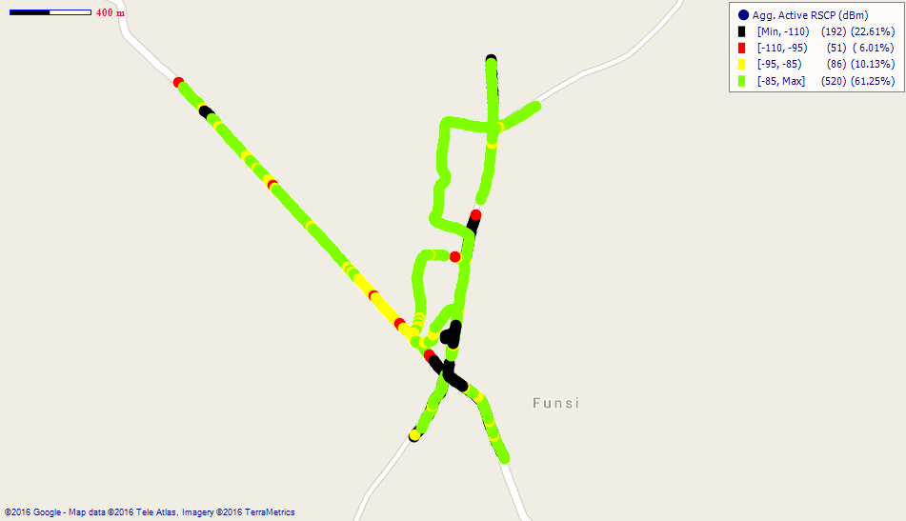
Remarks: Good 3G network coverage in Funsi with some coverage gaps at the center of the town. Major improvements needed.

Fig. 3 - Tigo Coverage Map, Funsi – May, 2016
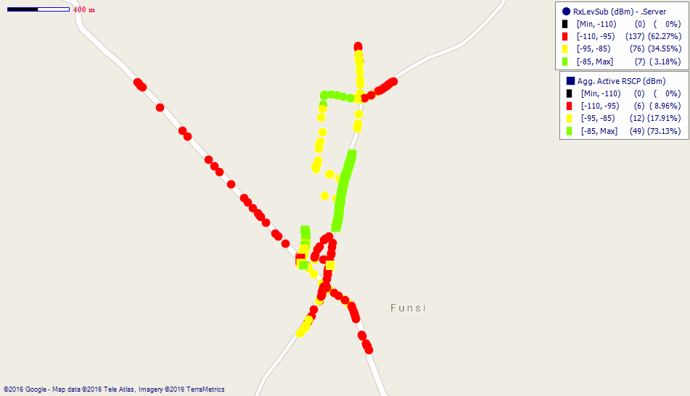
Remarks: Poor network coverage in Funsi. Major improvements needed.

Fig. 4- Airtel Coverage Map, Funsi - May 2016
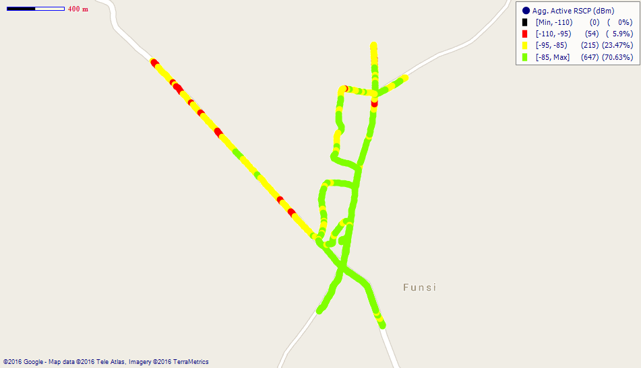
Remarks: Fair 3G network coverage in Funsi.

COVERAGE AT GWOLLU

Fig. 5- MTN Coverage Map, Gwollu – May, 2016
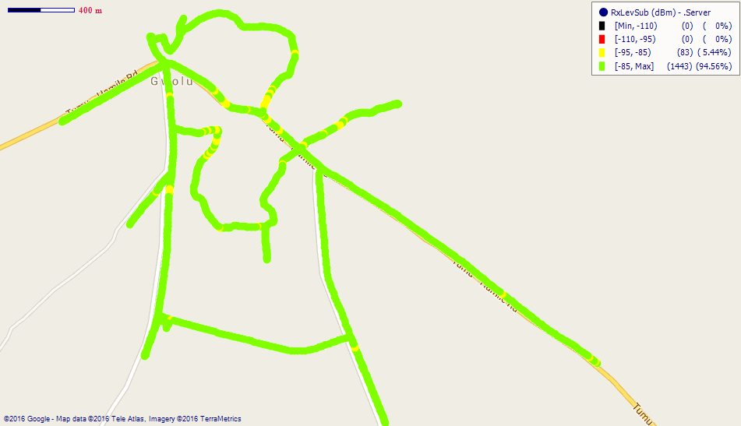
Remarks: Good 2G network coverage.
Fig. 6 - Vodafone Coverage Map, Gwollu – May, 2016
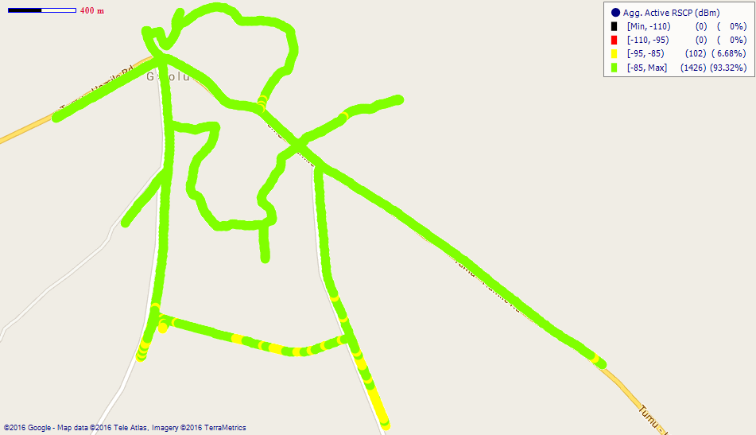
Remarks: Good 3G network coverage across Gwollu

Fig. 7- Tigo Coverage Map, Gwollu – May, 2016
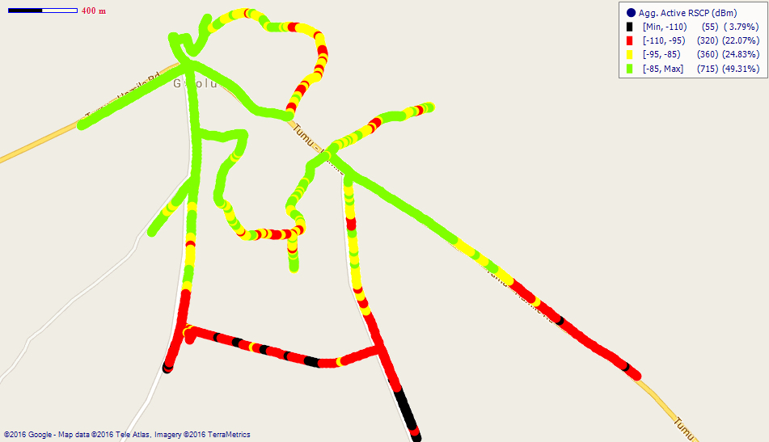
Remarks: Fair network coverage in Gwollu. However areas at the southern parts around the District Assembly office have poor coverage. Major improvements needed.

Fig. 8- Airtel Coverage Map, Gwollu – May, 2016
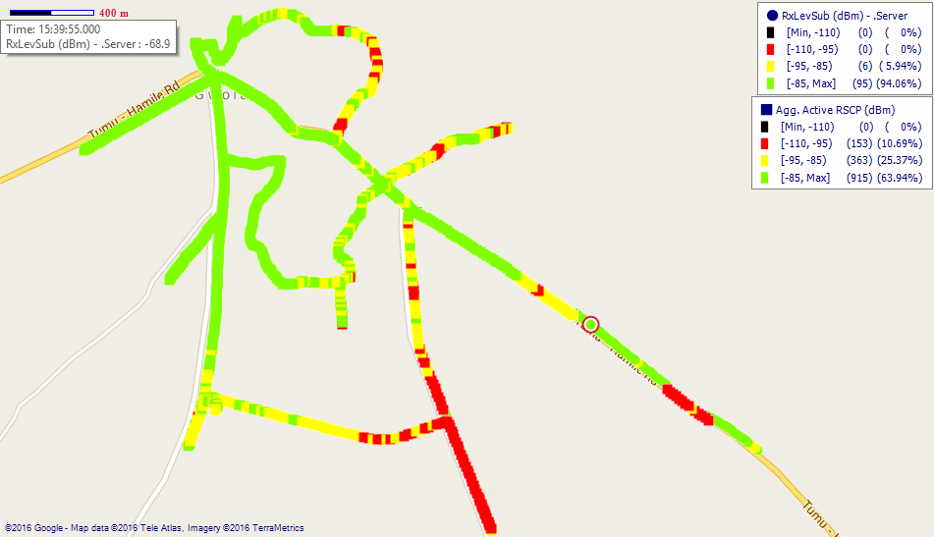
Remarks: Good network coverage in Gwollu however major improvement is needed around the southern end.

COVERAGE AT JIRAPA

Fig. 9 - MTN Coverage Map, Jirapa - May 2016
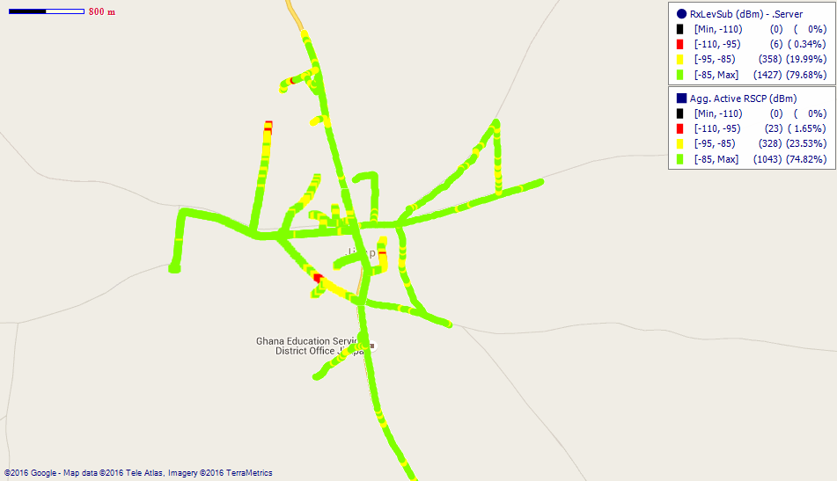
Remarks: Good network coverage.
Fig. 10 - Vodafone Coverage Map, Jirapa –May, 2016
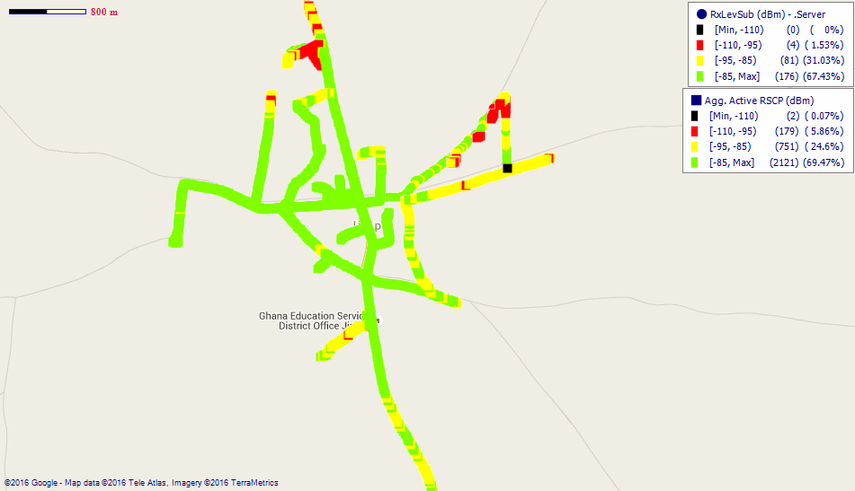
Remarks: Good network coverage with improvement needed.

Fig. 11 - Tigo Coverage Map, Jirapa – May, 2016
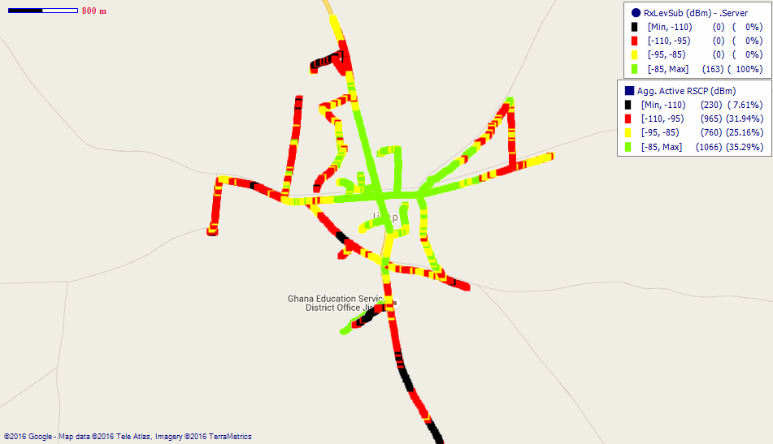
Remarks: Poor network coverage in Jirapa. Major improvements needed.

Fig. 12 - Airtel Coverage Map, Jirapa – May, 2016
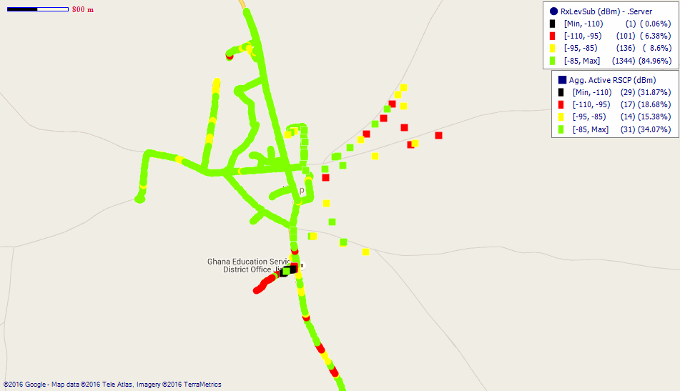
Remarks: Good 2G network coverage across Jirapa. However, major improvements on 3G network.
COVERAGE AT LAMBUSSIE

Fig. 13 - MTN Coverage Map, Lambussie – May, 2016
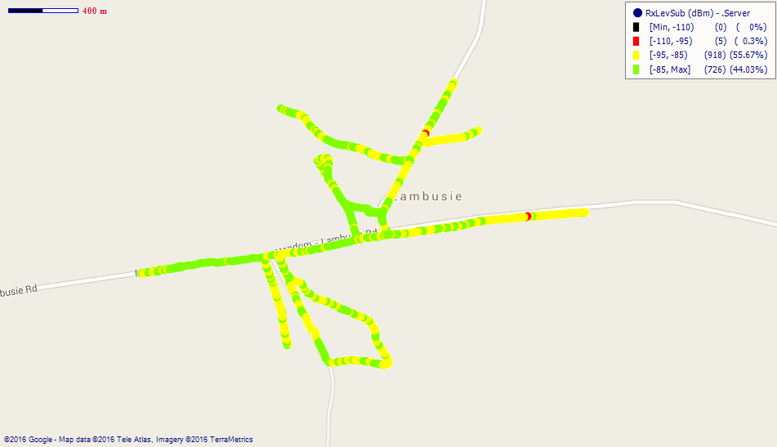
Remarks: Fair network coverage across Lambussie. Improvements needed.
Fig. 14 - Vodafone Coverage Map, Lambussie – May, 2016
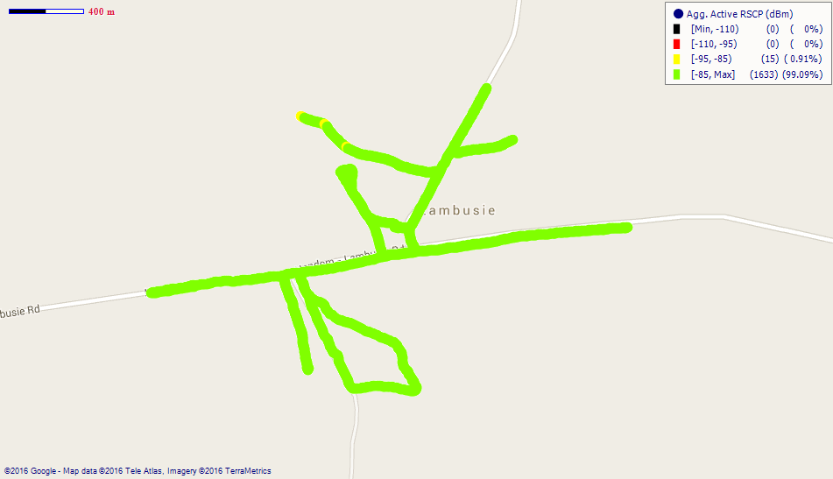
Remarks: Good 3G network coverage.

Fig. 15 - Tigo Coverage Map, Lambussie – May, 2016
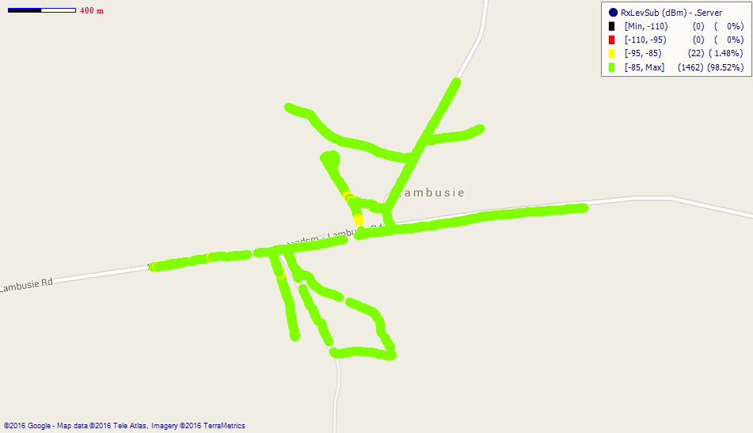
Remarks: Good 2G network coverage in Lambussie.

Fig. 16 - Airtel Coverage Map, Lambussie – May, 2016
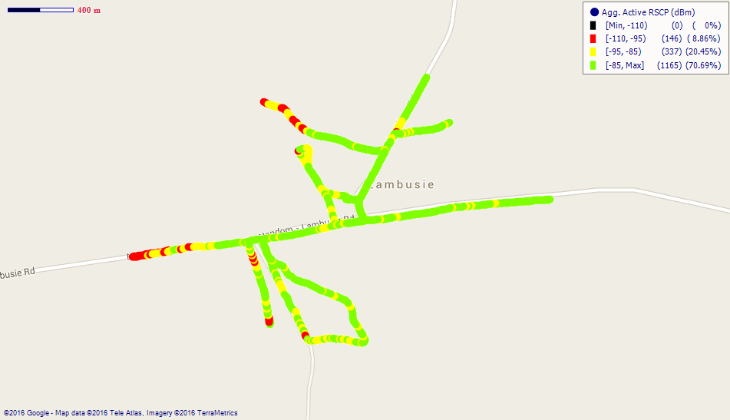
Remarks: Good 3G network network coverage.

COVERAGE AT LAWRA

Fig. 17 - MTN Coverage Map, Lawra – May, 2016
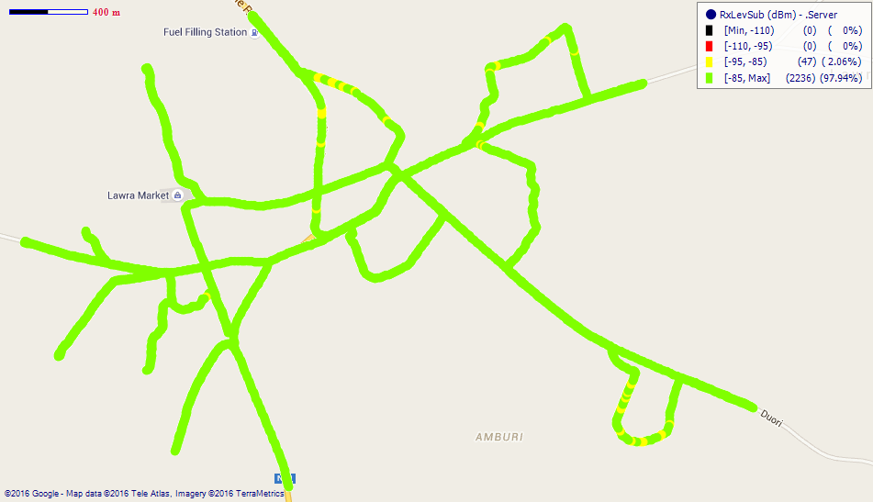
Remarks: Good 2G network coverage.
Fig. 18 - Vodafone Coverage Map, Lawra – May, 2016
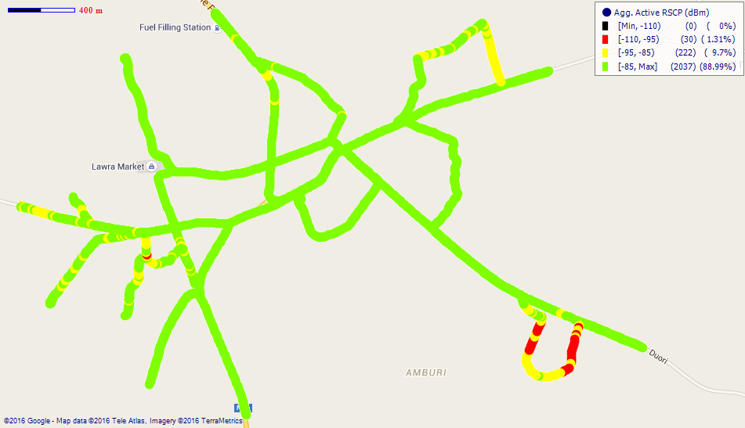
Remarks: Good network coverage.

Fig. 19 - Tigo Coverage Map, Lawra – May, 2016
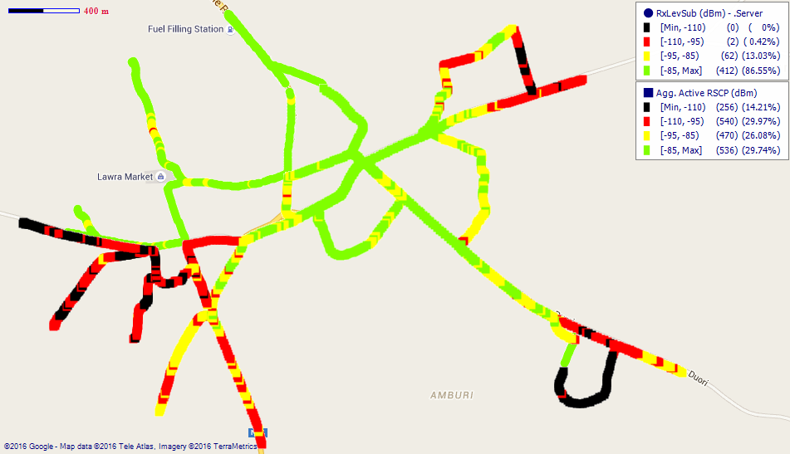
Remarks: Good 2G network coverage across Lawra. However the 3G network coverage needs major improvement.

Fig. 20 - Airtel Coverage Map, Lawra – May, 2016
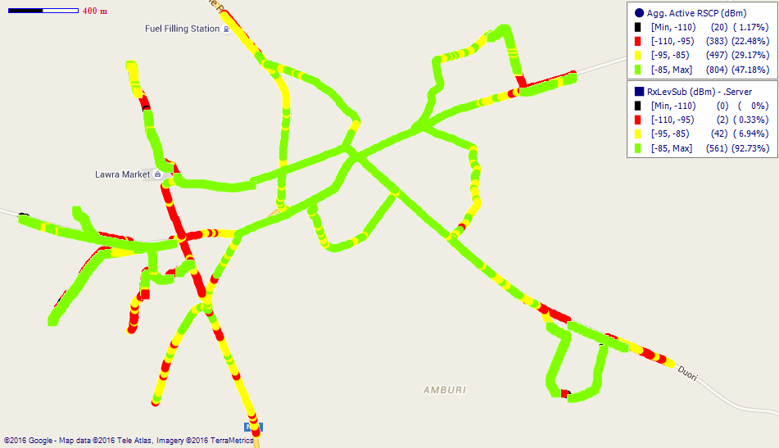
Remarks: Good 2G network coverage across Lawra. Improvement needed on 3G network.

COVERAGE AT NADOWLI
Fig. 21- MTN Coverage Map, Nadowli – May, 2016
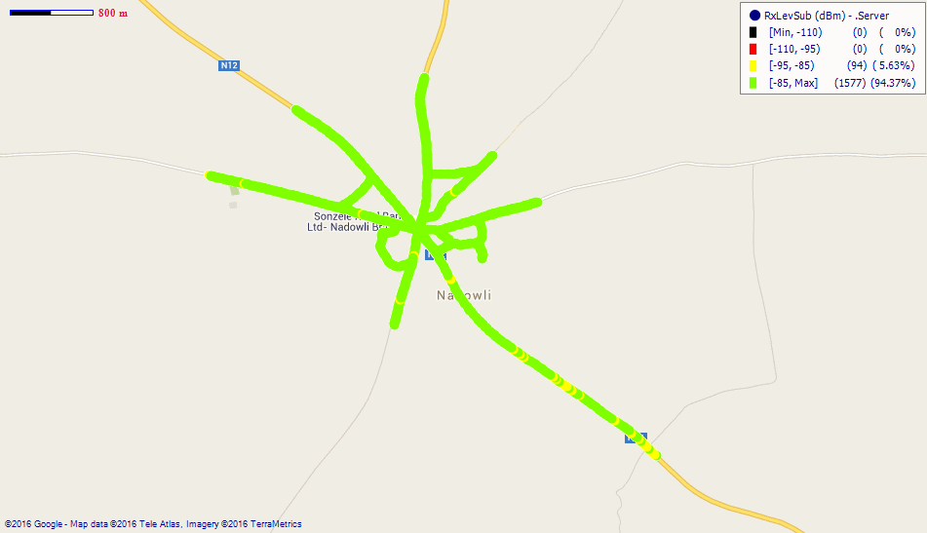
Remarks: Good 2G network coverage across Nadowli.

Fig. 22 - Vodafone Coverage Map, Nadowli - May 2016
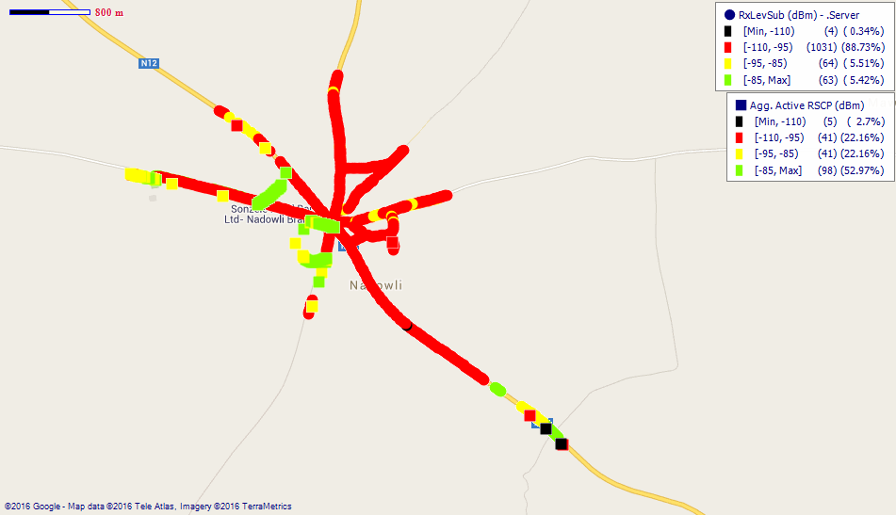
Remarks: Poor network coverage in Nadowli. Major improvement is required.
.
Fig. 23- Tigo Coverage Map, Nadowli – May, 2016
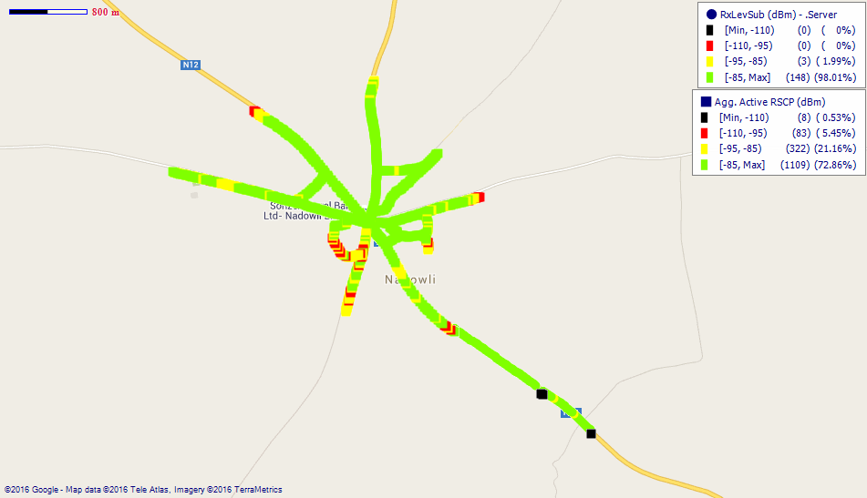
Remarks: Good network coverage in Nadowli yet improvement is needed.

Fig. 24 - Airtel Coverage Map, Nadowli – May, 2016
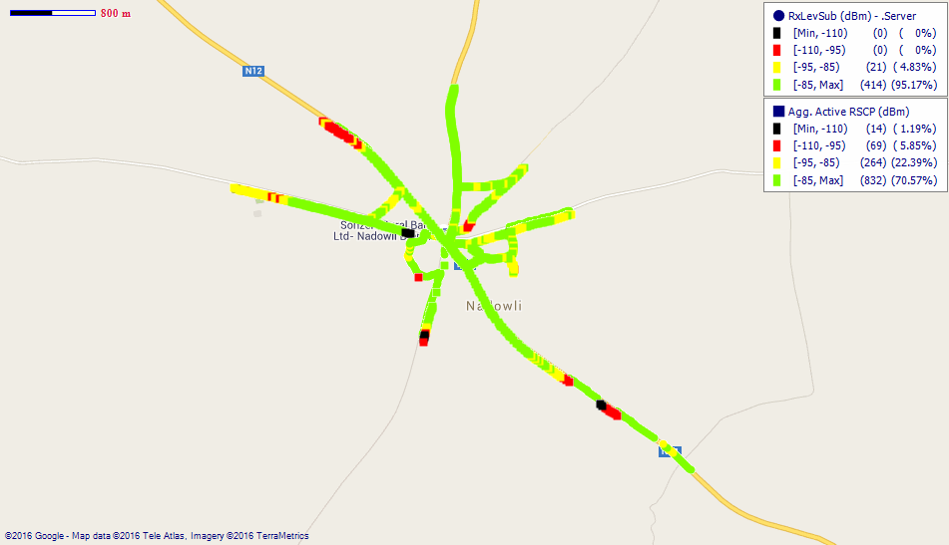
Remarks: Fair network coverage.

COVERAGE AT TUMU
Fig. 25 - MTN Coverage Map, Tumu – May, 2016
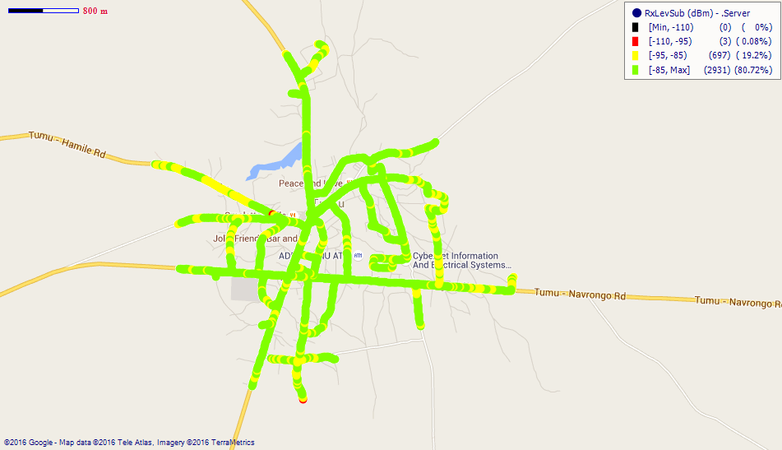
Remarks: Good 2G network coverage at Tumu.
Fig. 26 - Vodafone Coverage Map, Tumu – May, 2016
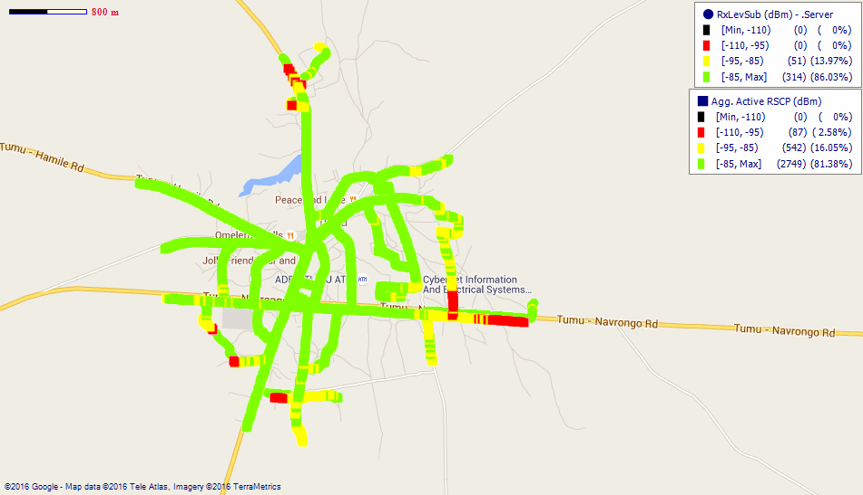
Remarks: Good network coverage across Tumu. However coverage around the Senior High School needs improvement.

Fig. 27 - Tigo Coverage Map, Tumu – May, 2016
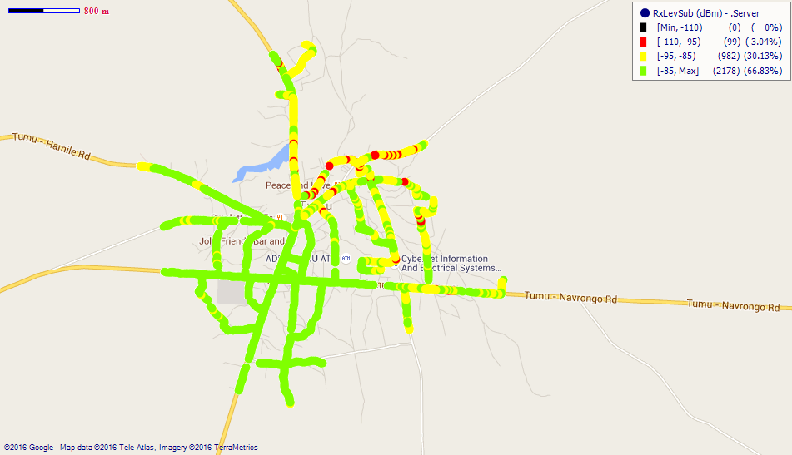
Remarks: Good 2G network coverage in Tumu however coverage around the Chief’s palace needs improvement.
Fig. 28 – Airtel Coverage Map, Tumu – May, 2016
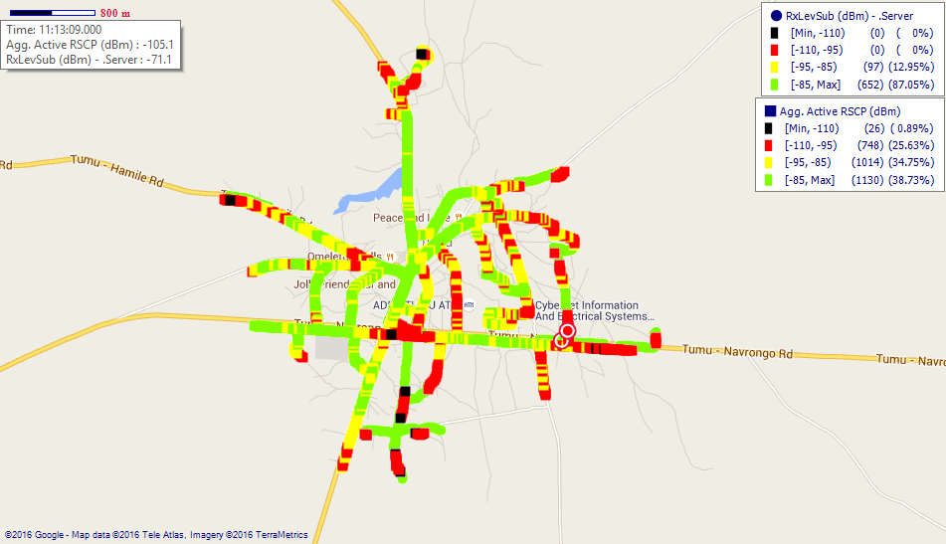
Remarks: Good 2G network coverage yet improvement is needed on the 3G.

COVERAGE AT WA
Fig. 29 - MTN Coverage Map, Wa – May, 2016
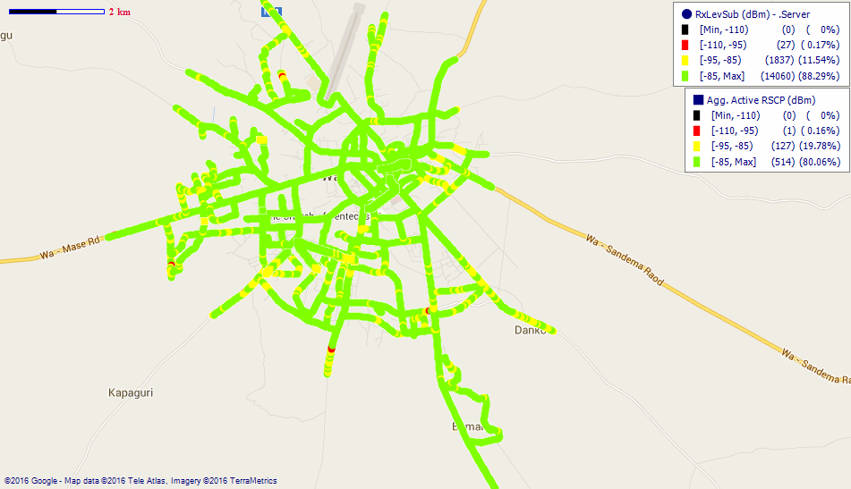
Remarks: Good network coverage.

Fig. 30 - Vodafone Coverage Map, Wa – May, 2016
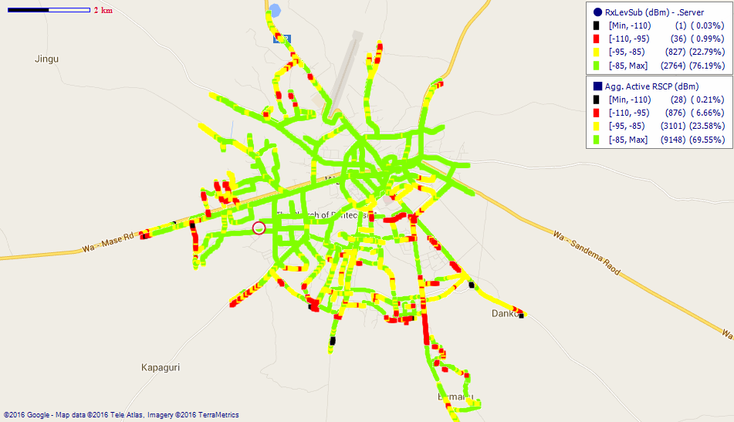
Remarks: Good network coverage across Wa. However, coverage at areas around SSNIT Estates, Xavier, Teagber, Mangu and Kunbiehi need major improvement.

Fig. 31 - Tigo Coverage Map, Wa – May, 2016
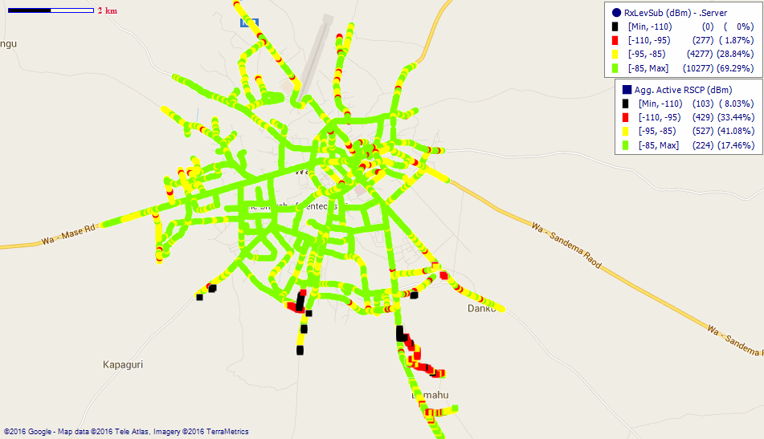
Remarks: Good 2G network coverage with general improvement needed especially on the 3G network.
Fig. 32- Airtel Coverage Map, Wa – May, 2016
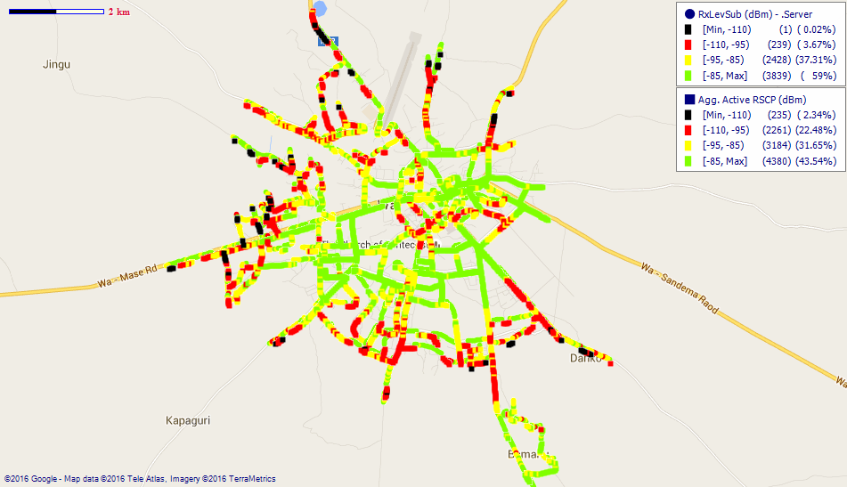
Remarks: Generally Fair network which gets poor along the outskirts. Major improvements needed.

Fig. 33 - Glo Coverage Map, Wa – May, 2016
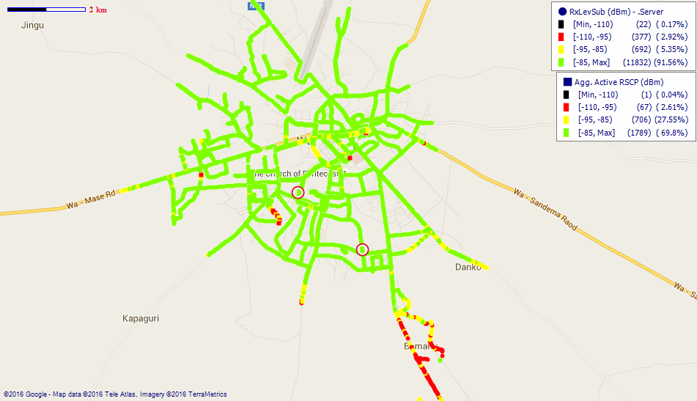
Remarks: Good network coverage across Wa, however that at the UDS-Wa Campus and surrounding areas is poor. Major improvement needed.
COVERAGE AT WECHIAU

Fig. 34 - MTN Coverage Map, Wechiau – May, 2016
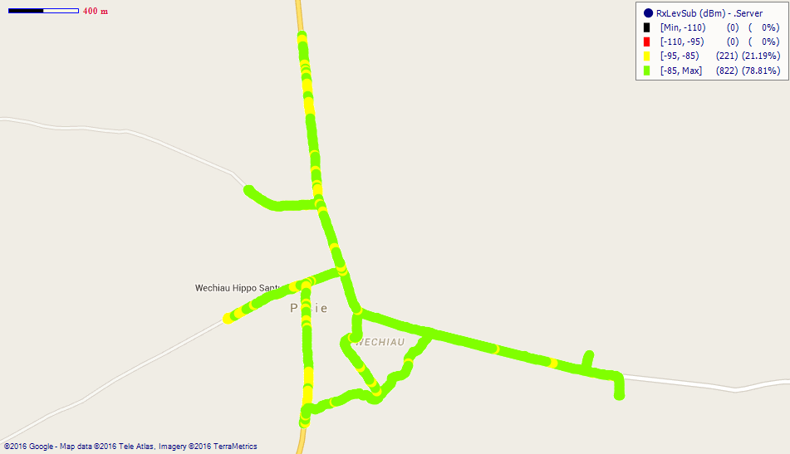
Remarks: Good network coverage across Wechiau.

Fig. 35 - Vodafone Coverage Map, Wechiau – May, 2016
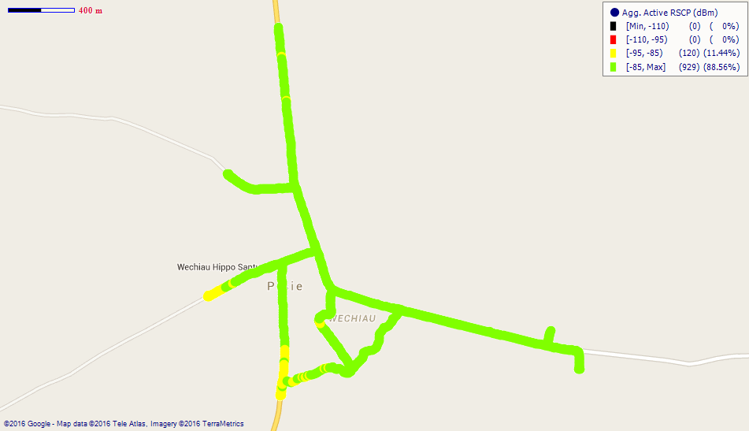
Remarks: Good network coverage at Wechiau.

Fig. 36 - Tigo Coverage Map, Wechiau – May, 2016
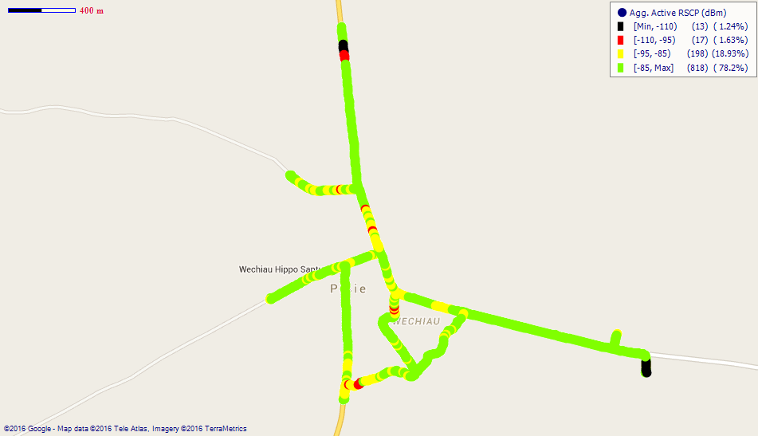
Remarks: Good network coverage in Wechiau.

Fig. 37 - Airtel Coverage Map, Wechiau – May, 2016
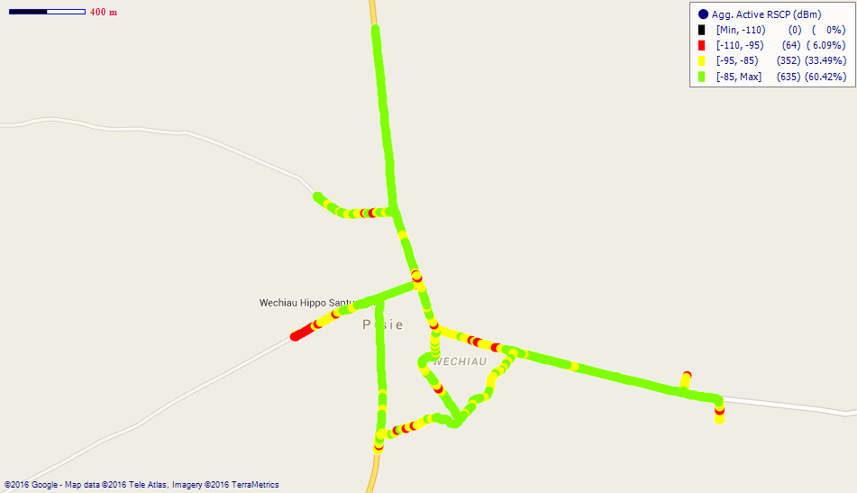
Remarks: Good network across Wechiau with improvement needed.

Fig. 38 - Glo Coverage Map, Wechiau – May, 2016
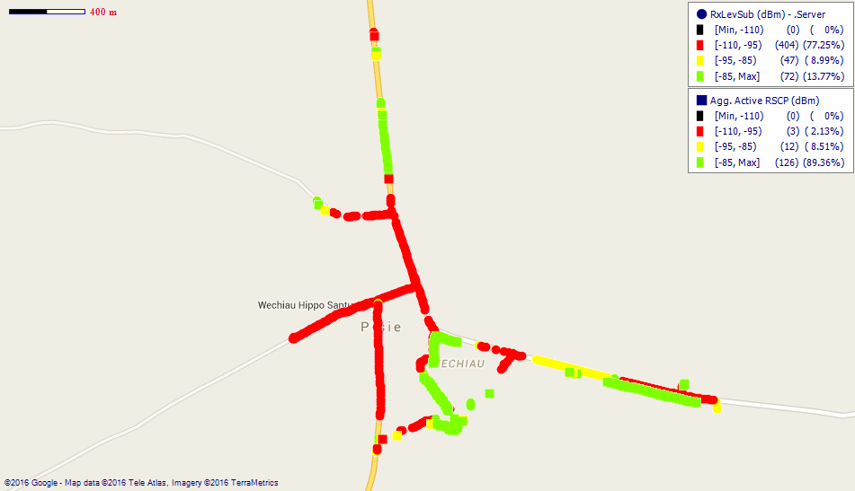
Remarks: Poor network in Wechiau. Major improvements needed.

APPENDIX II
SPEECH QUALITY FOR OPERATORS
Fig. 39 - MTN Speech Quality report in Upper West Region
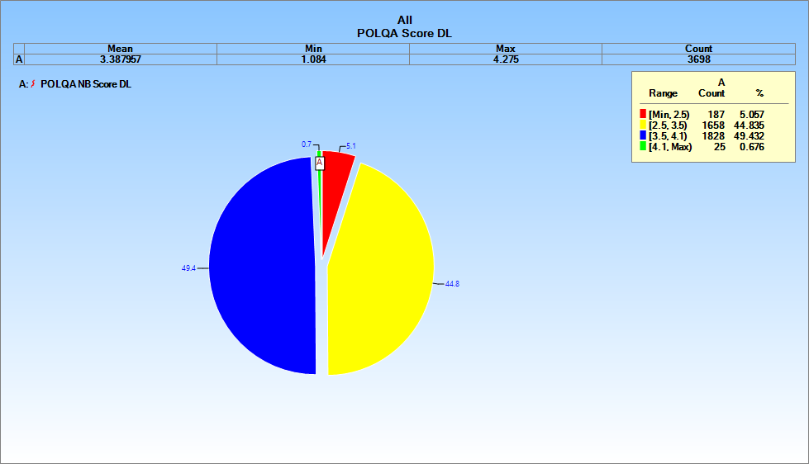
Fig. 40- Vodafone Speech Quality report in Upper West Region
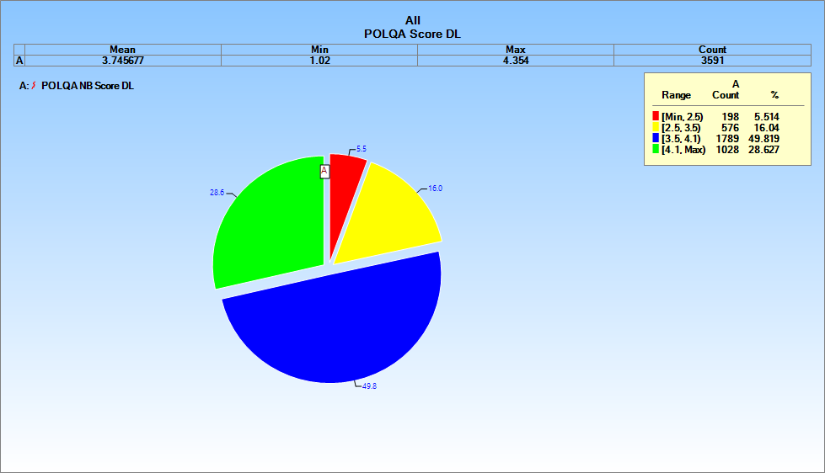

Fig. 41- Tigo Speech Quality report in Upper West Region
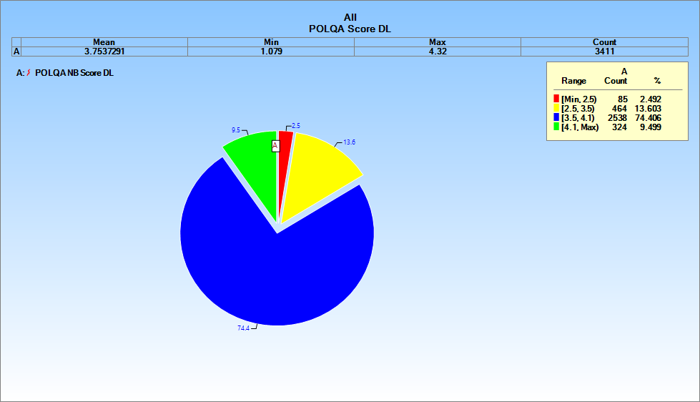

Fig. 42 - Airtel Speech Quality report in Upper West Region
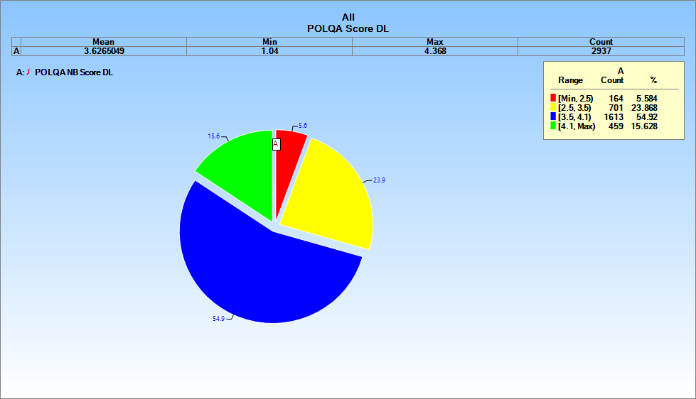

Fig. 43 - Glo Speech Quality report in Upper West Region
