Quality of Service (QoS) Monitoring of Cellular Mobile Voice Services- Upper East Region
[May 2016]
[Communications for Development]


NATIONAL COMMUNICATIONS AUTHORITY

Table of Contents
1. Background 2
2. What we measure 2
3. Findings 2-7
4. Remedies 7
5. Coverage and Speech Maps 8-29

Background
In pursuance of Annexure D1 and D2 of the Cellular Mobile Licence of Telecommunication Operators, the user perspective of the quality of voice services are tested to ensure the compliance of Operators to the obligations on service quality to the user.
The report is based on findings on quality of service in Upper East Region from 12th May to 16th May, 2016 for all Operators except for Expresso due to technical challenges.

What we measure
As per the Cellular Mobile licence obligations, the QoS indicators and their respective threshold for compliance under assessment considering the user’s perspective are;
• Stand-alone Dedicated Control Channel (SDCCH) Congestion Rate
• Call Setup Time (CST)
• Call Congestion Rate
• Call Drop Rate (CDR)
• Call Completion Rate (CCR)
• Voice Call Audio Quality
• Coverage

Findings
The results for the District Capitals within Upper East Region tested during the period are as below:
- Stand-alone Dedicated Control Channel (SDCCH) Congestion Rate
SDCCH Congestion is defined as the probability of failure of accessing a stand-alone dedicated control channel during call set up.

For analysis and calculations,
$\text{SDCCH Congestion }\left[\text{\%}\right]=\frac{\text{Number of connect fails due to Immediate Assignment Failures }}{\text{ MOC call attempts }}×\text{100\%}$
SDCCH Congestion Rate should be equal or less than one per cent (1%).
The results for the cities and towns tested in May are as below:
Table 1 Signalling Congestion Rate Cellular Mobile Voice Service, May 2016
Month | Town | MTN | Vodafone | Tigo | Airtel | Glo
May | Bawku | 0% | 0% | 0% | 0% | No Network
May | Bolgatanga | 0% | 0% | 0% | 0% | 0%
May | Bongo | 0% | 0% | 0% | 0% | No Network
May | Garu | 0% | 0% | 0% | 0% | No Network
May | Navrongo | 0% | 0% | 0% | 0% | No Network
May | Paga | 0% | 0% | 0% | 0% | No Network
May | Sandema | 0% | 0% | 0% | 0% | No Network
May | Tongo | 0% | 0% | 0% | 0% | 0%
May | Zebilla | 0% | 0% | 0% | 0% | No Network

REMARKS:
- All Operators were in compliance in the available Districts tested, with the signalling congestion threshold of less than 1 percent (1%) .

- Call Setup Time (CST)

Call Setup Time is the period of time elapsing from the sending of a complete destination address (target telephone number) to the setting up of a call to the receiving terminal;
$$\text{Call set-up time }\left[s\right]=t_{\text{alerting}−\text{signal}}−t_{\text{address}−\text{sending}}$$
$t_{\text{alerting}\text{signal}}$– Moment when an alerting signal is sent to the called terminal
$t_{\text{address}\text{sending}}$– Moment user presses the SEND button on the calling terminal
CST should be less than ten seconds (<10secs) in 95% of cases.
Table 2 Call Setup Time of Cellular Mobile Voice Service, May 2016
Month | Town | MTN | Vodafone | Tigo | Airtel | Glo
May | Bawku | 7.67secs | 5.21secs | 8.01secs | 14.77secs | No Network
May | Bolgatanga | 8.44secs | 6.60secs | 9.53secs | 10.79secs | 18.14secs
May | Bongo | 7.39secs | 3.96secs | 9.34secs | 14.19secs | No Network
May | Garu | 8.20secs | 4.15secs | 7.92secs | 9.85secs | No Network
May | Navrongo | 8.53secs | 5.05secs | 9.42secs | 10.09secs | No Network
May | Paga | 6.95secs | 3.51secs | 13.26secs | 11.64secs | No Network
May | Sandema | 8.51secs | 3.68secs | 8.23secs | 8.46secs | No Network
May | Tongo | 6.68secs | 5.14secs | 9.14secs | 13.76secs | 18.23secs
May | Zebilla | 6.55secs | 3.65secs | 9.31secs | 14.05secs | No Network

REMARKS:
- All Operators except MTN and Vodafone failed to meet the parameter threshold in certain localities.
- Tigo had Call Setup Time delays in Paga.
- Airtel had Call Setup Time delays in all tested District Capitals except Garu and Sandema.
- Glo had Call Setup Time delays in the two available Capitals tested (Bolgatanga and Tongo).

- Call Congestion Rate

Call Congestion Rate is the probability of failure of accessing a traffic channel during call setup;
$$\text{Call Congestion }\left[\text{\%}\right]=\frac{\text{Number of Connect failed calls}}{\text{Total number of call attempts}}×\text{100\%}$$
Traffic Channel Congestion should be equal or less than one per cent (1%).
Table 3 Call Congestion Rate Cellular Mobile Voice Service, May 2016
Month | Town | MTN | Vodafone | Tigo | Airtel | Glo
May | Bawku | 0% | 0% | 0% | 0% | No Network
May | Bolgatanga | 0% | 0% | 0% | 0% | 0%
May | Bongo | 0% | 0% | 0% | 0% | No Network
May | Garu | 0% | 0% | 0% | 0% | No Network
Month | Town | MTN | Vodafone | Tigo | Airtel | Glo
May | Navrongo | 0% | 0% | 0% | 0% | No Network
May | Paga | 0% | 0% | 0% | 0% | No Network
May | Sandema | 0% | 0% | 0% | 0% | No Network
May | Tongo | 0% | 0% | 0% | 0% | 0%
May | Zebilla | 0% | 0% | 0% | 0% | No Network

REMARKS:
- All Operators were compliant with the licence threshold of less than one percent (1%) in all the avalable locations tested.

- Call Drop Rate ( CDR)

Voice Call Drop Rate is the probability of a call terminating without any of the users’ will;
$$\text{Drop Rate }\left[\text{\%}\right]=\frac{\text{Number of calls terminated unwillingly}}{\text{Total number of call attempts}}×\text{100\%}$$
Call drop rate should be equal or less than three per cent (3%).
Table 4 Call Drop Rate Cellular Mobile Voice Service, May 2016
Month | Town | MTN | Vodafone | Tigo | Airtel | Glo
May | Bawku | 0% | 0% | 0% | 0% | No Network
May | Bolgatanga | 0% | 0% | 0% | 0% | 0%
May | Bongo | 0% | 0% | 0% | 0% | No Network
May | Garu | 0% | 0% | 0% | 0% | No Network
May | Navrongo | 0% | 0% | 0% | 0% | No Network
May | Paga | 0% | 0% | 0% | 0% | No Network
May | Sandema | 0% | 0% | 0% | 0% | No Network
May | Tongo | 0% | 0% | 0% | 0% | 0%
May | Zebilla | 0% | 0% | 0% | 0% | No Network

REMARK:
- All Operators were in compliance with the Call Drop Rate licence threshold of less than three percent (3%) in all the available localities tested.
- Call Completion Rate ( CCR)

Call Completion Rate is defined as the probability that a call has, after being successfully set up, be maintained during a period of time and ending normally.
$$\text{Call Completion }\left[\text{\%}\right]=\frac{\text{Number of normally ended calls}}{\text{Total number of call attempts}}×\text{100\%}$$
Call Completion Rate should be equal or better than seventy percent (70%).
Table 5 Call Completion Rate Cellular Mobile Voice Service, May 2016
Month | Town | MTN | Vodafone | Tigo | Airtel | Glo
May | Bawku | 96.88% | 100.00% | 100.00% | 89.06% | No Network
May | Bolgatanga | 99.71% | 95.39% | 98.79% | 92.61% | 85.00%
May | Bongo | 97.78% | 97.87% | 100.00% | 72.09% | No Network
May | Garu | 98.53% | 94.29% | 98.15% | 98.67% | No Network
May | Navrongo | 100.00% | 100.00% | 100.00% | 85.50% | No Network
May | Paga | 97.22% | 100.00% | 96.88% | 81.48% | No Network
May | Sandema | 97.37% | 100.00% | 100.00% | 100.00% | No Network
May | Tongo | 100.00% | 100.00% | 98.04% | 68.75% | 100.00%
May | Zebilla | 100.00% | 100.00% | 100.00% | 89.16% | No Network

REMARKS:
- All Operators except Airtel were in compliance with the Call Completion Rate licence threshold of less than seventy percent (70%) in all available locations tested.
- Airtel failed the Call Completion Rate obligation in Tongo.
- Voice Call Audio Quality
It is the perceptibility of the conversation during a call. Voice Call Audio Quality is measured by a parameter called the Mean Opinion Score (MOS) which categorizes speech samples in ranges from 0 to 5.
Range | Colour Code | Rating
[0 – 2.5) |  | Poor
[2.5 – 3.5) |  | Fair
[3.5 – 4) |  | Good
[4.1 – 5) |  | Excellent

Table 6 Speech Quality Mean Opinion Score Upper East Region, May 2016
Upper East | MTN | Vodafone | Tigo | Airtel | Glo
MOS | 3.42 | 3.80 | 3.80 | 3.40 | 3.83

REMARK:
- Vodafone, Tigo and Glo were assessed to give GOOD speech quality.
- MTN and Airtel were assessed to give FAIR speech quality.

REMEDIES
- The NCA has notified Operators of these findings and has directed to improve their coverage in some localities.
- Airtel has been granted moratorium till July, 2016 to resolve the persistent Call Setup Time delays.
- Glo has been directed to improve their coverage in the Upper East Region by December, 2016.

APPENDICES

COVERAGE AND SPEECH MAPS

The Maps below show the coverage level and speech quality in the various towns where monitoring was performed. The coverage map is a combination of both 2G and 3G network signal strength. In each plot is a legend to indicate definitions of signal strength and quality range attained by Operators during measurement. Coverage levels in green falls in the rage of -85dBm and above, and are considered good. Those between -85 and -95dBm are considered average and are indicated in yellow. The red samples represent worse coverage in the range of -95 to -105dBm. The black samples represent areas with no coverage. The speech quality was assessed with Mean Opinion Score (MOS) which ranges from 5 to 1.

APPENDIX I

COVERAGE AT BAWKU
Fig. 1- MTN Coverage Map, Bawku – May, 2016
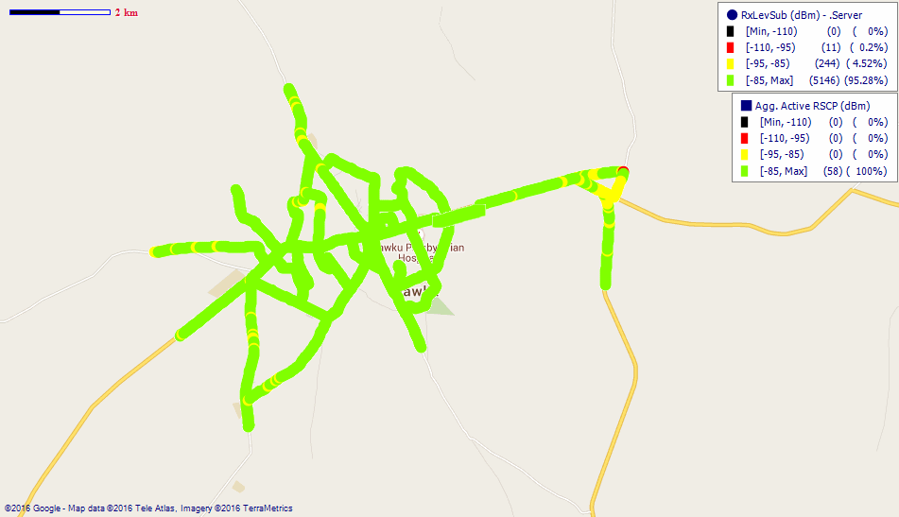
Remarks: Good network coverage across Bawku.

Fig. 2- Vodafone Coverage Map, Bawku – May, 2016
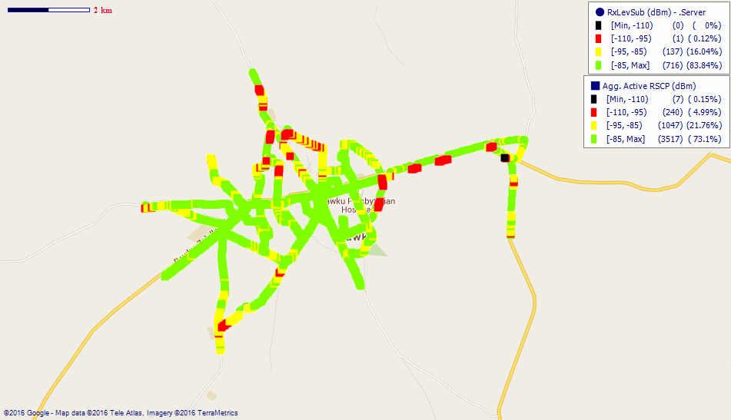
Remarks: Good network coverage across Bawku yet improvement is needed.

Fig. 3- Tigo Coverage Map, Bawku – May, 2016
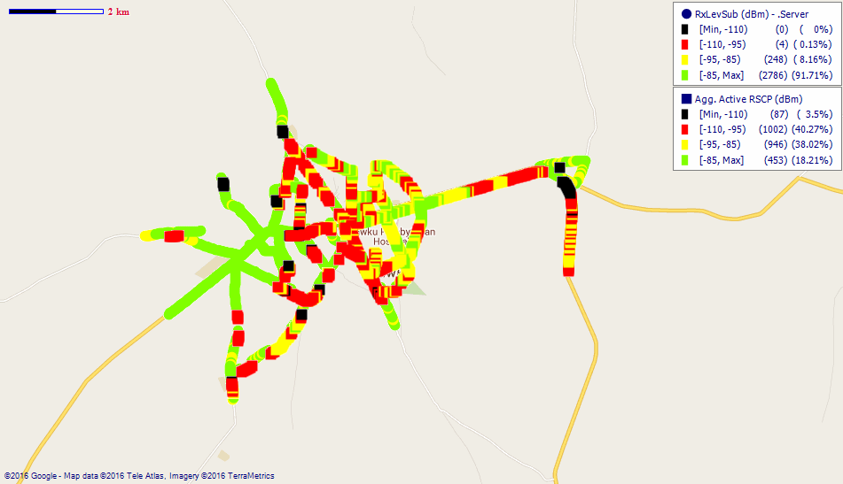
Remarks: Good 2G network with major improvement needed on the 3G.

Fig. 4 - Airtel Coverage Map, Bawku - May 2016
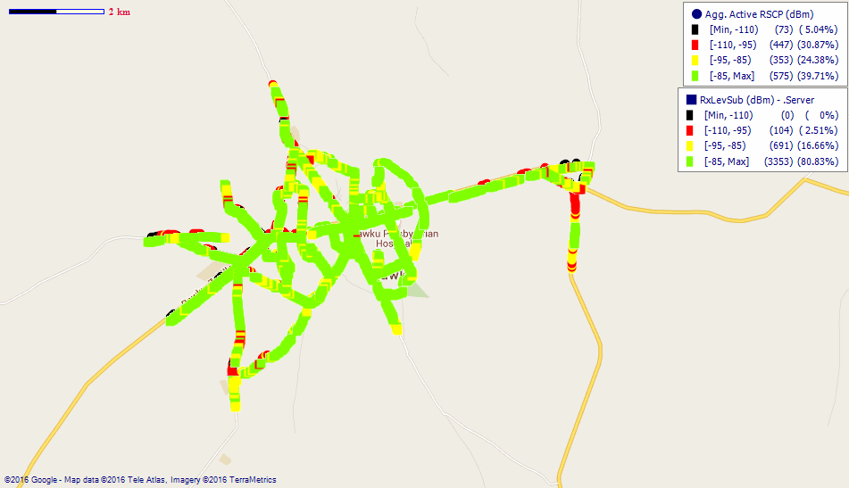
Remarks: Good 2G network coverage across Bawku with fair 3G coverage. Holistic improvements are needed on the 3G network across Bawku.

COVERAGE AT BOLGATANGA

Fig. 5- MTN Coverage Map, Bolgatanga – May, 2016
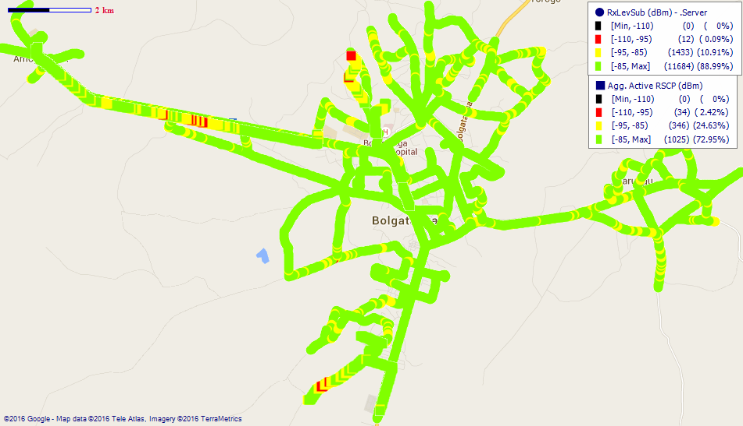
Remarks: Good network coverage.
Fig. 6- Vodafone Coverage Map, Bolgatanga – May, 2016
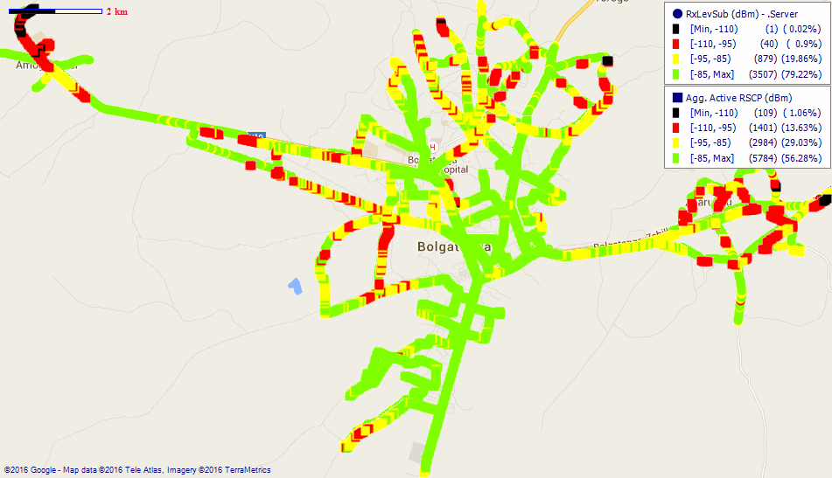
Remarks: Good network coverage across Bolgatanga however network at areas such as Sumbrungu, Yikene, Tanzui, Zaare and Zuarung needs improvement.

Fig. 7- Tigo Coverage Map, Bolgatanga – May, 2016
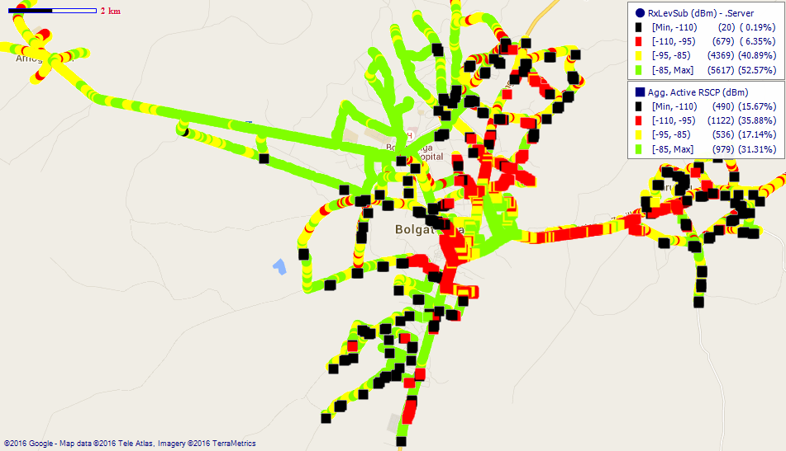
Remarks: Good 2G network however 3G network around Zaare, SSNIT Traffic Light, Soe and Zuarungu needs major improvement.
Fig. 8- Airtel Coverage Map, Bolgatanga – May, 2016
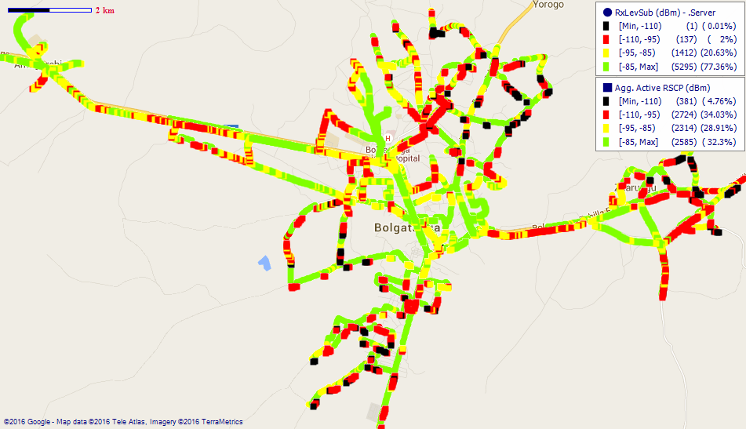
Remarks: Good 2G network coverage however improvement is needed on the 3G network coverage at areas around Yikene, Zaare, Soe, Zuarungu and Tanzui.

Fig. 9- Glo Coverage Map, Bolgatanga – May, 2016
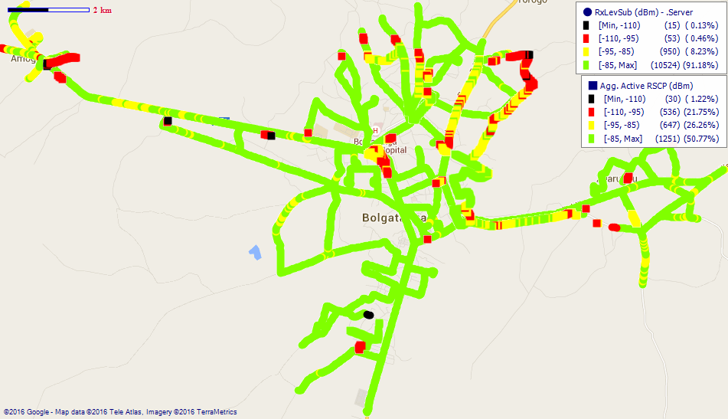
Remarks: Fair network coverage across Bolgatanga. Improvements are needed at Soe, Sumbrungu and Zaare.
COVERAGE AT BONGO

Fig. 10- MTN Coverage Map, Bongo - May 2016
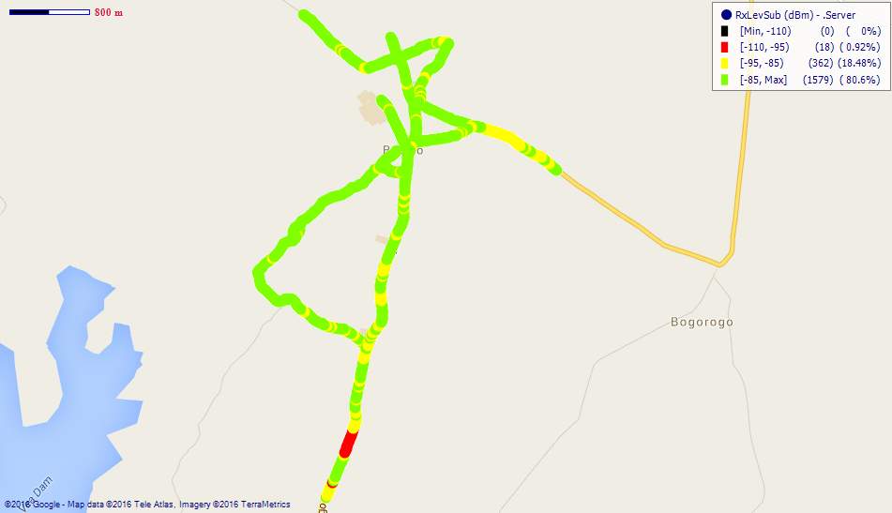
Remarks: Good 2G network coverage.
Fig. 11- Vodafone Coverage Map, Bongo –May, 2016
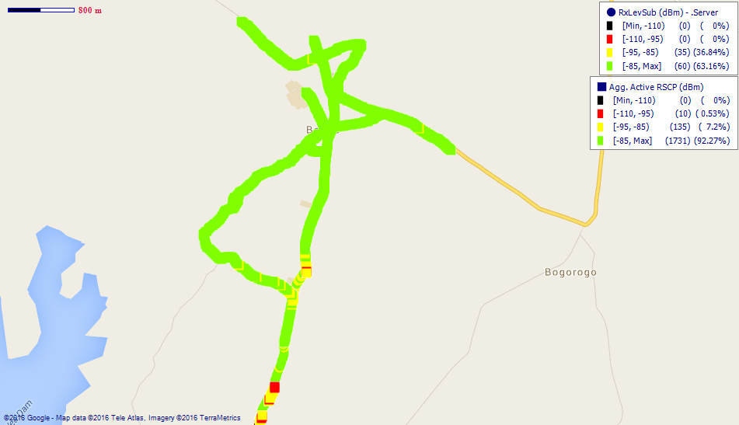
Remarks: Good network coverage across Bongo.

Fig. 12- Tigo Coverage Map, Bongo – May, 2016
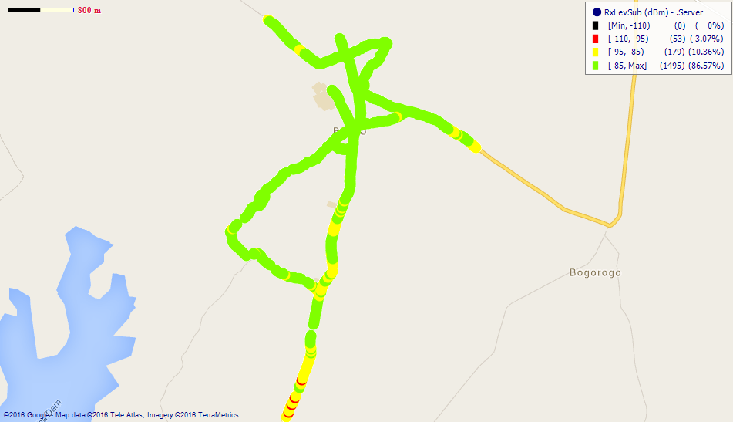
Remarks: Good network coverage.

Fig. 13- Airtel Coverage Map, Bongo – May, 2016
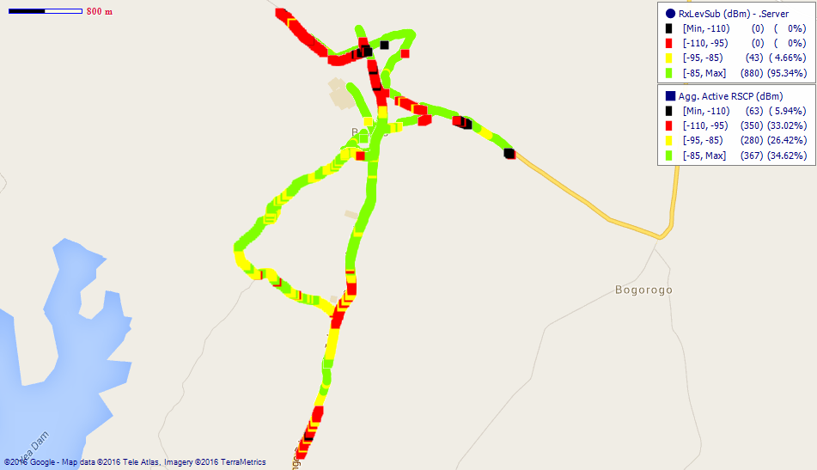
Remarks: Good 2G network coverage with scattered fair 3G coverage. Major improvement needed.
COVERAGE AT GARU

Fig. 14- MTN Coverage Map, Garu – May, 2016
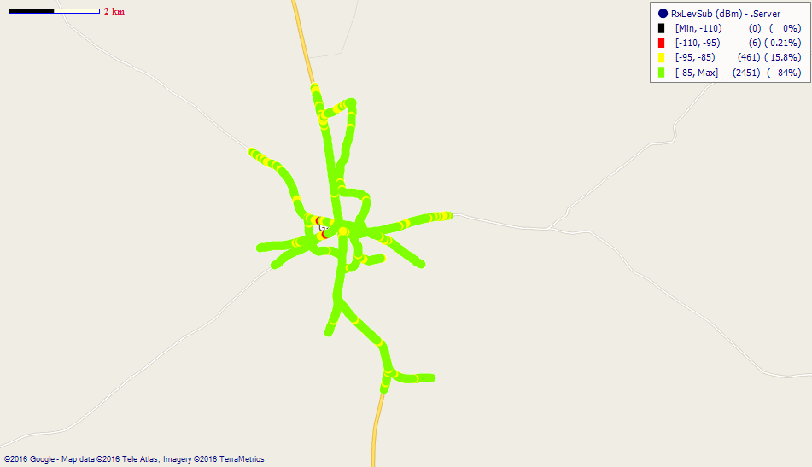
Remarks: Good network coverage.
Fig. 15- Vodafone Coverage Map, Garu – May, 2016
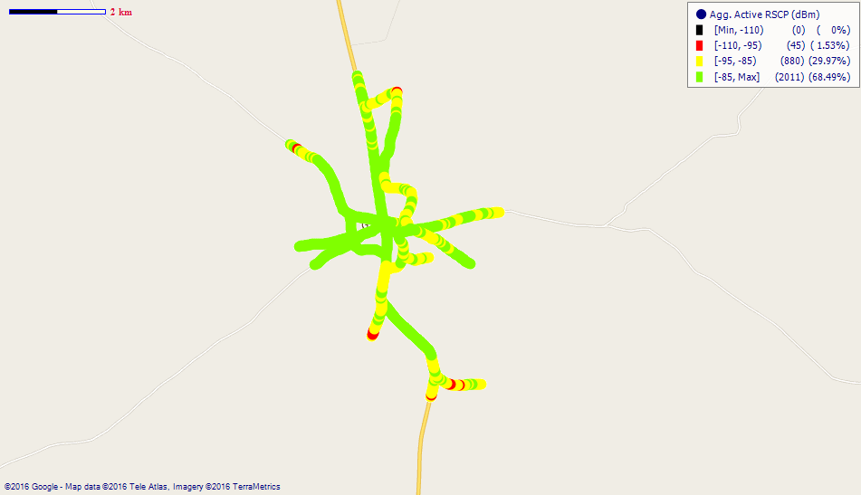
Remarks: Good network coverage.
Fig. 16- Tigo Coverage Map, Garu – May, 2016
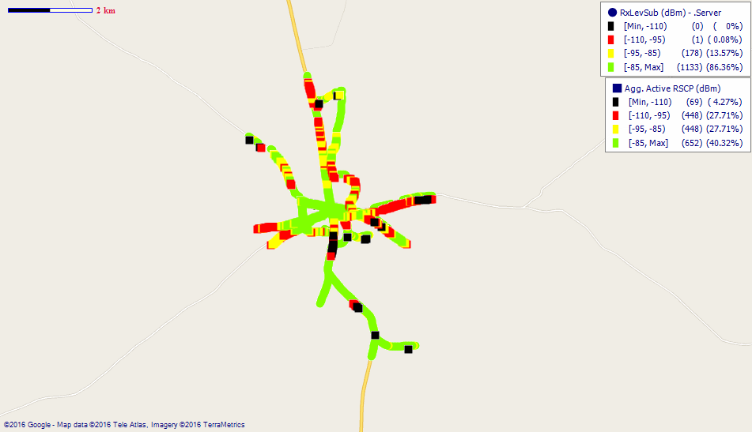
Remarks: Good 2G network however improvement is needed on the 3G network.

Fig. 17- Aitel Coverage Map, Garu – May, 2016
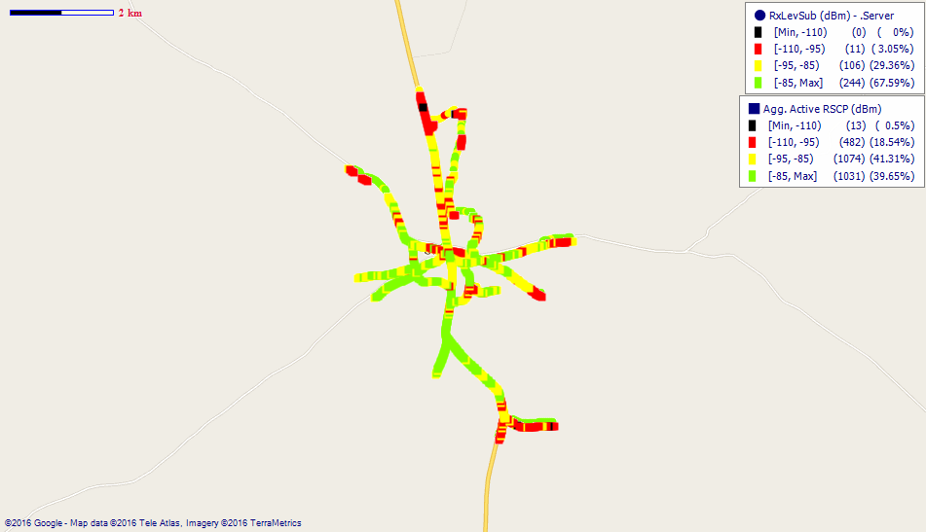
Remarks: Fair network coverage across Garu. Major improvement needed.

COVERAGE AT NAVRONGO

Fig. 18- MTN Coverage Map, Navrongo – May, 2016
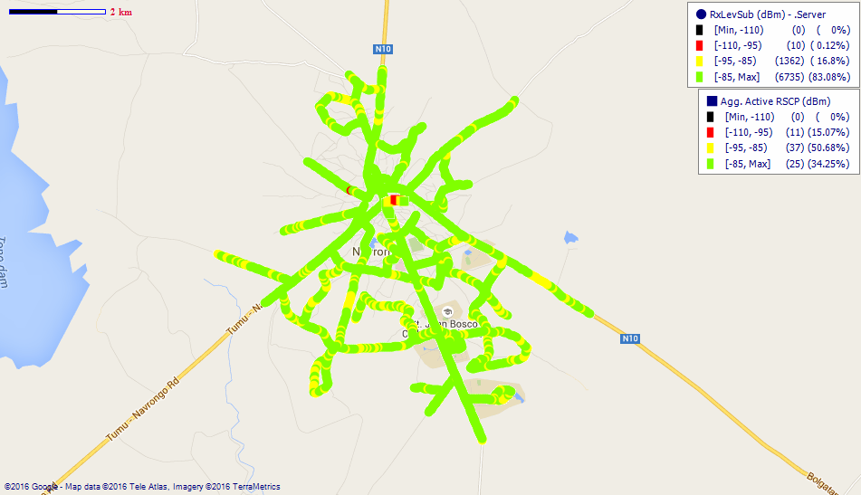
Remarks: Good network coverage.
Fig. 19- Vodafone Coverage Map, Navrongo – May, 2016
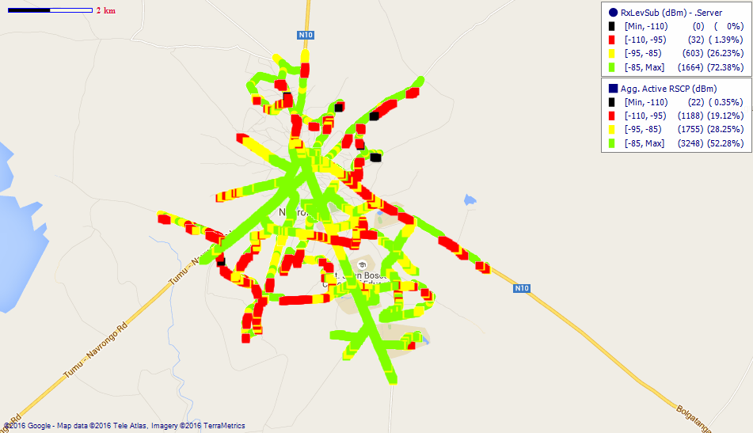
Remarks: Fair network coverage across Navrongo. Major coverage improvement is needed especially along the Bolgatanga and Tumu Road.
Fig. 20- Tigo Coverage Map, Navrongo – May, 2016
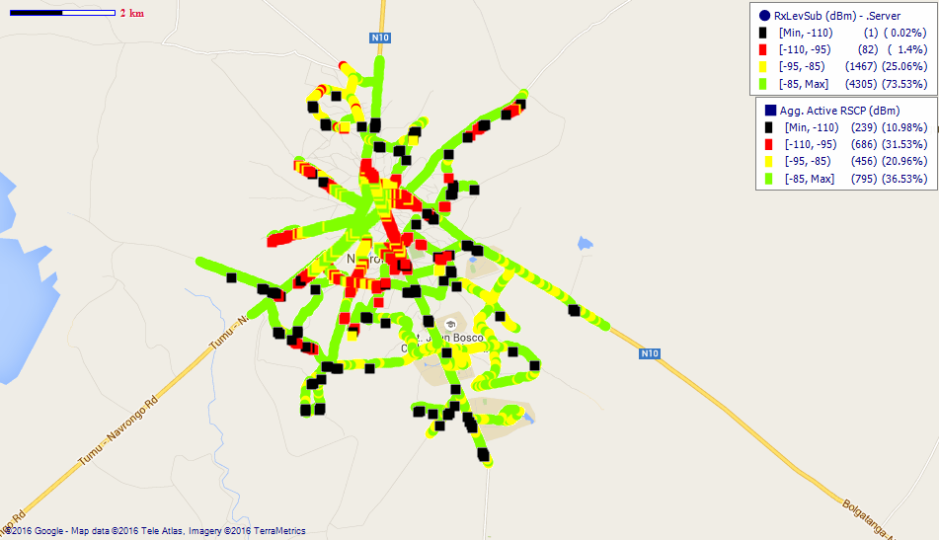
Remarks: Good 2G network however the 3G network need’s improvement.

Fig. 21- Airtel Coverage Map, Navrongo – May, 2016
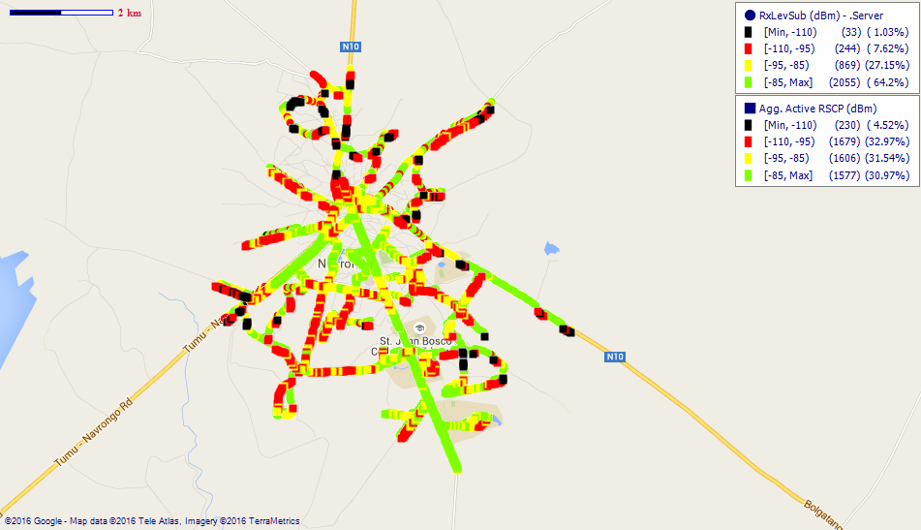
Remarks: Fair network coverage with improvement needed across Navrongo.

COVERAGE AT PAGA
Fig. 22- MTN Coverage Map, Paga – May, 2016
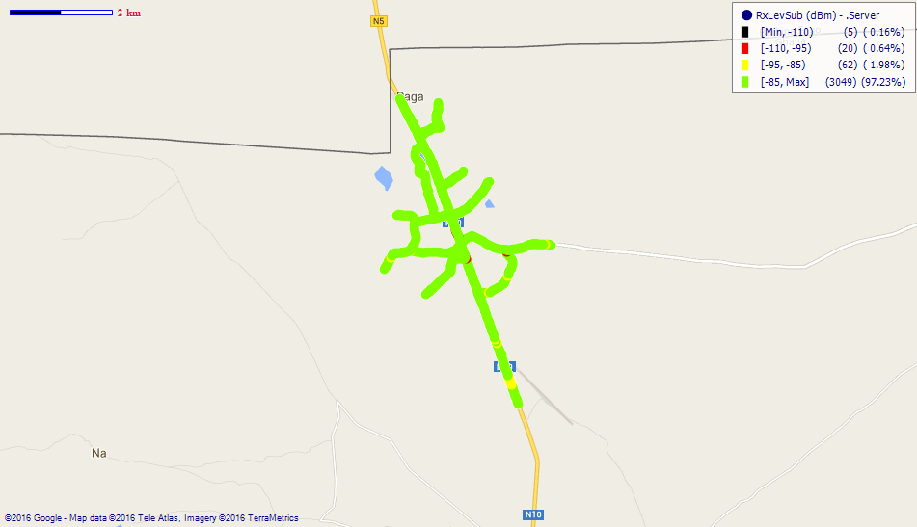
Remarks: Good network coverage.

Fig. 23- Vodafone Coverage Map, Paga - May 2016
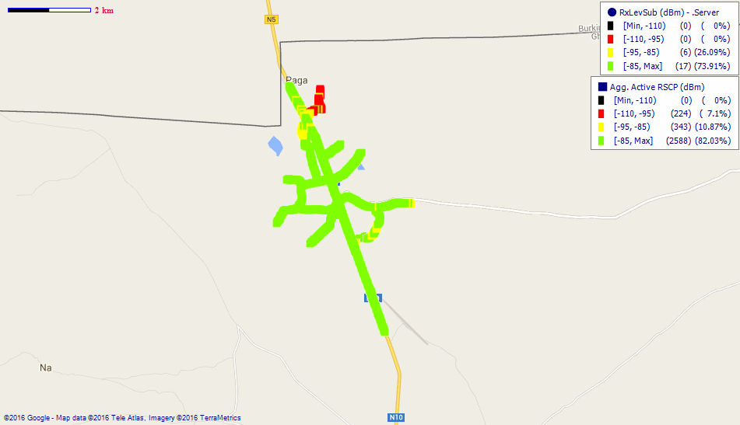
Remarks: Good network coverage.
.
Fig. 24- Tigo Coverage Map, Paga – May, 2016
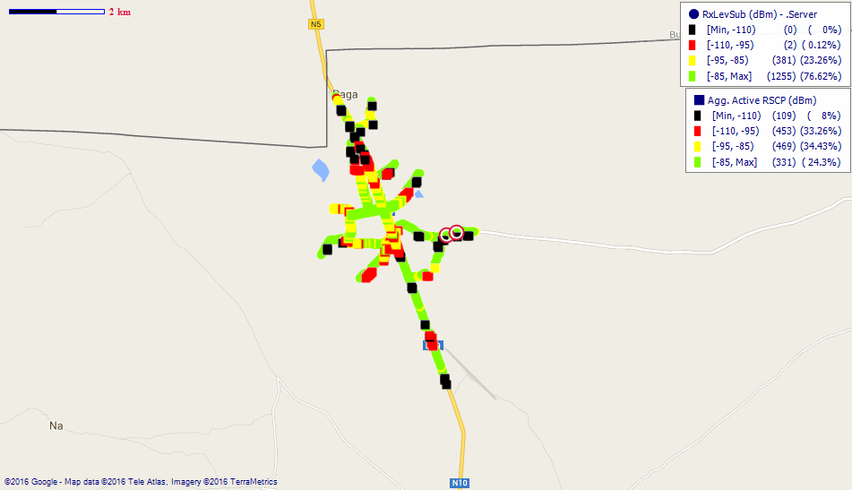
Remarks: Good 2G network yet a general improvement needed on the 3G.

Fig. 25- Airtel Coverage Map, Paga – May, 2016
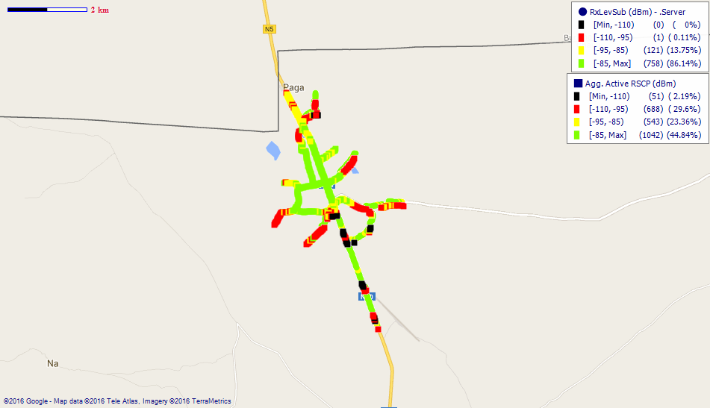
Remarks: Good 2G network coverage yet improvement is needed on the 3G network.

COVERAGE AT SANDEMA
Fig. 26- MTN Coverage Map, Sandema – May, 2016
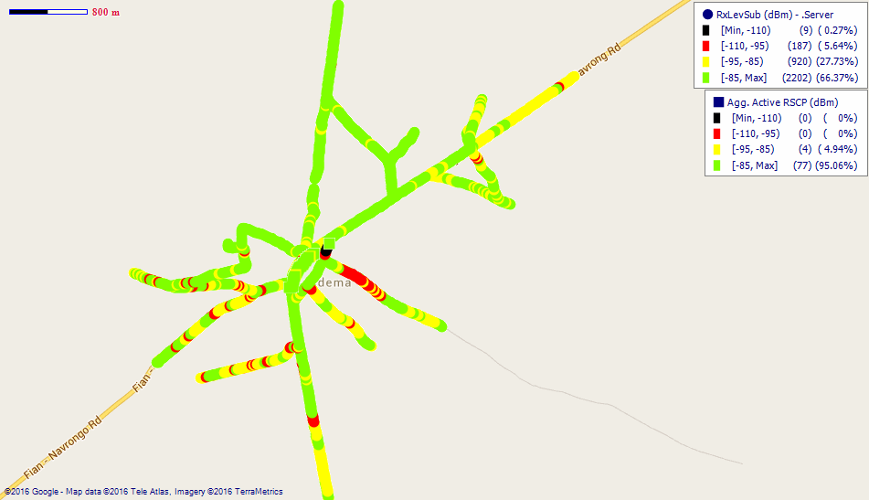
Remarks: Good network coverage yet improvement is needed.
Fig. 27- Vodafone Coverage Map, Sandema – May, 2016
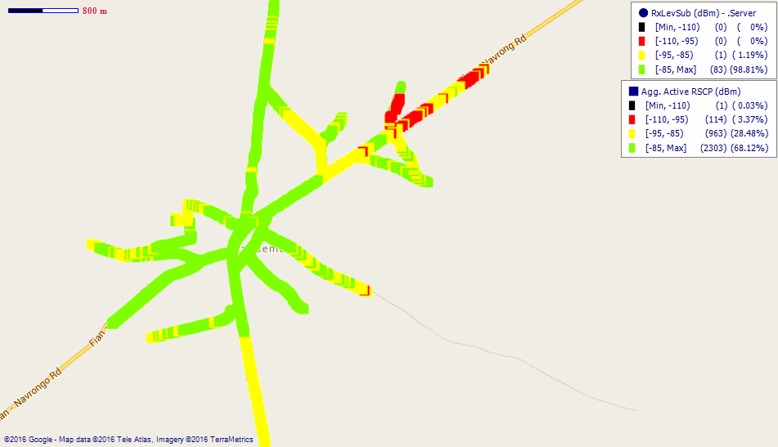
Remarks: Good network coverage across Sandema. However coverage along the Navrongo road needs improvement.

Fig. 28- Tigo Coverage Map, Sandema – May, 2016
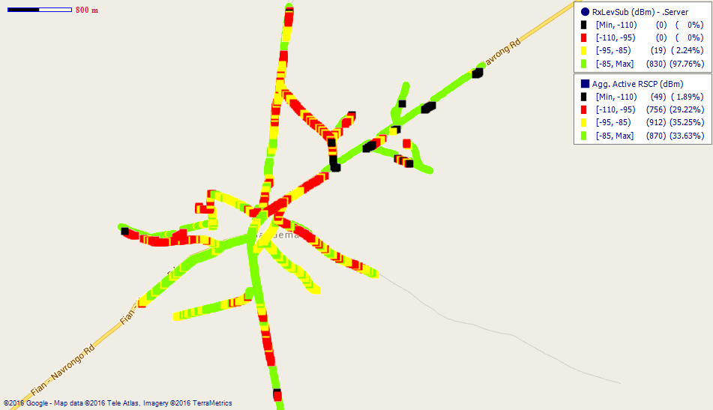
Remarks: Good 2G network coverage. Major improvements are needed on the 3G.
Fig. 29– Airtel Coverage Map, Sandema – May, 2016
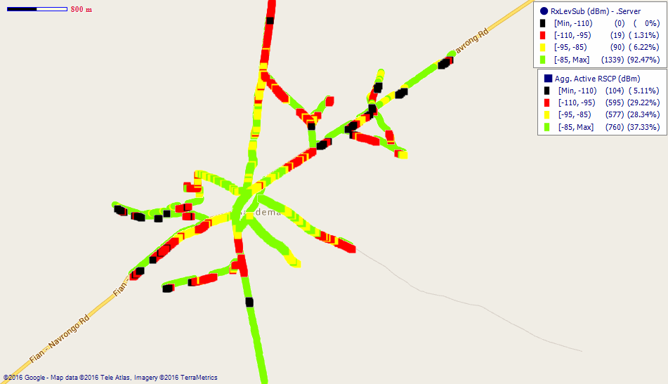
Remarks: Good 2G network coverage yet improvement is needed on the 3G network.

COVERAGE AT TONGO
Fig. 30- MTN Coverage Map, Tongo – May, 2016
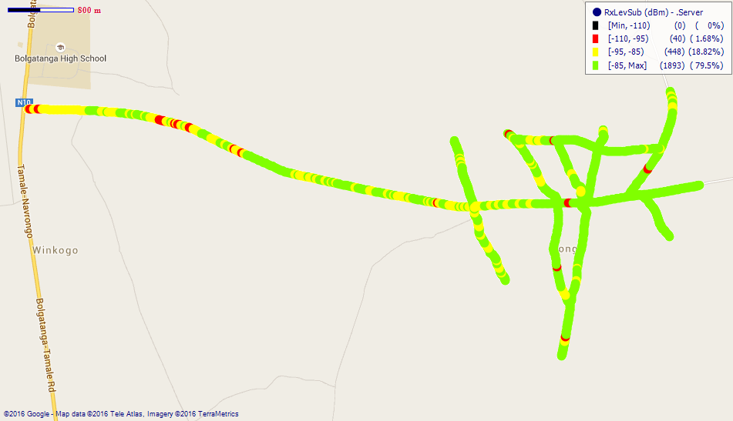
Remarks: Good network coverage with improvement needed.
Fig. 31- Vodafone Coverage Map, Tongo – May, 2016
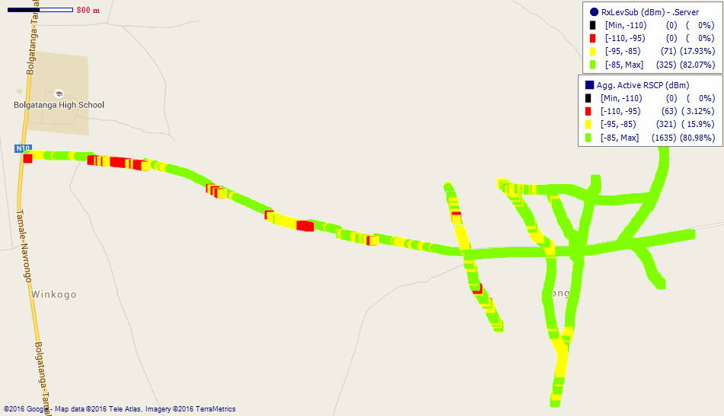
Remarks: Good network coverage across Tongo with improvement needed along the main Bolgatanga road.

Fig. 32- Tigo Coverage Map, Tongo – May, 2016
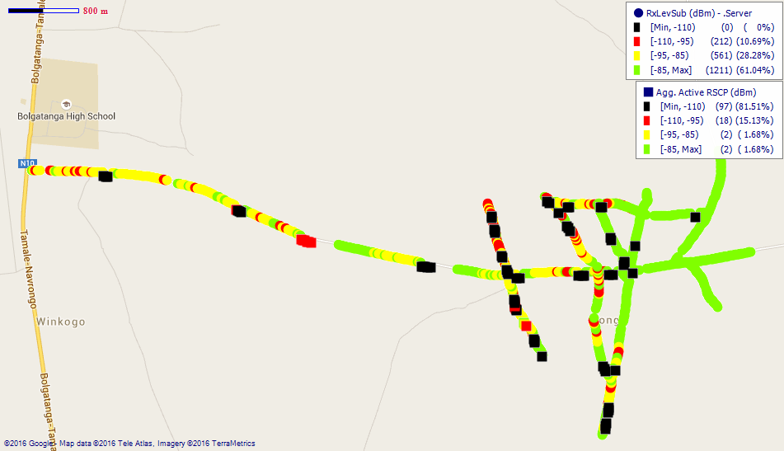
Remarks: Good 2G network with nonexistent 3G network.

Fig. 33- Airtel Coverage Map, Tongo – May, 2016
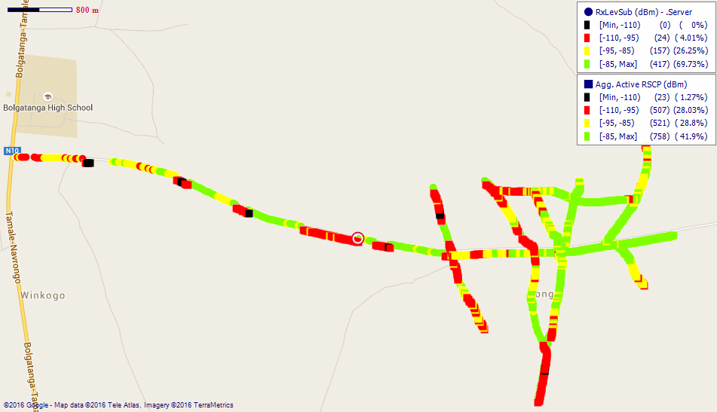
Remarks: Fair network coverage across Tongo. Major improvements needed.

Fig. 34- Glo Coverage Map, Tongo – May, 2016
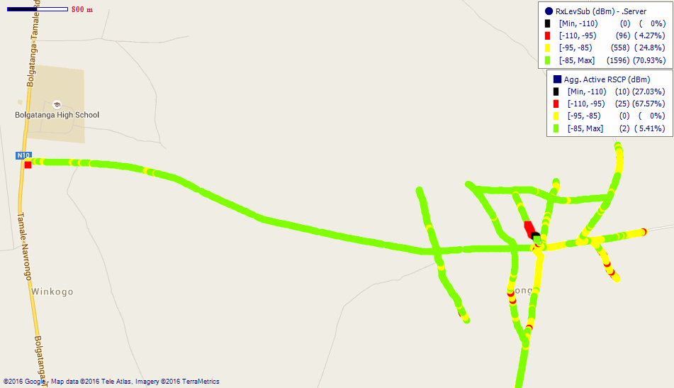
Remarks: Good network coverage across Tongo.

COVERAGE AT ZEBILLA

Fig. 35- MTN Coverage Map, Zebilla – May, 2016
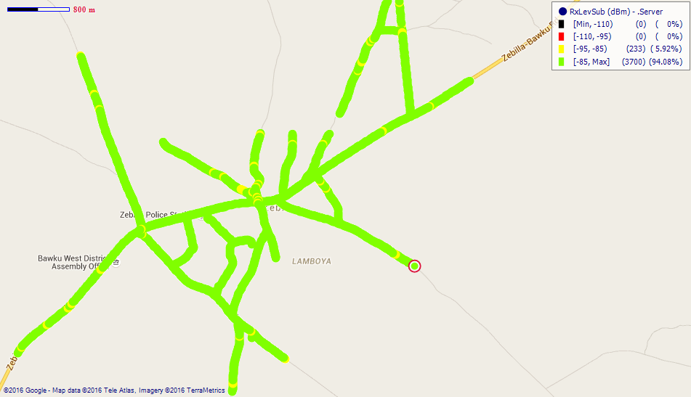
Remarks: Good network coverage.
Fig. 36- Vodafone Coverage Map, Zebilla – May, 2016
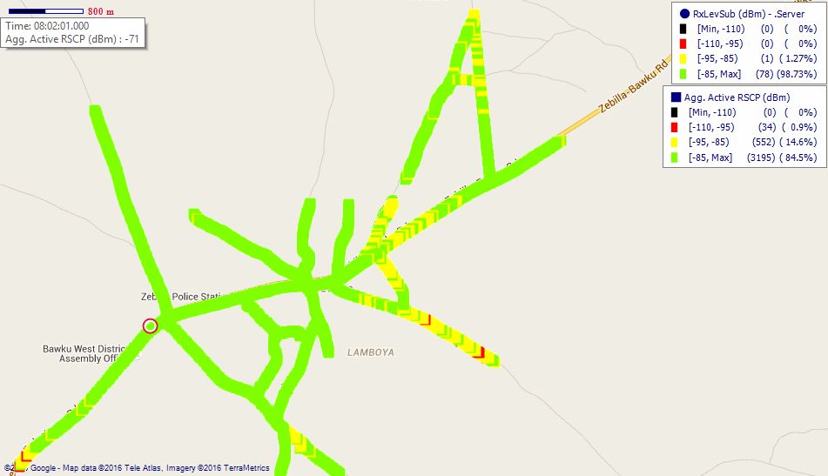
Remarks: Good network coverage across Zebilla.

Fig. 37- Tigo Coverage Map, Zebilla – May, 2016
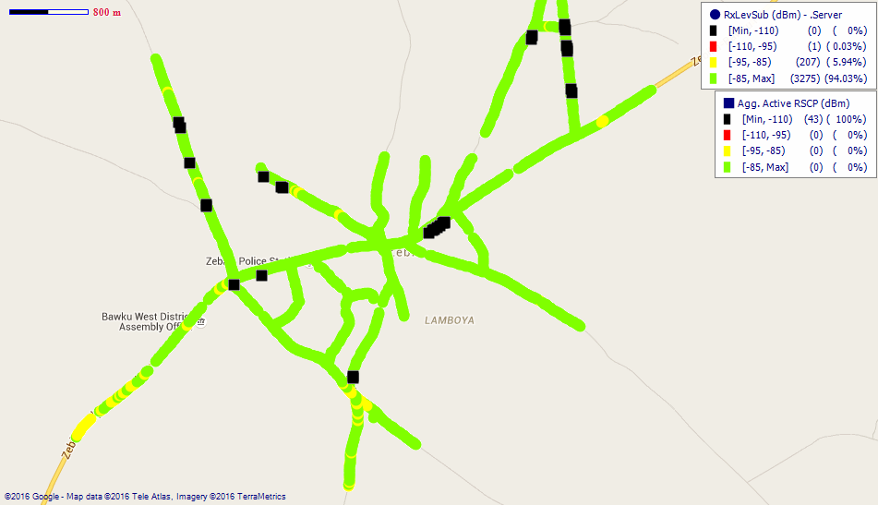
Remarks: Good network coverage.

Fig. 38- Airtel Coverage Map, Zebilla – May, 2016
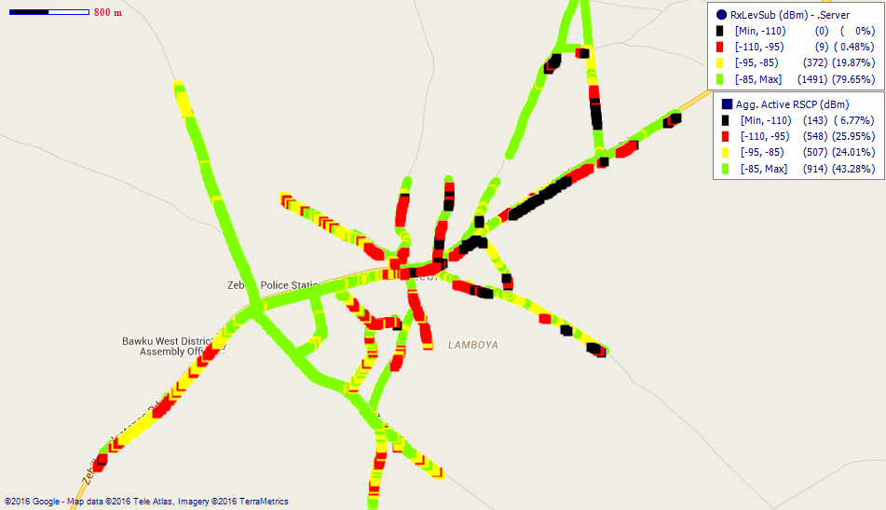
Remarks: Good 2G network coverage. Major 3G coverage improvement is needed.

APPENDIX II
SPEECH QUALITY FOR OPERATORS
Fig. 39- MTN Speech Quality report in Upper East Region
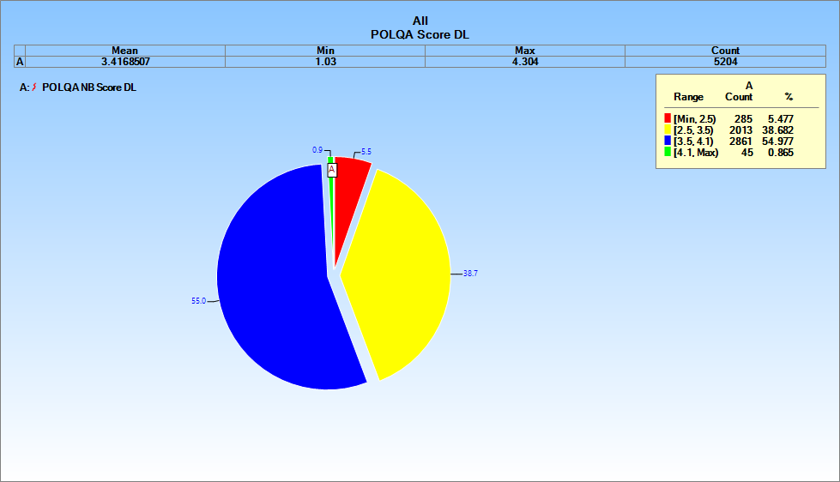

Fig. 40- Vodafone Speech Quality report in Upper East Region
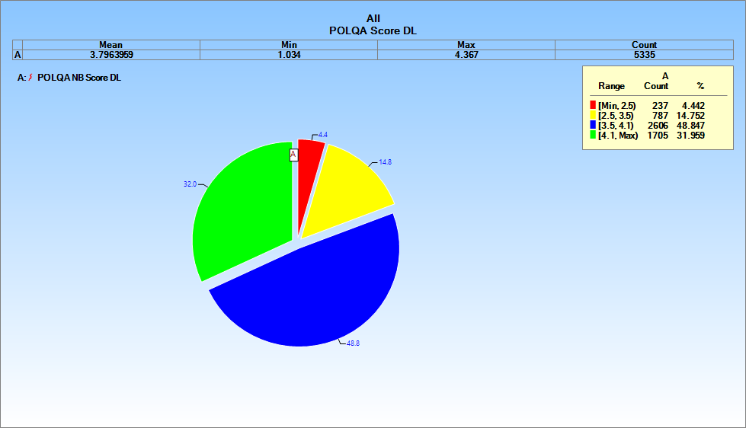

Fig. 41- Tigo Speech Quality report in Upper East Region
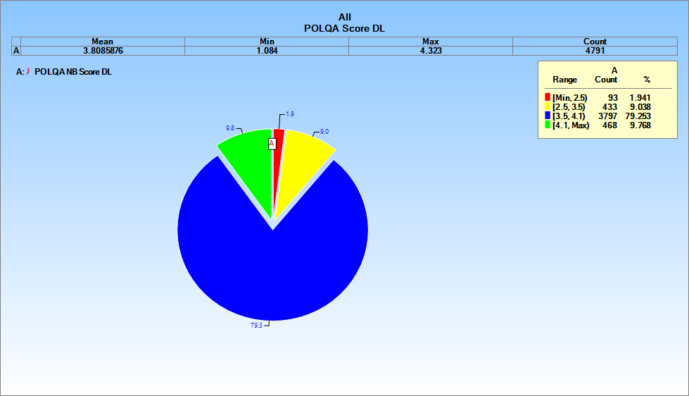

Fig. 42- Airtel Speech Quality report in Upper East Region
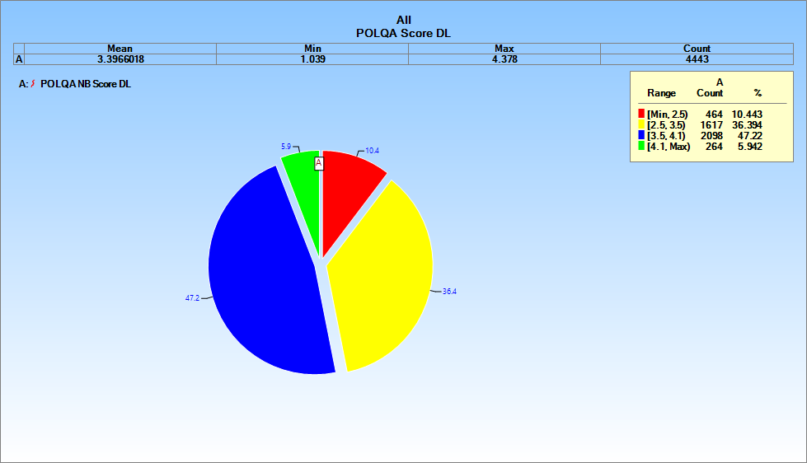

Fig. 43- Glo Speech Quality report in Upper East Region
