Quality of Service (QoS) Monitoring of Cellular Mobile Data Services-UPPER EAST REGION
[May 2016]
[Communications for Development]

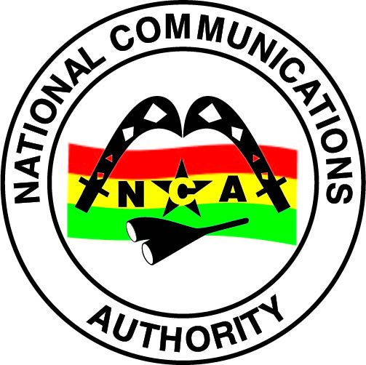
NATIONAL COMMUNICATIONS AUTHORITY

Table of Contents
1. Background 2
2. What we measure 2
3. Findings 2-4
4. Remedies 5
5. Appendix 6 - 13

Background
In pursuance of obligations of the 3G Cellular Mobile Licence of Telecommunication Operators, the consumer perspective of the quality of data services are tested to ensure the compliance of Operators to the obligations on service quality to the user.
The report is based on findings on quality of data service in the Upper East Region between 12th May and 16th May 2016 for all Operators except for Expresso due to technical challenges.

What we measure

As per the 3G Cellular Mobile licence obligations, the QoS indicators and their respective threshold for compliance under assessment considering the user’s perspective are as below;

- Data Access Success Rate (DASR)
- Data Drop Rate (DDR)
- Data Throughput

Findings

The results for the district capitals within Eastern Region tested during the period are as below:

- Data Access Success Rate

Data Access Success Rate is the probability of success in connecting to the public server.
Data Access Success Rate should be equal or better than ninety-five per cent (95%)
For analysis and calculations,
The results for the district capitals tested during the period are as below:

Table 1. Data Access Success Rate, May 2016
DISTRICT CAPITAL | MTN | VODAFONE | TIGO | AIRTEL | GLO
Bawku | 100 | 100 | 100 | 93.10 | No 3G Coverage
Bolgatanga | 100 | 100 | 100 | 90.15 | 100
Bongo | 100 | 100 | No 3G Coverage | 66.67 | No 3G Coverage
Garu | 100 | 100 | 100 | 100 | No 3G Coverage
Navrongo | 100 | 100 | 100 | 93.33 | No 3G Coverage
Paga | 100 | 100 | 100 | 85.42 | No 3G Coverage
Sandema | 100 | 100 | 100 | 96.55 | No 3G Coverage
Tongo | 100 | 100 | No 3G Coverage | 97.37 | No 3G Coverage
Zebilla | 100 | 100 | No 3G Coverage | 97.06 | No 3G Coverage

REMARKS:
- All Operators except Airtel complied with the Data Access Success Rate obligation in all the available District Capitals tested.
- Airtel failed the Data Access Success Rate obligation at Bawku, Bolgatanga, Bongo, Navrongo and Paga.

- Data Drop Rate

Data Drop Rate is the probability to drop in connection to a public server without end user’s intervention.
Data Drop Rate should be equal or less than one per cent (1%).
Table 2. Data Drop Rate, May 2016
DISTRICT CAPITAL | MTN | VODAFONE | TIGO | AIRTEL | GLO
Bawku | 0 | 0 | 0 | 0 | No 3G Coverage
Bolgatanga | 0 | 0 | 0 | 0 | 0
Bongo | 0 | 0 | No 3G Coverage | 0 | No 3G Coverage
Garu | 0 | 0 | 0 | 0 | No 3G Coverage
DISTRICT CAPITAL | MTN | VODAFONE | TIGO | AIRTEL | GLO
Navrongo | 0 | 0 | 0 | 0 | No 3G Coverage
Paga | 0 | 0 | 0 | 0 | No 3G Coverage
Sandema | 0 | 0 | 0 | 0 | No 3G Coverage
Tongo | 0 | 0 | No 3G Coverage | 0 | No 3G Coverage
Zebilla | 0 | 0 | No 3G Coverage | 0 | No 3G Coverage
REMARKS:
- All Operators complied with the licence threshold of less than one percent (1%) in the available District Capitals tested.

- Data Throughput

Data Throughput is the rate of data transfer.
As per the 3G licence obligations, the minimum data transfer rate for 90% of data connections should be 256kbps or better

Table 3. Data Throughput, May 2016
DISTRICT CAPITAL | MTN | VODAFONE | TIGO | AIRTEL | GLO
Bawku | 5127.26 | 5399.92 | 2263.00 | 564.59 | No 3G Coverage
Bolgatanga | 6974.15 | 5428.52 | 2601.40 | 3021.10 | 1924.57
Bongo | 8000.59 | 709.52 | No 3G Coverage | 1506.10 | No 3G Coverage
Garu | 6900.61 | 100.54 | 2887.81 | 220.6 | No 3G Coverage
Navrongo | 7629.68 | 4028.5 | 2744.34 | 663.25 | No 3G Coverage
Paga | 6503.20 | 2754.11 | 1781.95 | 663.15 | No 3G Coverage
Sandema | 9155.66 | 2893.52 | 2078.62 | 603.66 | No 3G Coverage
Tongo | 9814.65 | 6492.93 | No 3G Coverage | 580.38 | No 3G Coverage
Zebilla | 6105.44 | 4768.98 | No 3G Coverage | 700.21 | No 3G Coverage
REMARKS:
- MTN,Tigo and Glo complied with the licence threshold of Data Throughput in all the available District Capitals tested.
- Vodafone and Airtel failed the Data Throughput licence threshold at Garu.
REMEDIES
- The NCA has notified Operators of publication of these findings and directed all Operators to improve any obligation in default by September, 2016.
- Sanctions will be applied to Operators on obligations in default after September, 2016.

- Glo was directed to improve its 3G Service in the Upper East Region by December, 2016.

APPENDIX 1
The Graphs below show the Throughput levels attained by Operators in each location where monitoring was performed.
Figure 1. Data Throughput May 2016, Bawku
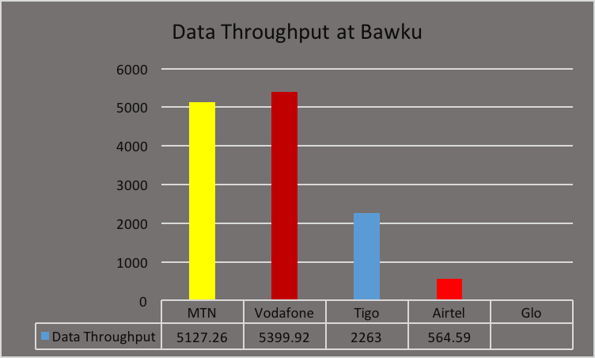
REMARKS:
- MTN, Vodafone, Tigo and Airtel exceeded Data Throughput threshold of 256kbps.
- Glo had no 3G Service at the time of the tests.

Figure 2. Data Throughput May 2016, Bolgatanga Polytechnic
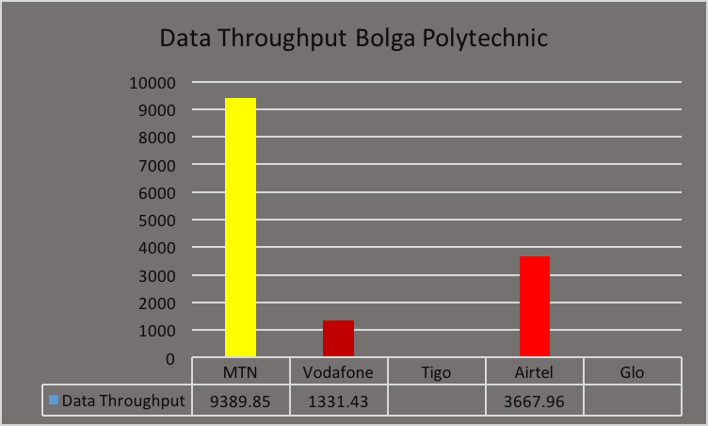
REMARKS:
- MTN, Vodafone and Airtel exceeded Data Throughput threshold of 256kbps.
- Tigo and Glo had no 3G Service at the time of the test.
Figure 3. Data Throughput May 2016, Bolgatanga Commercial Area
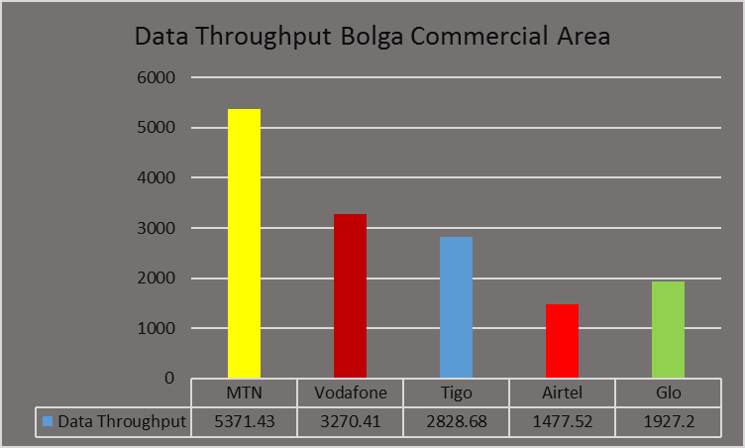
REMARKS:
- All Operators exceeded the Data Throughput threshold of 256kbps.

Figure 4. Data Throughput May 2016, Bolgatanga Hospital Roundabout
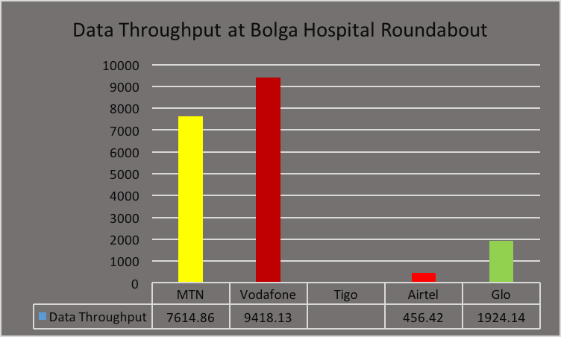
REMARKS:
- MTN, Vodafone, Glo and Airtel exceeded the Data Throughput threshold of 256kbps.
- Tigo had no 3G Service at the time of the test.

Figure 5. Data Throughput May 2016, Bolgatanga Soe
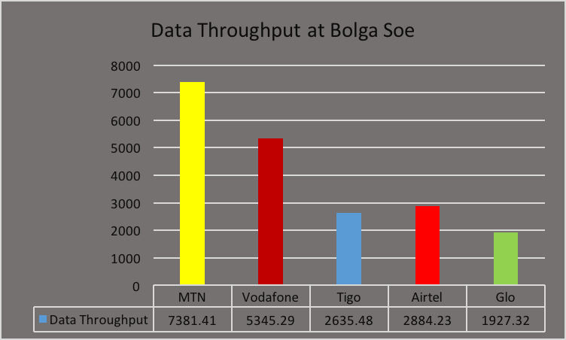
REMARKS:
- All Operators exceeded the Data Throughput threshold of 256kbps.

Figure 6. Data Throughput May 2016, Bolgatanga Stadium Road
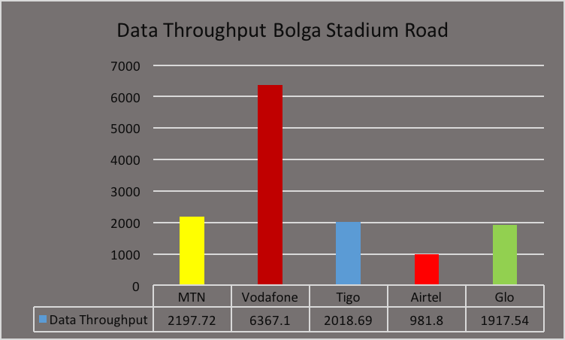
REMARKS:
- All Operators exceeded the Data Throughput threshold of 256kbps.

Figure 7. Data Throughput May 2016, Bolgatanga Zaare
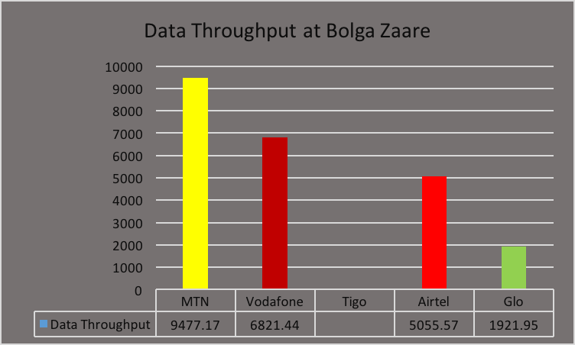
REMARKS:
- MTN, Vodafone, Glo and Airtel exceeded Data Throughput threshold of 256kbps.
- Tigo had no 3G Service at the time of the test.

Figure 8. Data Throughput May 2016, Bolgatanga Zuarungu
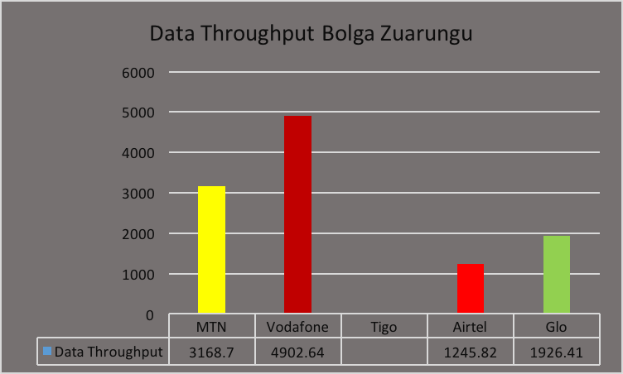
REMARKS:
- MTN, Vodafone, Glo and Airtel exceeded Data Throughput threshold of 256kbps.
- Tigo had no 3G Service at the time of the tests.

Figure 9. Data Throughput May 2016, Bongo
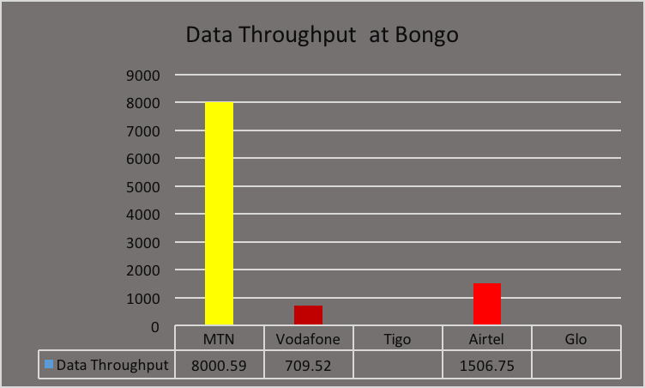
REMARKS:
- MTN, Vodafone and Airtel exceeded the Data Throughput threshold of 256kbps.
- Glo and Tigo had no 3G Service at the time of the test.

Figure 10. Data Throughput May 2016, Garu
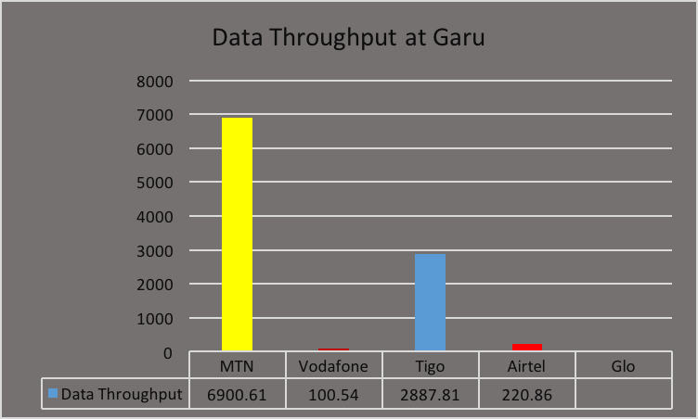
REMARKS:
- MTN and Tigo exceeded the Data Throughput threshold of 256kbps.
- Vodafone and Airtel failed the Data Throughput licence condition at Garu.
- Glo had no 3G Service at the time of the test.
Figure 11. Data Throughput May 2016, Navrongo
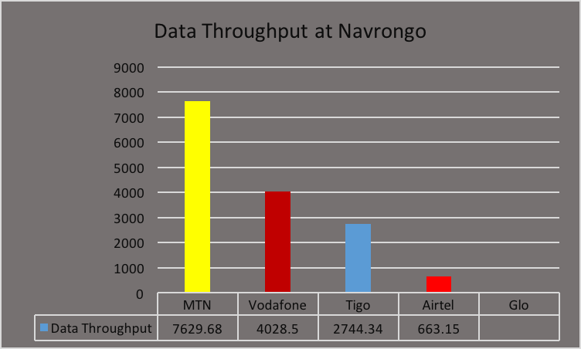
REMARKS:
- MTN, Vodafone, Airtel and Tigo exceeded the Data Throughput threshold of 256kbps.
- Glo had no 3G Service at the time of the test.

Figure 12. Data Throughput May 2016, Paga
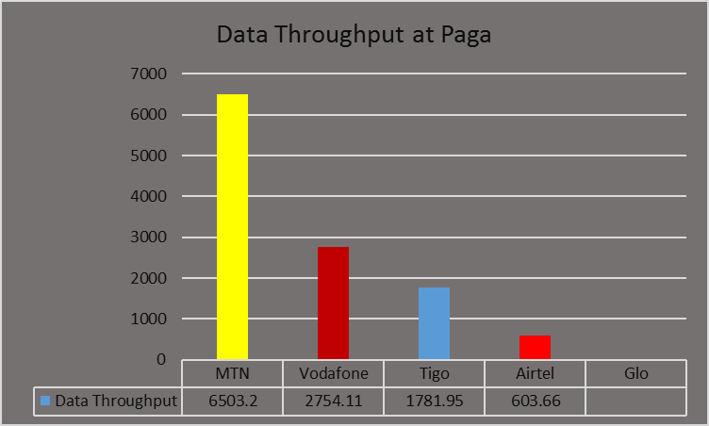
REMARKS:
- MTN, Vodafone, Airtel and Tigo exceeded the Data Throughput threshold of 256kbps.
- Glo had no 3G Service at the time of the test
Figure 13. Data Throughput May 2016, Sandema
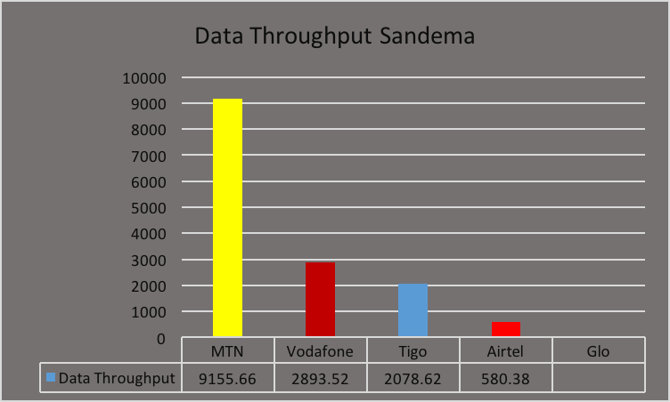
REMARKS:
- MTN, Vodafone, Airtel and Tigo exceeded the Data Throughput threshold of 256kbps.
- Glo had no 3G Service at the time of the test.
Figure 14. Data Throughput May 2016, Tongo
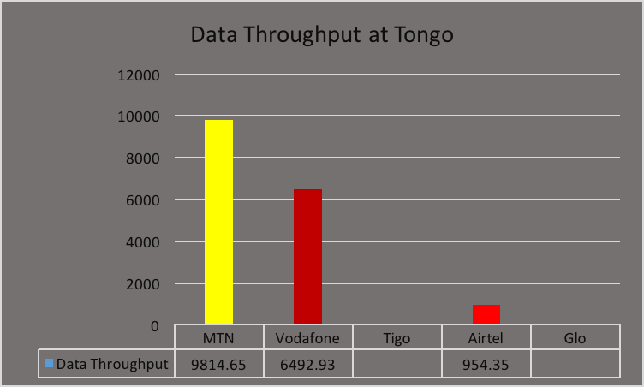
REMARKS:
- MTN, Vodafone and Airtel exceeded the Data Throughput threshold of 256kbps.
- Tigo and Glo had no 3G Service at the time of the test.

Figure 15. Data Throughput May 2016, Zebilla
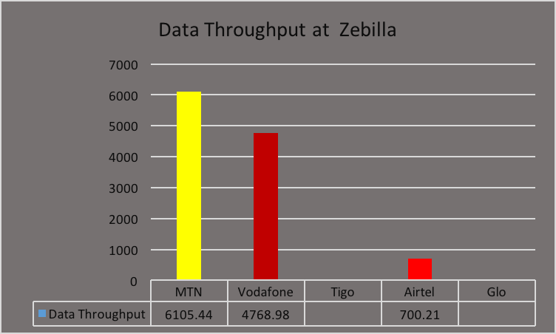
REMARKS:
- MTN, Vodafone and Airtel exceeded the Data Throughput threshold of 256kbps.
- Tigo and Glo had no 3G Service at the time of the test.

