Quality of Service (QoS) Monitoring of Cellular Mobile Data Services- CENTRAL REGION
[MAY 2016]
[Communications for Development]


NATIONAL COMMUNICATIONS AUTHORITY

Table of Contents
1. Background 2
2. What we measure 2
3. Findings 2-5
4. Remedies 5
5. Appendix 6 - 10

Background
In pursuance of obligations of the 3G Cellular Mobile Licence of Telecommunication Operators, the consumer perspective of the quality of data services are tested to ensure the compliance of Operators to the obligations on service quality to the user.
The report is based on findings on quality of data service in the Central Region between 4th May and 16th May 2016 for all Operators except Expresso due to technical challenges.

What we measure

As per the 3G Cellular Mobile licence obligations, the QoS indicators and their respective threshold for compliance under assessment considering the user’s perspective are as below;

- Data Access Success Rate (DASR)
- Data Drop Rate (DDR)
- Data Throughput

Findings

The results for the district capitals within Central Region tested during the period are as below:

- Data Access Success Rate

Data Access Success Rate is the probability of success in connecting to the public server.
Data Access Success Rate should be equal or better than ninety five per cent (95%)
For analysis and calculations,
The results for the district capitals tested during the period are as below:

Table 1. Data Access Success Rate, May2016
DISTRICT CAPITAL | MTN | VODAFONE | TIGO | AIRTEL | GLO
Ajumako | 100% | 100% | 99% | 100% | No 3G Coverage
Apam | 100% | 100% | 100% | 100% | No 3G Coverage
Cape Coast | 100% | 100% | 100% | 100% | 100%
Dunkwa On-Offin | 100% | 100% | 100% | 100% | 100%
Elmina | 100% | 100% | 100% | 99% | 97.22%
Essakyir | No 3G Coverage | No 3G Coverage | No 3G Coverage | No 3G Coverage | No 3G Coverage
Nsuaem Kyekyewere | 100% | 100% | 100% | No 3G Coverage | No 3G Coverage
Twifo Hemang | 100% | 100% | 100% | 100% | No 3G Coverage

REMARKS:
- All Operators complied with the Data Access Success Rate obligation in all the available District Capitals tested.

- Data Drop Rate

Data Drop Rate is the probability to drop in connection to a public server without end user’s intervention.
Data Drop Rate should be equal or less than one per cent (1%).

Table 2. Data Drop Rate, May2016
DISTRICT CAPITAL | MTN | VODAFONE | TIGO | AIRTEL | GLO
Ajumako | 0% | 0% | 0% | 0% | No 3G Coverage
Apam | 0% | 0% | 0% | 0% | No 3G Coverage
Cape Coast | 0% | 0% | 0% | 0% | 0%
Dunkwa On-Offin | 0% | 0% | 0% | 0% | 0%
Elmina | 0% | 0% | 0% | 0% | 0%
Essakyir | No 3G Coverage | No 3G Coverage | No 3G Coverage | No 3G Coverage | No 3G Coverage
Nsuaem Kyekyewere | 0% | 0% | 0% | No 3G Coverage | No 3G Coverage
Twifo Hemang | 0% | 0% | No 3G Coverage | No 3G Coverage | No 3G Coverage

REMARKS:
- All Operators complied with the licence threshold of less than one percent (1%) in the available District Capitals tested.

- Data Throughput

Data Throughput is the rate of data transfer.
As per the 3G licence obligations, the minimum data transfer rate for 90% of data connections should be 256kbps or better

Table 3. Data Throughput, May2016
DISTRICT CAPITAL | MTN | VODAFONE | TIGO | AIRTEL | GLO
Ajumako | 355 | 718 | 319 | 1187 | No 3G Coverage
Apam | 3940 | 627 | 3959 | 1235 | No 3G Coverage
DISTRICT CAPITAL | MTN | VODAFONE | TIGO | AIRTEL | GLO
Cape Coast | 3691 | 2625 | 862 | 3751 | 3420
Dunkwa On-Offin | 2839 | 1197 | 1105 | 4057 | 2989
Elmina | 3546 | 3487 | 1150 | 3547 | 3187.7
Essakyir | No 3G Coverage | No 3G Coverage | No 3G Coverage | No 3G Coverage | No 3G Coverage
Nsuaem Kyekyewere | 3481 | 169 | 4441 | No 3G Coverage | No 3G Coverage
Twifo Hemang | 4205 | No 3G Coverage | No 3G Coverage | No 3G Coverage | No 3G Coverage

REMARKS:
- All Operators except Vodafone were compliant with the licence threshold of Data Throughput in all the available District Capitals tested.
- Vodafone failed the Data Throughput licence threshold at Nsuaem Kyekyewere.

REMEDIES
- The NCA has notified Operators of publication of these findings and directed all Operators to improve any obligation in default by September, 2016.
- Sanctions will be applied to Operators on obligations in default after September, 2016.

- All Operators were directed to improve their 3G Service in the Central Region by December, 2016.

APPENDIX 1
The Graphs below show the Throughput levels attained by Operators in each location where monitoring was performed.
Figure 1. Data Throughput May 2016, Ajumako – District Office
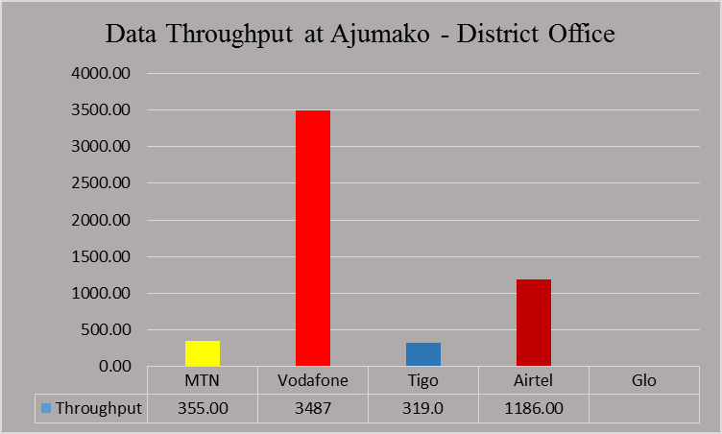
REMARKS:
- MTN, Vodafone, Tigo and Airtel exceeded Data Throughput threshold of 256kbps.
- Glo had no 3G Service at the time of the test.
Figure 2. Data Throughput May 2016, Apam Junction
REMARKS:
- All Operators exceeded the Data Throughput threshold of 256kbps.
- Glo had no 3G Service at the time of the test.
Figure 3. Data Throughput May 2016, Bosah Square- Cape Coast Polytechnic
REMARKS:
- All operators exceeded the Data throughput threshold of 256kbps.

Figure 4. Data Throughput May 2016, Atlantic Hall Old Site UCC.
REMARKS:
- MTN, Vodafone, Tigo and Glo exceeded Data Throughput threshold of 256kbps.
- Airtel had no 3G Service at the time of the test.

Figure 5. Data Throughput May 2016, London Bridge.
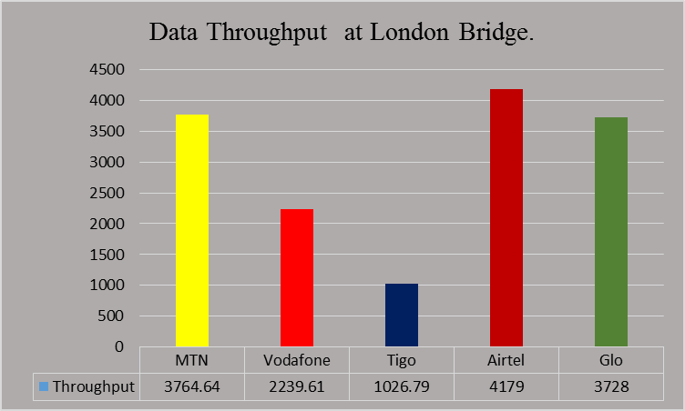
REMARKS:
- All the network operators exceeded Data Throughput threshold of 256kbps.

Figure 6. Data Throughput May 2016, Science Market UCC
REMARKS:
- All Operators exceeded the Data Throughput threshold of 256kbps.

Figure 7. Data Throughput May 2016, Dunkwa Lorry Station
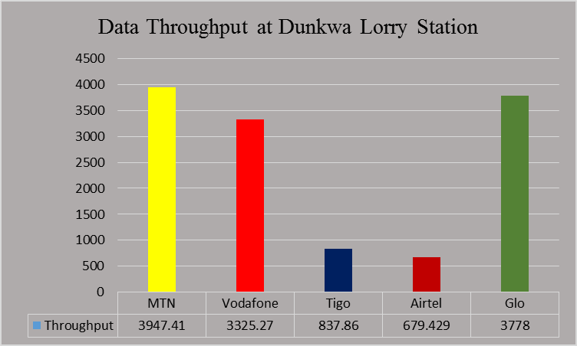
REMARKS:
- All the network operators exceeded the Data Throughput threshold of 256kbps.

Figure 8. Data Throughput May 2016, Elmina Kobina Gyan Square.
REMARKS:
- All network operator exceeded the Data Throughput threshold of 256kbps.

Figure 9. Data Throughput May 2016, Nsuaem Kyekyewere District Office.
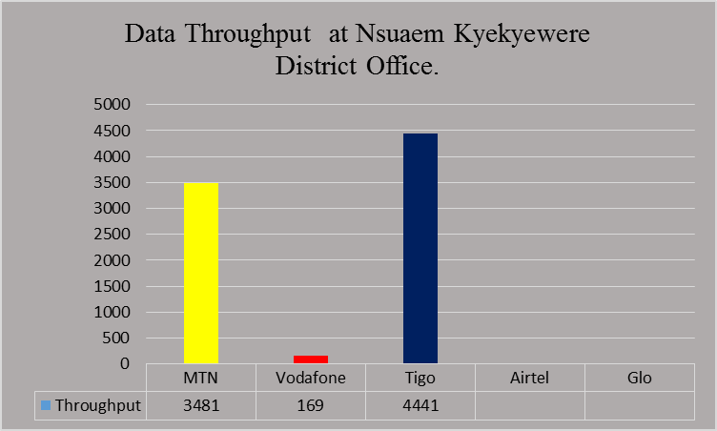
REMARKS:
- MTN and Tigo exceeded the Data Throughput threshold of 256kbps.
- Vodafone failed the Data Throughput licence condition at Nsuaem Kyekyewere District Office.
- Airtel and Glo had no 3G Service at the time of the test.

Figure 10. Data Throughput May 2016, New Market Twifo Hemang
REMARKS:
- All Operators except MTN had no 3G service at the time of the test.
- MTN exceeded the Data Throughput threshold of 256kbps.

