Quality of Service (QoS) Monitoring of Cellular Mobile Data Services- BRONG AHAFO REGION
[April 2016]
[Communications for Development]


NATIONAL COMMUNICATIONS AUTHORITY

Table of Contents
1. Background 2
2. What we measure 2
3. Findings 2
4. Remedies 6
5. Appendix 6 - 17

Background
In pursuance of obligations of the 3G Cellular Mobile Licence of Telecommunication Operators, the consumer perspective of the quality of data services are tested to ensure the compliance of Operators to the obligations on service quality to the user.
The report is based on findings on quality of data service in the Brong Ahafo region from 4th to 14th April 2016 for all Operators except for Expresso due to technical challenges.

What we measure

As per the 3G Cellular Mobile licence obligations, the QoS indicators and their respective threshold for compliance under assessment considering the user’s perspective are as below;

- Data Access Success Rate (DASR)
- Data Drop Rate (DDR)
- Data Throughput

Findings

The results for the district capitals within Brong Ahafo Region tested during the period are as below:

- Data Access Success Rate

Data Access Success Rate is the probability of success in connecting to the public server.
Data Access Success Rate should be equal or better than ninety five per cent (95%)
For analysis and calculations,
The results for the district capitals tested during the period are as below:

Table 1. Data Access Success Rate, April 2016
District Capital | MTN | Vodafone | Tigo | Airtel | Glo
Atebubu | 100 | 100 | No 3G Coverage | 100 | No 3G Coverage
Bechem | 100 | No 3G Coverage | 100 | 95.35 | No 3G Coverage
Busunya | 100 | 100 | 100 | 100 | No 3G Coverage
Dormaa Ahenkro | 100 | 100 | 100 | No 3G Coverage | No 3G Coverage
Drobo | 100 | 100 | 100 | 97.82 | No 3G Coverage
Duayaw Nkwanta | 100 | 100 | 100 | 100 | No 3G Coverage
Goaso | 100 | 100 | 100 | 100 | No 3G Coverage
Jema | 100 | 100 | 100 | 100 | No 3G Coverage
Kenyasi | 100 | 100 | 100 | 100 | No 3G Coverage
Kintampo | 100 | 100 | 100 | 100 | 100
Kukuom | 100 | 100 | 100 | 100 | No 3G Coverage
Kwame Danso | 100 | 100 | 100 | 100 | No 3G Coverage
Nkoranza | 100 | 100 | 100 | 100 | No 3G Coverage
Nsawkwa | 100 | 100 | 100 | 97.06 | No 3G Coverage
Odumasi | 100 | 100 | 100 | 100 | No 3G Coverage
Sampa | 100 | 100 | 100 | 100 | No 3G Coverage
Sunyani | 100 | 100 | 100 | 100 | 100
Techiman | 100 | 100 | 100 | 100 | 100
Wamfie | 100 | 100 | 100 | 100 | No 3G Coverage
Wenchi | 100 | 100 | 100 | 100 | No 3G Coverage
Yeji | 100 | 100 | 100 | 100 | No 3G Coverage

REMARKS:
- All Operators complied with the Data Access Success Rate obligation in the available Metropolitan, Municipal and District Capitals tested.
- Data Drop Rate

Data Drop Rate is the probability to drop in connection to a public server without end user’s intervention.
Data Drop Rate should be equal or less than one per cent (1%).

Table 2. Data Drop Rate, April 2016
District Capital | MTN | Vodafone | Tigo | Airtel | Glo
Atebubu | 0 | 0 | No 3G Coverage | 0 | No 3G Coverage
Bechem | 0 | No 3G Coverage | 0 | 0 | No 3G Coverage
Busunya | 0 | 0 | 0 | 0 | No 3G Coverage
Dormaa Ahenkro | 0 | 0 | 0 | No 3G Coverage | No 3G Coverage
Drobo | 0 | 0 | 0 | 0 | No 3G Coverage
Duayaw Nkwanta | 0 | 0 | 0 | 0 | No 3G Coverage
Goaso | 0 | 0 | 0 | 0 | No 3G Coverage
Jema | 0 | 0 | 0 | 0 | No 3G Coverage
Kenyasi | 0 | 0 | 0 | 0 | No 3G Coverage
Kintampo | 0 | 0 | 0 | 0 | 0
Kukuom | 0 | 0 | 0 | 0 | No 3G Coverage
Kwame Danso | 0 | 0 | 0 | 0 | No 3G Coverage
Nkoranza | 0 | 0 | 0 | 0 | No 3G Coverage
Nsawkwa | 0 | 0 | 0 | 0 | No 3G Coverage
Odumase | 0 | 0 | 0 | 0 | 0
Sampa | 0 | 0 | 0 | 0 | No 3G Coverage
Sunyani | 0 | 0 | 0 | 0 | 0
Techiman | 0 | 0 | 0 | 0 | 0
Wamfie | 0 | 0 | 0 | 0 | No 3G Coverage
Wenchi | 0 | 0 | 0 | 0 | No 3G Coverage
Yeji | 0 | 0 | 0 | 0 | No 3G Coverage

REMARKS:
- All operators complied with the licence threshold of less than one percent (1%) in the available District Capitals tested.

- Data Throughput

Data Throughput is the rate of data transfer.
As per the 3G licence obligations, the minimum data transfer rate for 90% of data connections should be 256kbps or better

Table 3. Data Throughput, April 2016
District Capital | MTN | Vodafone | Tigo | Airtel | Glo
Atebubu | 2183.27 | 1413.43 | No 3G Coverage | 2409.77 | No 3G Coverage
Bechem | 2438.5 | No 3G Coverage | 342.52 | 2506.11 | No 3G Coverage
Busunya | 8097.25 | 1598.61 | 342.52 | 2094.51 | No 3G Coverage
Dormaa Ahenkro | 4202.11 | 850.53 | 569.73 | No 3G Coverage | No 3G Coverage
Drobo | 2201.6 | 1407.04 | 1047.08 | 4201.69 | No 3G Coverage
Duayaw Nkwanta | 4436.97 | 1150.46 | 1751.57 | 4883.14 | No 3G Coverage
Goaso | 2186.95 | 1473 | 1830 | 3545.37 | No 3G Coverage
Jema | 7807.56 | 1334.93 | 807.51 | 1848.59 | No 3G Coverage
Kenyasi | 5397.13 | 1685.34 | 1828.04 | 1596.39 | No 3G Coverage
Kintampo | 2580.88 | 966.41 | 770.63 | 2331.27 | 808.16
Kukuom | 6762.1 | 1204.77 | 531.36 | 3382.97 | No 3G Coverage
Kwame Danso | 5969.23 | 1082.03 | 1201.69 | 1982.34 | No 3G Coverage
Nkoranza | 3023.15 | 2046.59 | 570.61 | 2808.48 | No 3G Coverage
Nsawkwa | 8381.63 | 1653.94 | 850.46 | 2292.89 | No 3G Coverage
Odumase | 5572.71 | 876.77 | 1020.47 | 1961.49 | 1405.42
Sampa | 1915.34 | 1189.96 | 592.53 | 3333.44 | No 3G Coverage
Sunyani | 1609.94 | 573.93 | 910.22 | 2227.68 | 1336.05
Techiman | 1837.21 | 1512.78 | 273.21 | 1581.33 | 1463.21
Wamfie | 6228.85 | 1238.67 | 1031.54 | 2168.36 | No 3G Coverage
Wenchi | 3984.97 | 1548.08 | 569.43 | 1197.99 | No 3G Coverage
Yeji | 4717.2 | 1323.8 | 1963.54 | 1835.90 | No 3G Coverage

REMARKS:
- All Operators met the Data Throuhgput threshold in the available District Capitals tested.
REMEDIES
- The NCA has notified Operators of publication of these findings and directed all Operators to improve any obligation in default before August 31, 2016.

- Sanctions will be applied to Operators on obligations in default after August 31, 2016.

APPENDIX 1
The Graphs below show the Throughput levels attained by operators in each location where monitoring was performed.

Figure 1. Data Throughput - April 2016, Atebubu
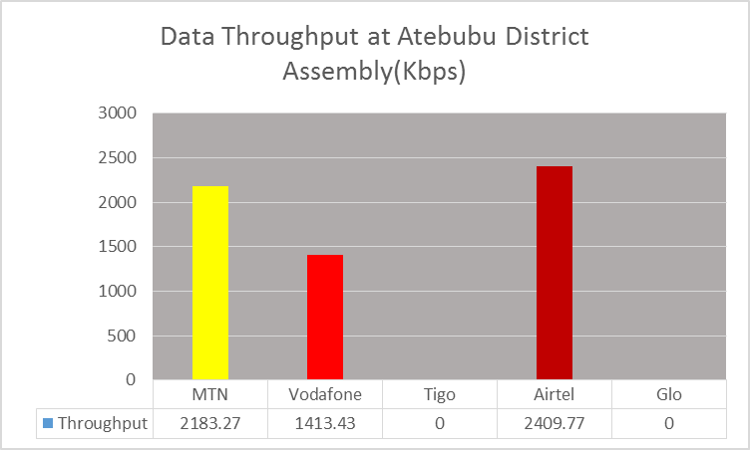

REMARKS:
- All Mobile Network Operators (MNOs) except Tigo and Glo exceeded the Throughput threshold of 256kbps at the tested location.
- Tigo and Glo had no 3G Service at the time of the test.

Figure 2. Data Throughput - April 2016, Bechem
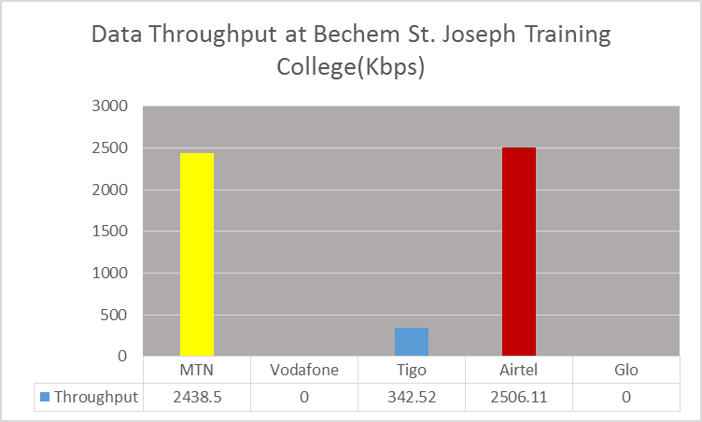
REMARKS:
- MTN, Tigo and Airtel exceeded the Throughput threshold of 256kbps
- Vodafone and Glo had no 3G coverage at the time the test was conducted.

Figure 3. Data Throughput - April 2016, Busunya
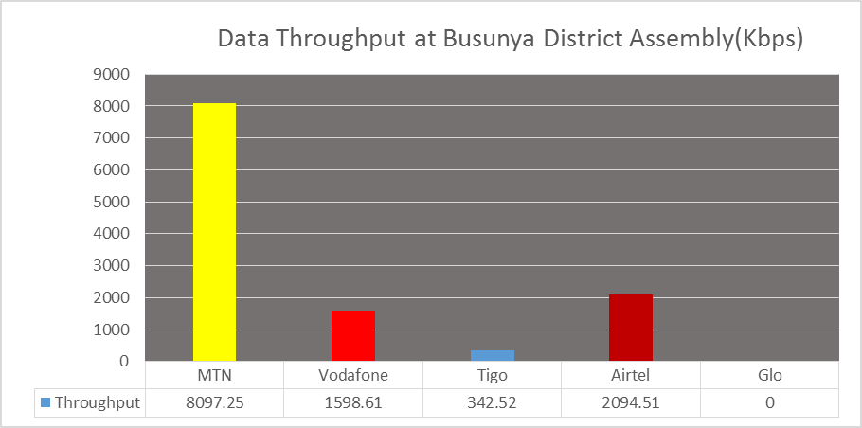
REMARKS:
- All MNOs except Glo exceeded Data Throughput threshold at the tested location.
- Glo had no 3G Service at the time of the test.

Figure 4. Data Throughput - April 2016, Dormaa Ahenkro
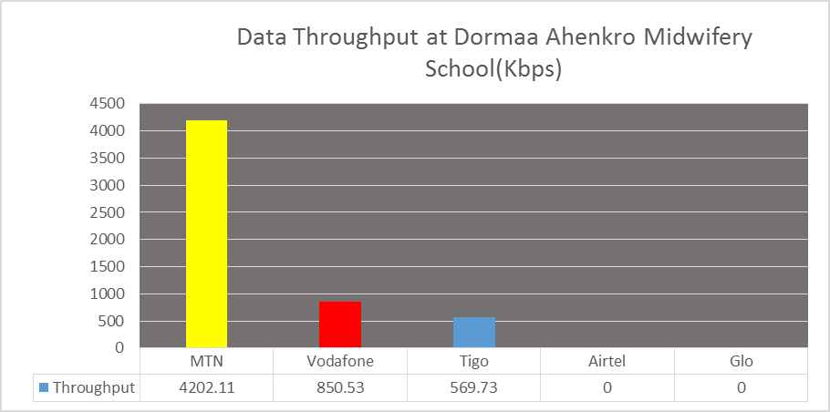
REMARKS:
- All MNOs except Airtel and Glo exceeded Data Throughput threshold at the tested locations.
- Airtel and Glo had no 3G coverage in Dormaa Ahenkro during the monitoring period.

Figure 5. Data Throughput - April 2016, Drobo
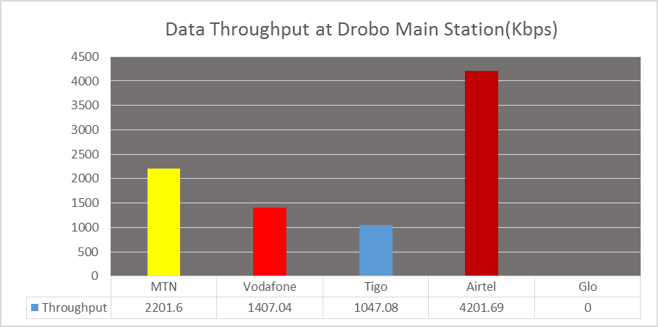
REMARKS:
- All MNOs except Glo exceeded the Data Throughput threshold of 256kbps at the tested location.
- Glo had no 3G Service at the time of the test.
Figure 6. Data Throughput - April 2016, Duayaw Nkwanta
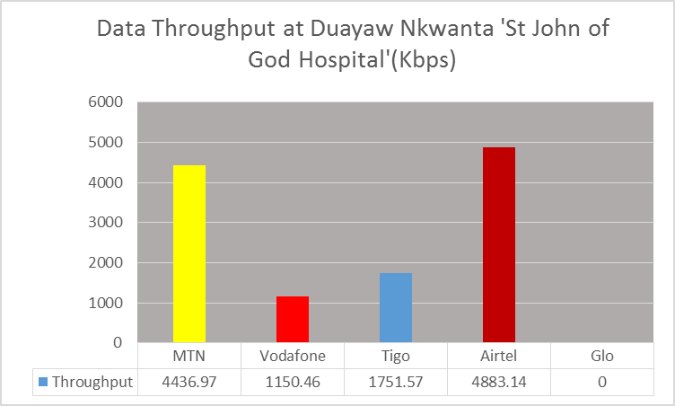
REMARKS:
- All MNOs except Glo exceeded the threshold of 256kbps in the tested location
- Glo had no 3G Service at the time of the test.

Figure 7. Data Throughput - April 2016, Goaso
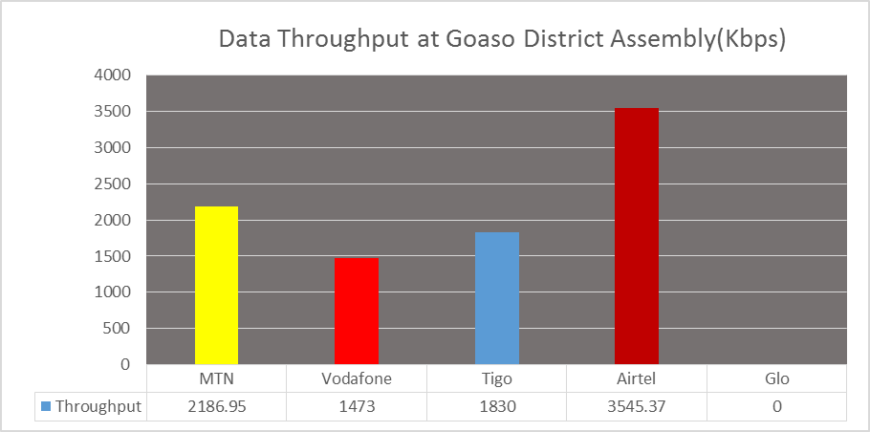
REMARKS:
- All MNOs except Glo exceeded the threshold of 256kbps.
- Glo had no 3G coverage in Goaso at the time of the test.

Figure 8. Data Throughput - April 2016, Jema
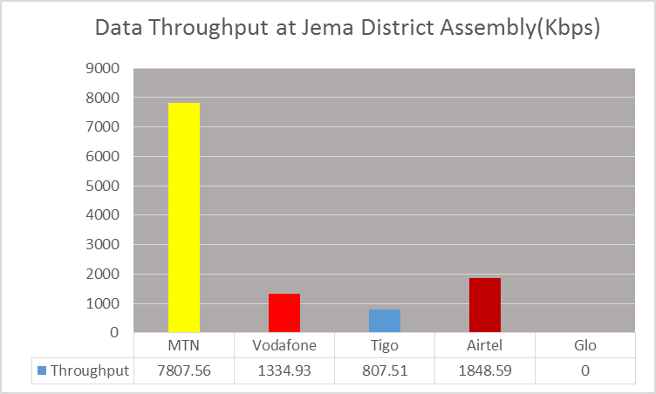
REMARKS:
- All MNOs except Glo exceeded the threshold of 256kbps at the tested location
- Glo had no 3G Service at the time of the test.

Figure 9. Data Throughput - April 2016, Kenyasi
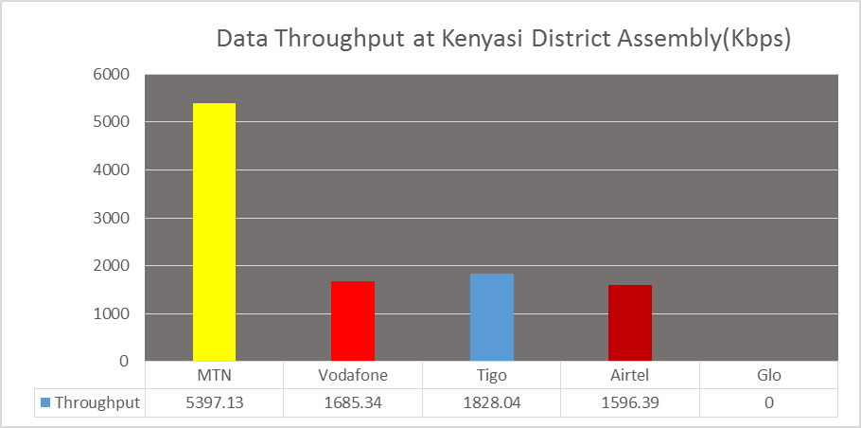
REMARKS:
- All MNOs except Glo exceeded the Threshold of 256kbps at the tested location.
- Glo had no 3G Service at the time of the test.
Figure 10. Data Throughput - April 2016, Kintampo
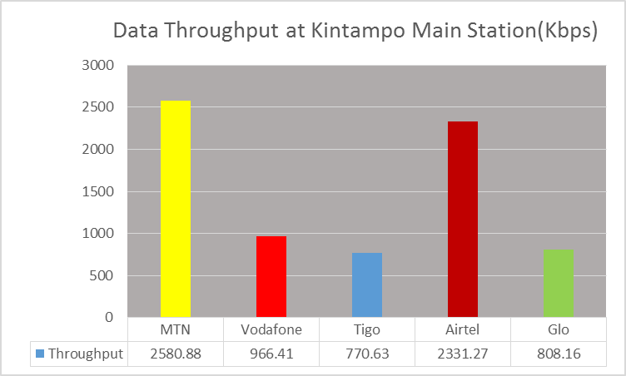
- REMARKS: All MNOs exceeded the Threshold of 256kbps at the tested location

Figure 11. Data Throughput - April 2016, Kukuom
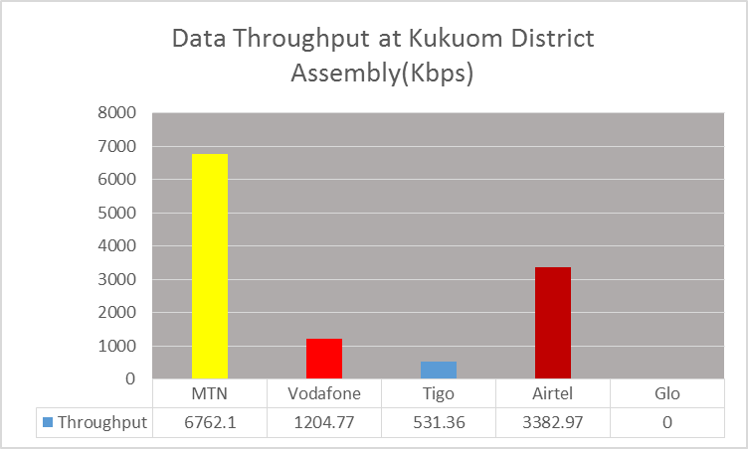
REMARKS:
- All MNOs except Glo exceeded the Threshold of 256kbps at the tested location.
- Glo had no 3G Service at the time of the test.

Figure 12. Data Throughput - April 2016, Kwame Danso
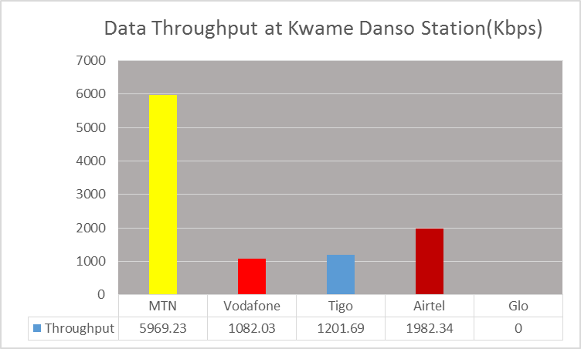
REMARKS:
- All MNOs except Glo exceeded the Threshold of 256kbps at the tested location.
- Glo had no 3G Service at the time of the test.

Figure 13. Data Throughput - April 2016, Nkoranza
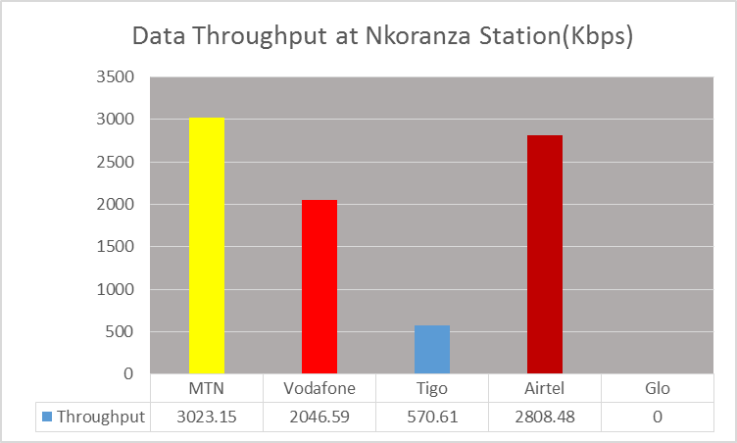
REMARKS:
- All operators except Glo exceeded the Throughput threshold at the tested location.
- Glo had no 3G Service at the time of the test.

Figure 14. Data Throughput - April 2016, Nsawkwa
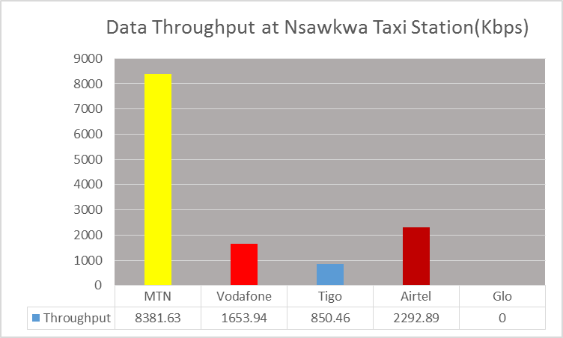
REMARKS:
- All operators except Glo exceeded the Throughput threshold at the tested location.
- Glo had no 3G Service at the time of the test.

Figure 15. Data Throughput - April 2016, Odumase
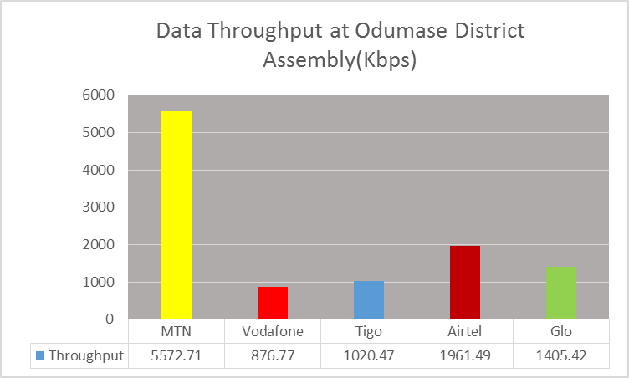
REMARKS:
- All operators exceeded the Throughput threshold at the tested location.

Figure 16. Data Throughput - April 2016, Sampa
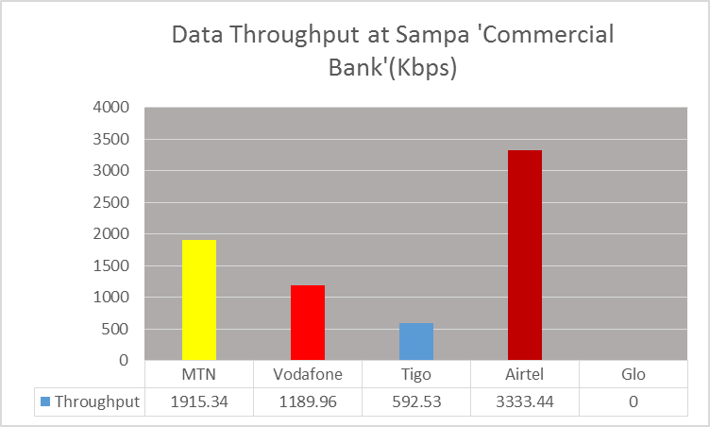
REMARKS:
- All operators except Glo exceeded the Throughput threshold at the tested location.
- Glo had no 3G Service at the time of the tests

Figure 17. Data Throughput - April 2016, Sunyani (Cocoaboard)
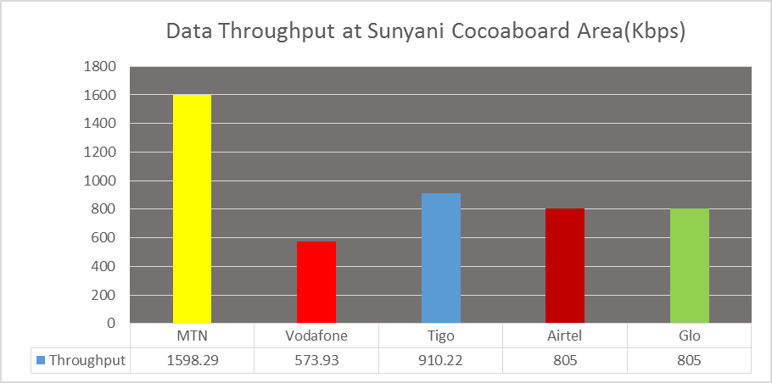
REMARKS:
- All operators exceeded the Throughput threshold at the tested location

Figure 18. Data Throughput - April 2016, Sunyani (Nursing Training College)

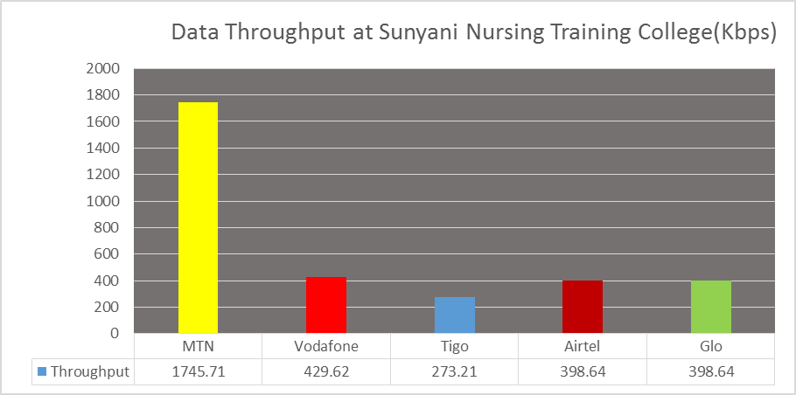
REMARKS:
- All operators exceeded the Throughput threshold at the tested location.

Figure 19. Data Throughput - April 2016, Sunyani (University of Energy& Nat. Resource)
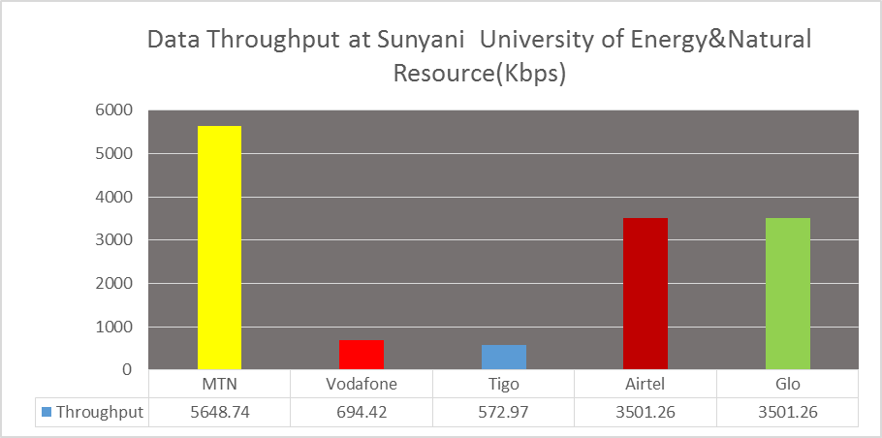
REMARKS:
- All operators exceeded the Throughput threshold at the tested location.

Figure 20. Data Throughput - April 2016, Techiman
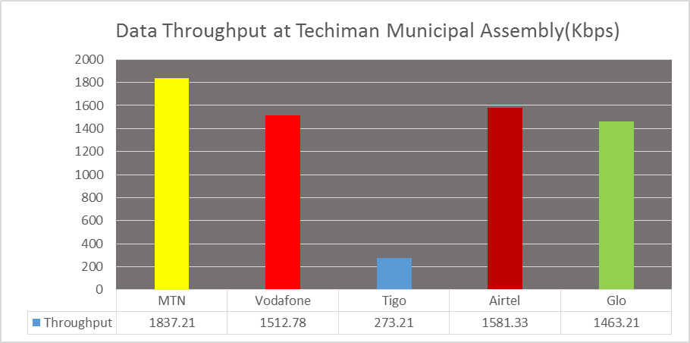
REMARKS:
- All MNOs exceeded the Threshold of 256kbps at the location tested

Figure 21. Data Throughput - April 2016, Wamfie
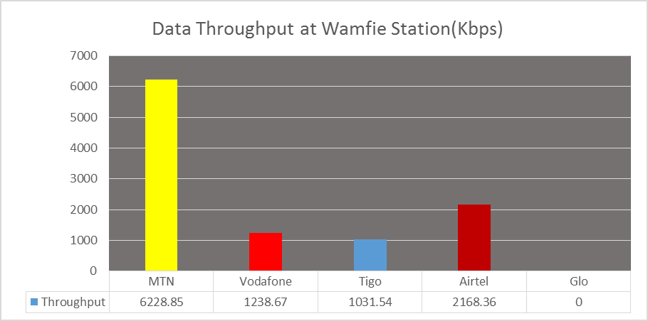
REMARKS:
- All MNOs except Glo exceeded the Threshold of 256kbps at the location tested
- Glo had no 3G Service at the time of the test.
Figure 22. Data Throughput - April 2016, Wenchi
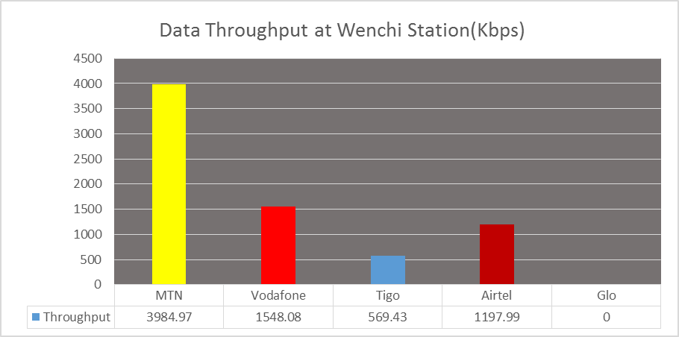
REMARKS:
- All operators except Glo exceeded the Throughput threshold at the location tested.
- Glo had no 3G Service at the time of the test.
Figure 23. Data Throughput - April 2016, Yeji
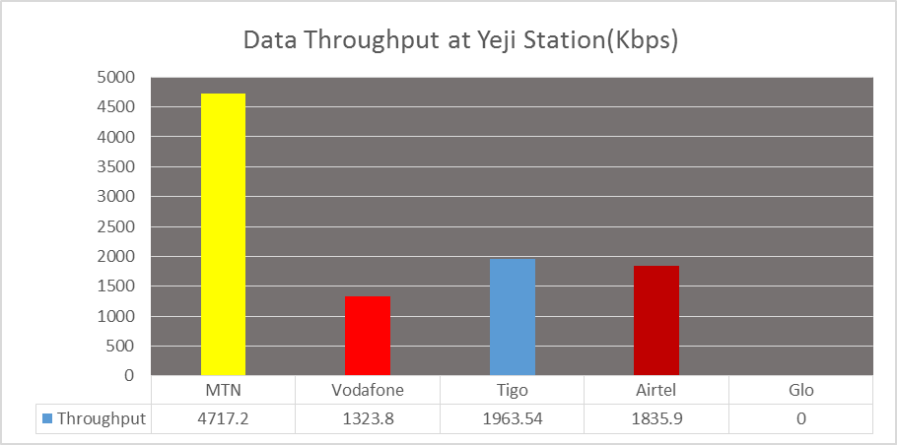
REMARKS:
- All operators except Glo exceeded the Throughput threshold at the location tested.
- Glo had no 3G Service at the time of the test.

