3G Coverage Assessment of Cellular Mobile Services- Upper West Region
[May 2016]
[Communications for Development]

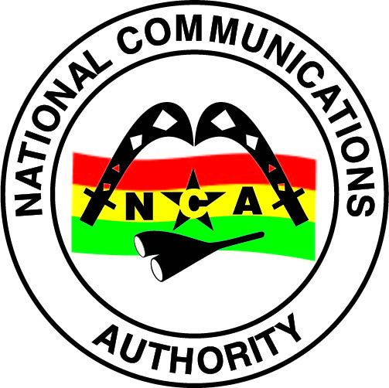
NATIONAL COMMUNICATIONS AUTHORITY

Table of Contents
1. Background 2
2. What we measure 2
3. Findings 2-3
4. Remedies 4
5. Coverage Signal Strength 4-22

Background
In pursuance of the 3G Cellular Mobile Licence obligations of Telecommunication Operators, the consumer experience of the 3G Coverage status is tested to ensure that Operators comply with the 3G Coverage obligations to the user.
The report is based on findings on 3G verification campaign in the Upper West Region from 8th to 10th May, 2016 for all Operators except for Expresso due to technical challenges.

What we measure
As per the 3G Cellular Mobile licence obligations, 3G-locked mode coverage samples are collected to obtain on the average, a signal strength measurement which is representative of the coverage situation in each of the District Capitals that was driven.
The 3G Signal Strength and their respective threshold for compliance considering the user’s perspective are categorised as follows;
Rating | 3G Signal Strength Range (dBm)
No 3G Coverage | -105>RSCP
Poor | –105≤ RSCP < -95
Fair | –95≤ RSCP< –85
Good | –85 ≤RSCP < –20

Findings
The results for the District Capitals within Upper West Region tested during the period are as below:
Table 1: Coverage Signal strength, May, 2016

DISTRICT CAPITAL | MTN | VODAFONE | TIGO | AIRTEL | GLO
Funsi | Good | No 3G Coverage | No 3G Coverage | Good | No 3G Coverage
Gwollu | Good | Good | Good | Good | No 3G Coverage
Jirapa | Good | Good | Fair | Fair | No 3G Coverage
DISTRICT CAPITAL | MTN | VODAFONE | TIGO | AIRTEL | GLO
Lambussie | Poor | Good | Fair | Good | No 3G Coverage
Lawra | Good | Good | Fair | No 3G Coverage | No 3G Coverage
Nadowli | Good | No 3G Coverage | Good | No 3G Coverage | No 3G Coverage
Tumu | Good | Good | No 3G Coverage | Fair | No 3G Coverage
Wa | Fair | Good | Poor | Fair | Fair
Wechiau | Good | Good | No 3G Coverage | Good | No 3G Coverage
REMARKS:
- All Operators except MTN failed to meet the 3G Coverage Obligation in all the District Capitals tested in the Upper West Region.
- MTN had good 3G coverage in all the District Capitals tested except Wa and Lambussie which had “fair” and “poor” 3G coverage respectively.
- Vodafone had good 3G coverage in all the District Capitals tested except Funsi and Nadowli which had “No 3G network” at the time of our test.
- Vodafone indicated they experienced service outage at Funsi and Nadowli at the period of our test.
- Tigo had good 3G coverage at Gwollu and Nadowli.
- Tigo had fair 3G network coverage at Jirapa, Lambussie and Lawra.
- Tigo had poor 3G coverage at Wa.
- Tigo had no 3G coverage at Funsi, Tumu and Wechiau at the time of our test.
- Airtel had good 3G coverage at Funsi, Gwollu, Lambussie and Wechiau.
- Airtel had fair 3G coverage at Jirapa, Tumu and Wa.
- Airtel had no 3G coverage at Lawra and Nadowli.
- Glo had no 3G coverage in all the tested District Capitals except Wa where the coverage was fair.

Remedies
- The NCA has notified Operators of these findings and has directed all Operators to improve their 3G coverage in some localities by August 31, 2016.

- Vodafone, Tigo and Airtel have been sanctioned for failing to maintain 3G coverage at the failed District Capitals.
- Glo has been granted moratorium till December 31, 2016 to cover all the failed District Capitals in the Upper West Region.

APPENDICES
Coverage Signal Strength

The Maps below show the coverage levels in District Capitals of the Upper West Region where the monitoring exercise were performed. The coverage map is based on the 3G network signal strength when tested in an idle mode. In each plot is a legend to indicate the signal strength and quality range attained by Operators during measurement.
Coverage levels in green falls in the range of -85dBm and above, and are considered good. Those between -85 and -95dBm are considered average or fair and are indicated in yellow. The red samples represent worse or poor coverage in the range of -95 to -105dBm. The black samples represent areas with no 3G coverage.
Coverage Legend
Colour | Area Coverage Rating
 | Good Coverage Areas
 | Fair Coverage Areas
 | Poor Coverage Areas
 | Non-Existent Coverage Areas

APPENDIX I

COVERAGE AT FUNSI
Fig. 1 - MTN 3G Coverage Map, Funsi – May, 2016
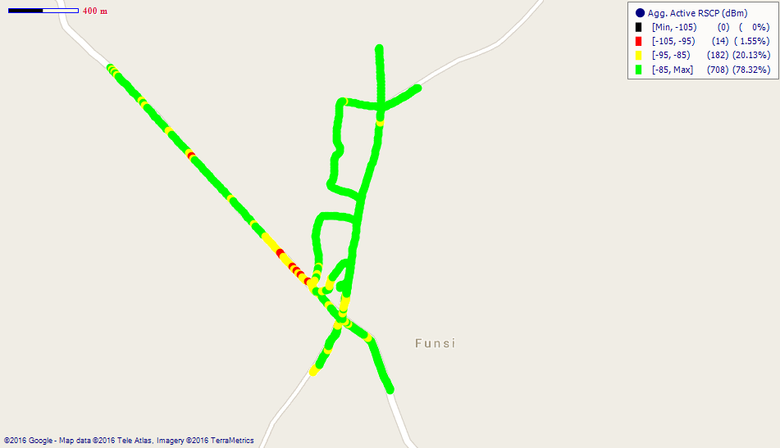
Remarks: Good 3G coverage in Funsi.

Fig. 2 - Airtel 3G Coverage Map, Funsi – May, 2016
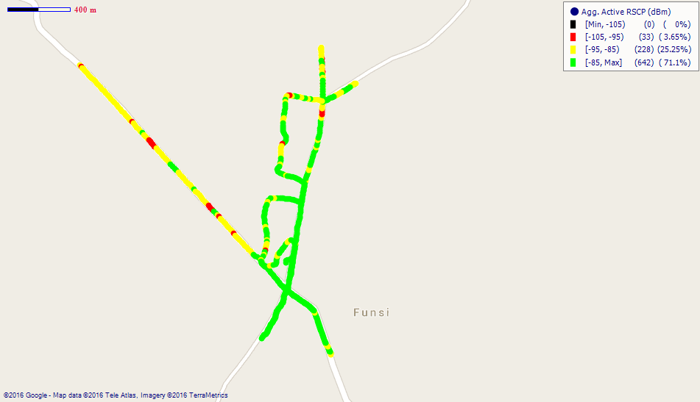
Remarks: Good 3G coverage in Funsi; Improvement is however needed at the western side of the town.
COVERAGE AT GWOLLU
Fig. 3 - MTN 3G Coverage Map, Gwollu –May, 2016
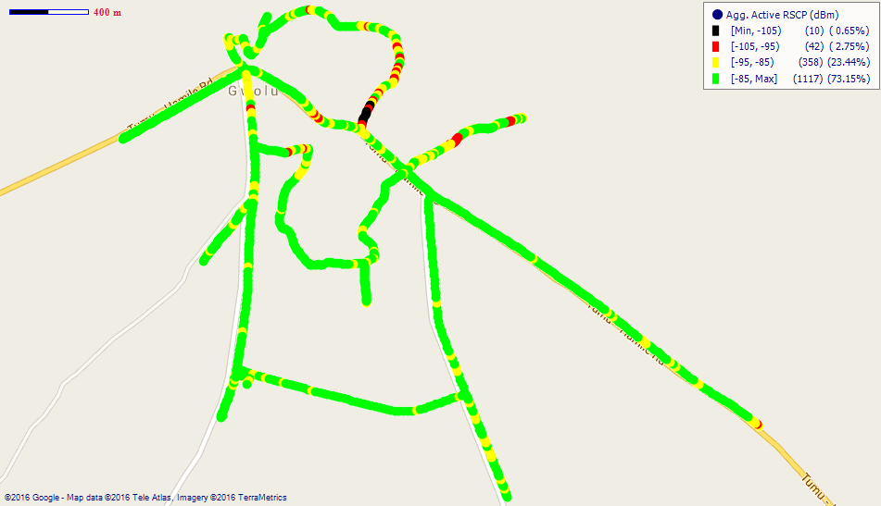
Remarks: Good 3G coverage in Gwollu.

Fig. 4- Vodafone 3G Coverage Map, Gwollu – May, 2016
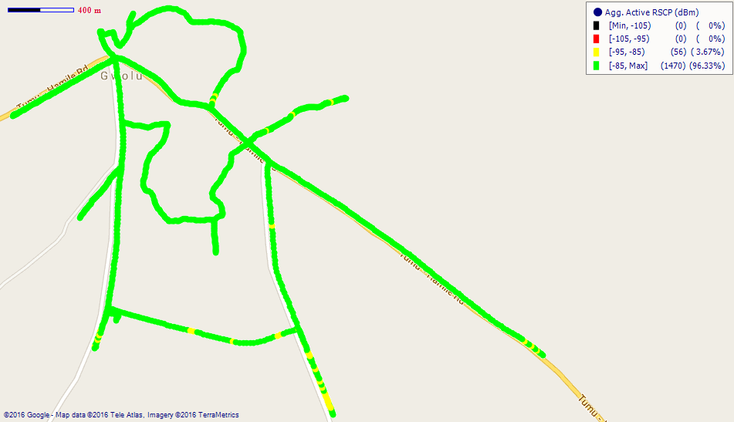
Remarks: Good 3G network coverage in Gwollu.
Fig. 5 - Tigo 3G Coverage Map, Gwollu - May, 2016
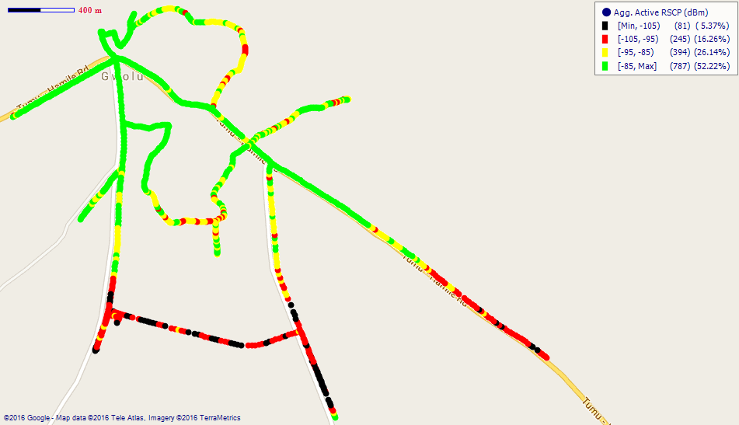
Remarks: Good 3G coverage in Gwollu; however, 3G coverage at the southern parts near the District Assembly office is poor. Major improvement is required.

Fig. 6 - Airtel 3G Coverage Map, Gwollu – May, 2016
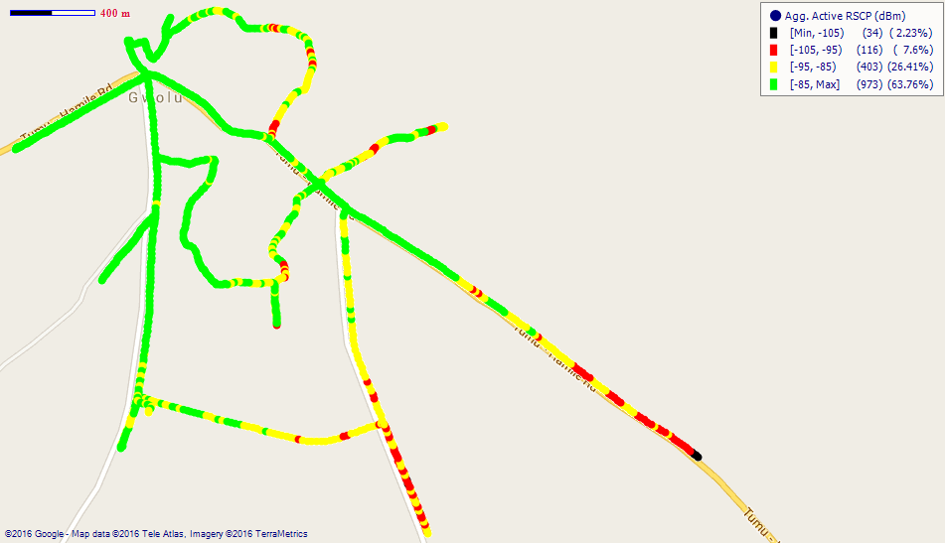
Remarks: Good 3G coverage in Gwollu; however, improvement is needed at the eastern side of the town.

COVERAGE AT JIRAPA
Fig. 7 – MTN 3G Coverage Map, Jirapa – May, 2016
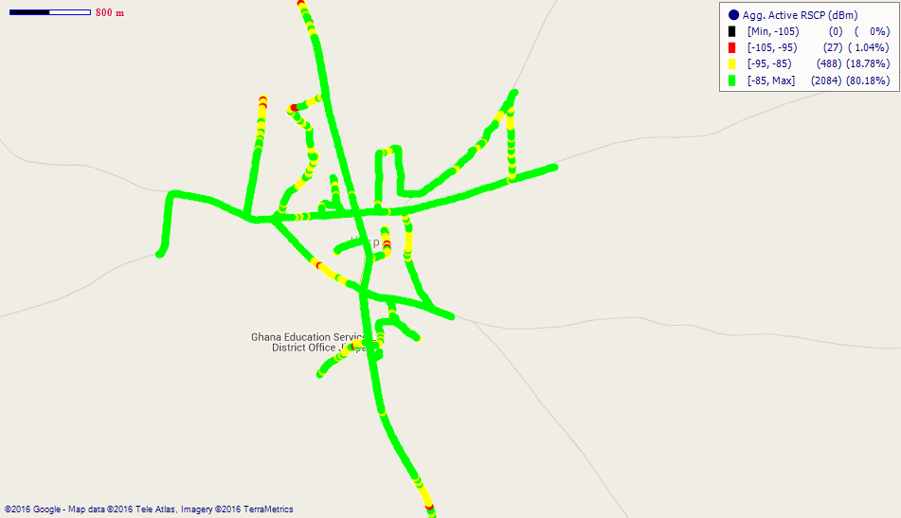
Remarks: Good 3G network coverage across Jirapa.

Fig. 8 - Vodafone 3G Coverage Map, Jirapa – May, 2016
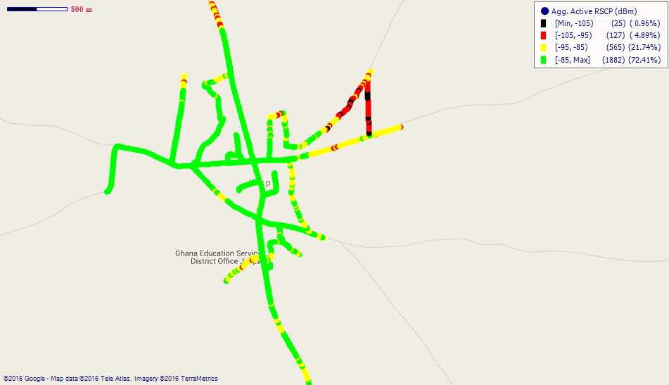
Remarks: Good 3G network coverage across Jirapa; however, coverage at the extreme eastern parts of Jirapa is poor. Major improvement is required.
Fig. 9 - Tigo 3G Coverage Map, Jirapa – May, 2016
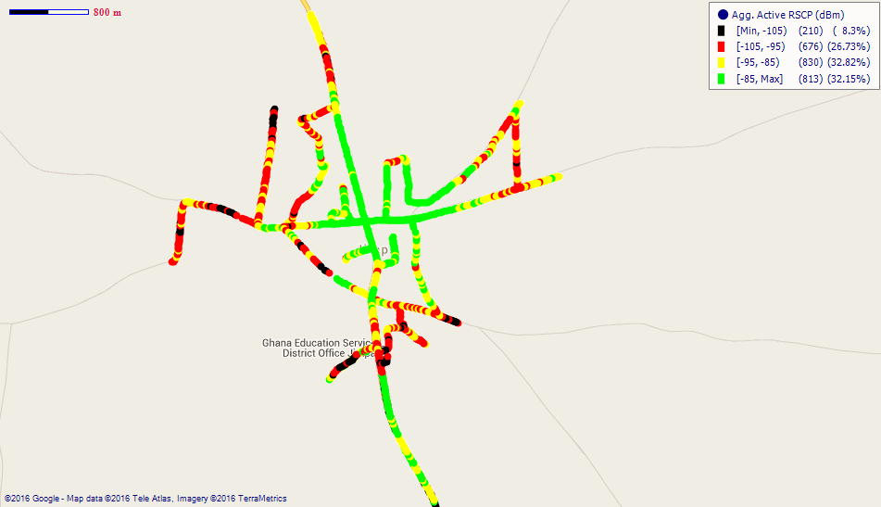
Remarks: Fair 3G network coverage across Jirapa with poor spots at the outskirts. Major improvement is needed.

Fig. 10 - Airtel 3G Coverage Map, Jirapa – May, 2016
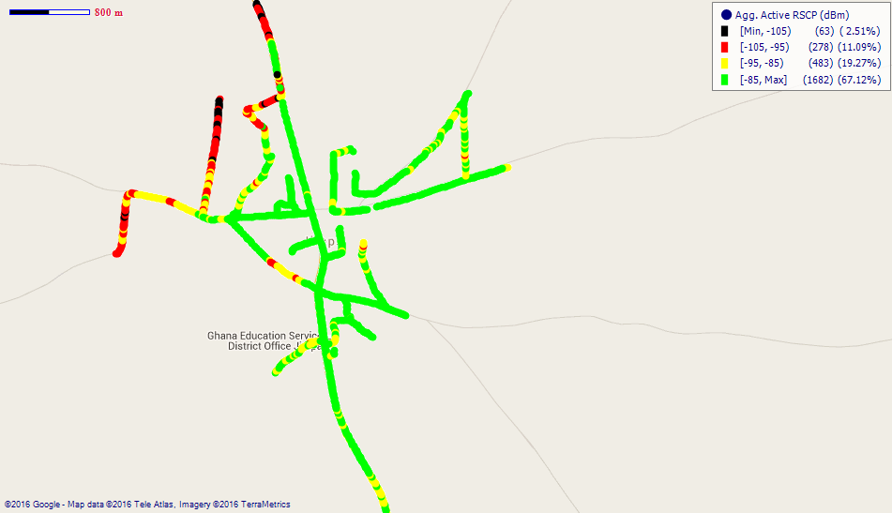
Remarks: Fair 3G network coverage in Jirapa which requires improvement.
COVERAGE AT LAMBUSSIE
Fig. 11 - MTN 3G Coverage Map, Lambussie – May, 2016
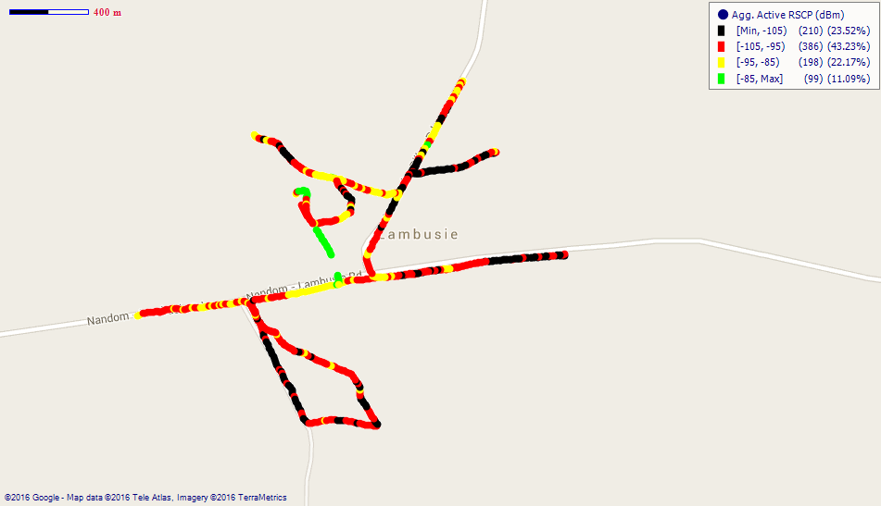
Remarks: Poor 3G network coverage in Lambussie. Major improvement is required.
Fig. 12 - Vodafone 3G Coverage Map, Lambussie – May, 2016
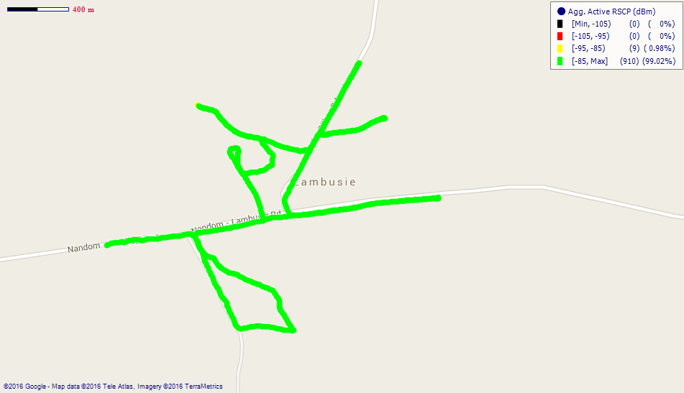
Remarks: Good 3G network coverage in Lambussie.

Fig. 13 - Tigo 3G Coverage Map, Lambussie – May, 2016

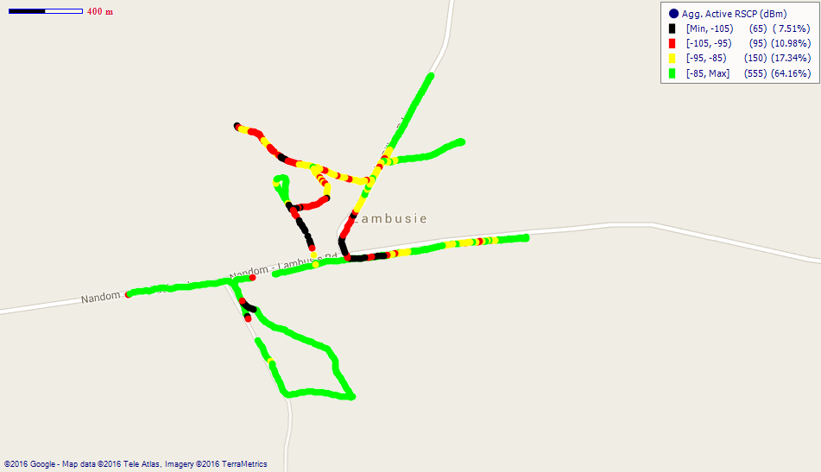

Remarks: Fair 3G coverage at Lambussie which requires major improvement.

Fig. 14 - Airtel 3G Coverage Map, Lambussie – May, 2016
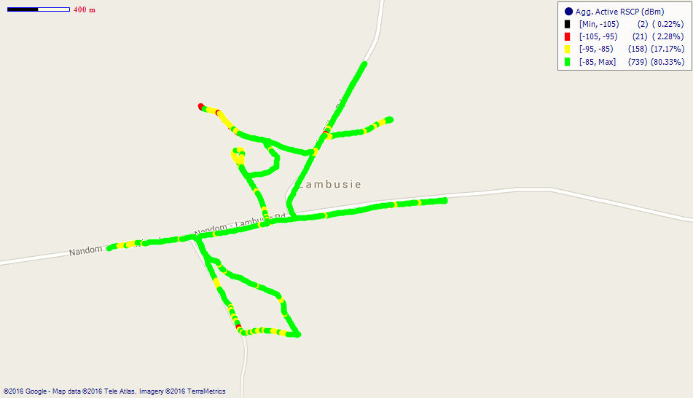
Remarks: Good network coverage in Lambussie.
COVERAGE AT LAWRA

Fig. 15 - MTN 3G Coverage Map, Lawra – May, 2016

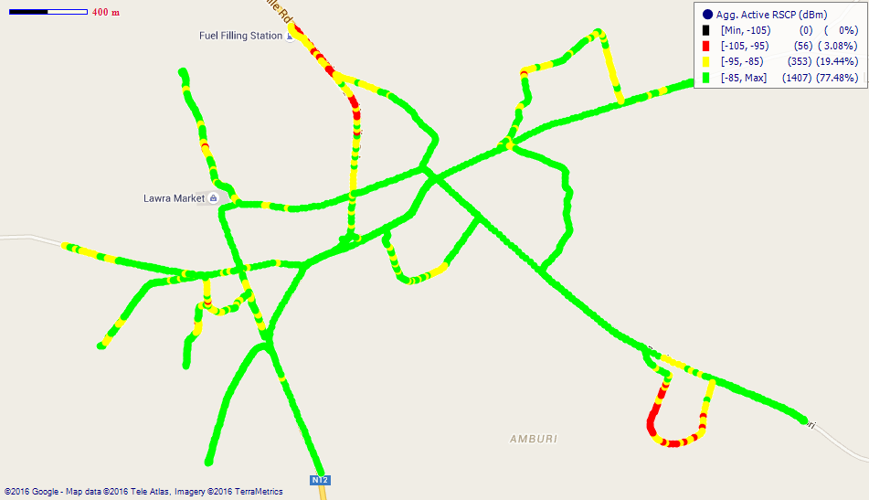

Remarks: Good network coverage in Lawra.

Fig. 16 - Vodafone 3G Coverage Map, Lawra – May, 2016
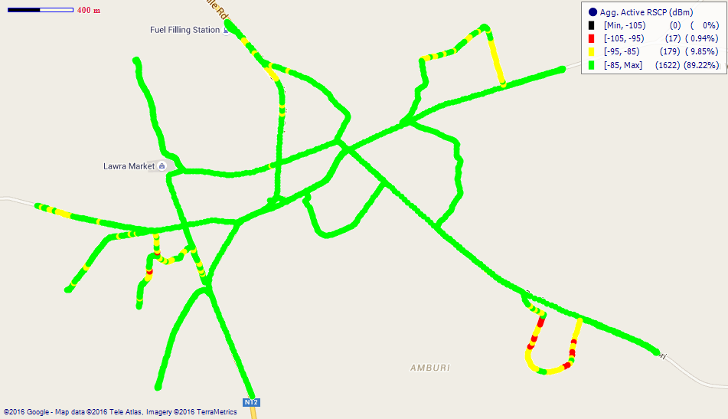
Remarks: Good 3G network coverage in Lawra.
Fig. 17 - Tigo 3G Coverage Map, Lawra - May, 2016
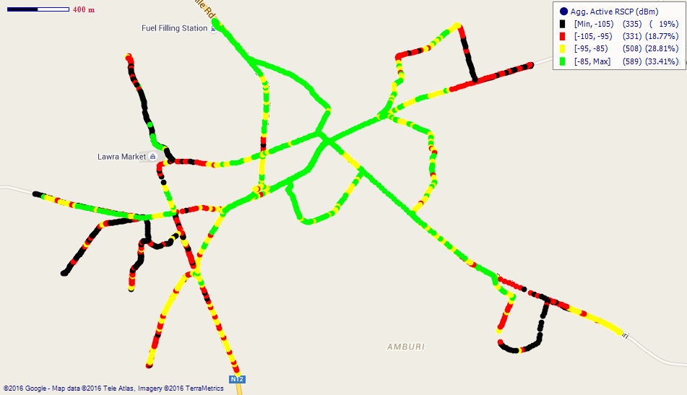
Remarks: Fair 3G coverage in Lawra with poor coverage spots at the outskirts of the town. Major improvement is required.

COVERAGE AT NADOWLI
Fig. 18 - MTN 3G Coverage Map, Nadowli – May, 2016
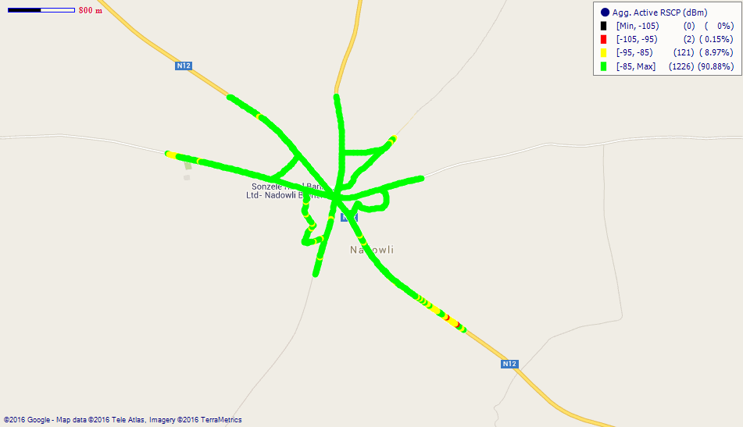
Remarks: Good 3G coverage in Nadowli.

Fig. 19 - Tigo 3G Coverage Map, Nadowli - May, 2016
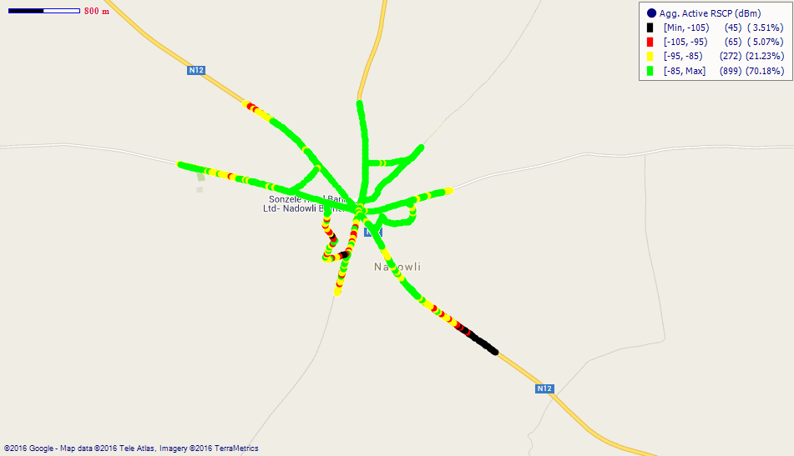
Remarks: Good 3G coverage at Nadowli.

COVERAGE AT TUMU
Fig. 20 - MTN 3G Coverage Map, Tumu – May, 2016
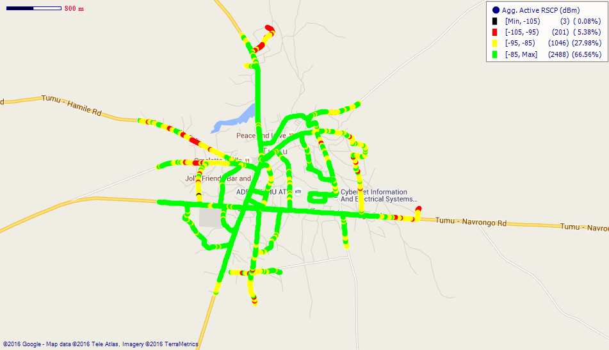
Remarks: Good 3G coverage at Tumu.

Fig. 21 - Vodafone 3G Coverage Map, Tumu – May, 2016
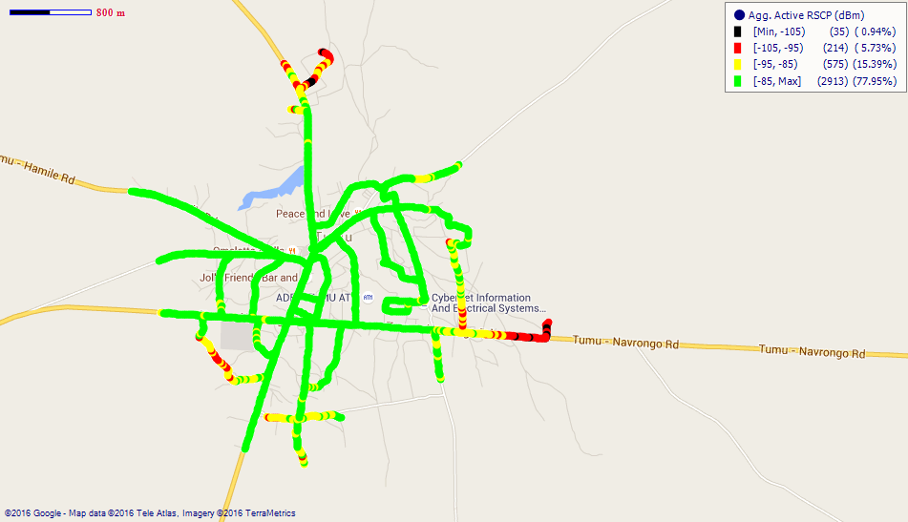
Remarks: Good 3G coverage at Tumu.

Fig. 22 - Airtel 3G Coverage Map, Tumu – May, 2016
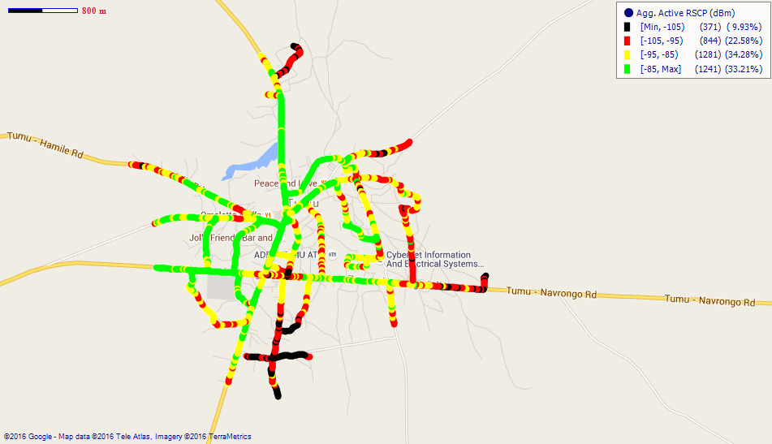
Remarks: Fair 3G network coverage in Tumu. However, 3G coverage at areas near the Chiefs Palace and the Stadium is poor. Major improvement is required.
COVERAGE AT WA
Fig. 23 - MTN 3G Coverage Map, Wa – May, 2016
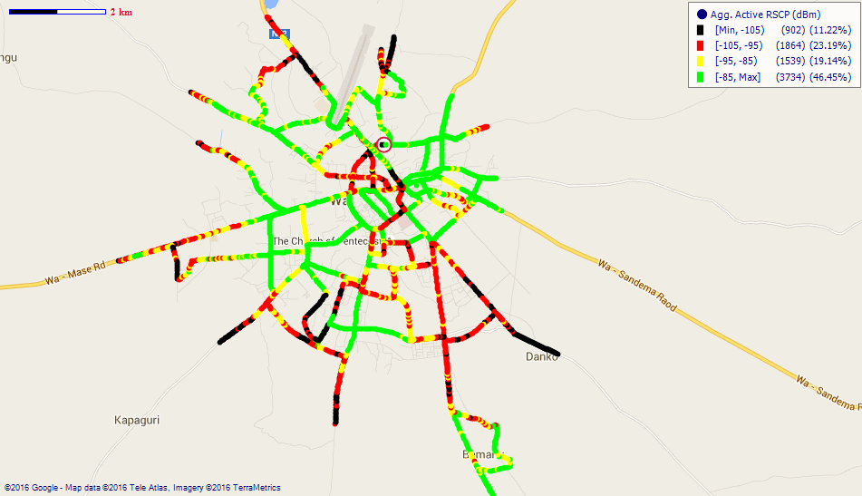
Remarks: Fair 3G coverage at Wa; however, coverage at Kpaguri, SSNIT Estates and its surrounding areas and the outskirts of Wa is poor. Major improvement is required.

Fig. 24 - Vodafone 3G Coverage Map, Wa – May, 2016
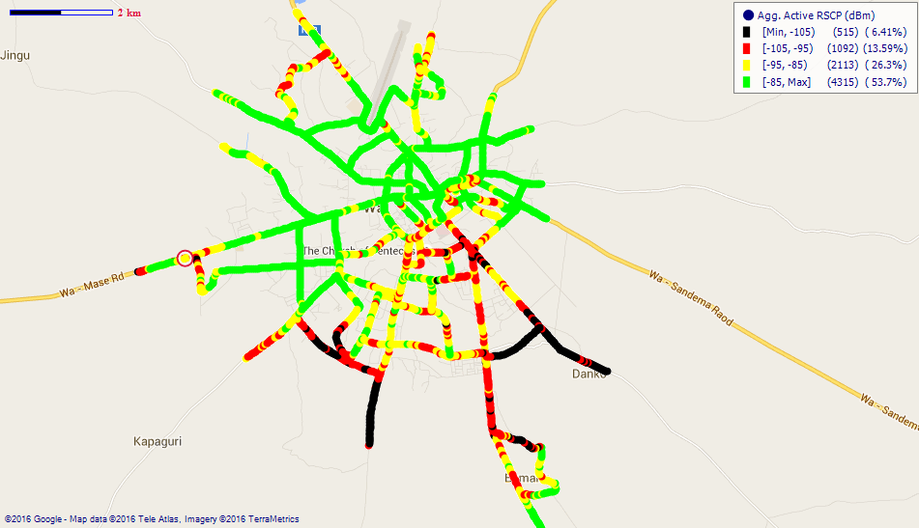
Remarks: Good 3G network coverage at Wa; however, coverage at SSNIT Estates, Kpaguri and Wa Poly is poor and requires a major improvement.
Fig. 25 - Tigo 3G Coverage Map, Wa – May, 2016
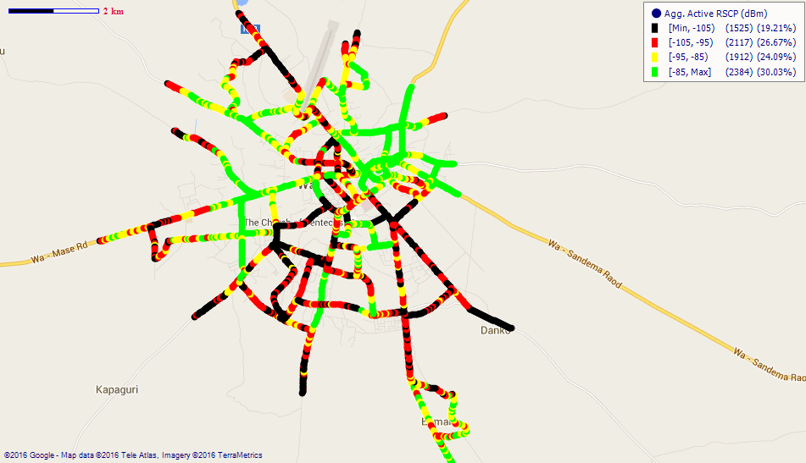
Remarks: Fair 3G network coverage at Wa; however, network coverage at SSNIT Estates, Wa Technical Institute, Kpaguri, Commercial Area and Teagber is poor. Major improvement needed.
Fig. 26 - Airtel 3G Coverage Map, Wa – May, 2016
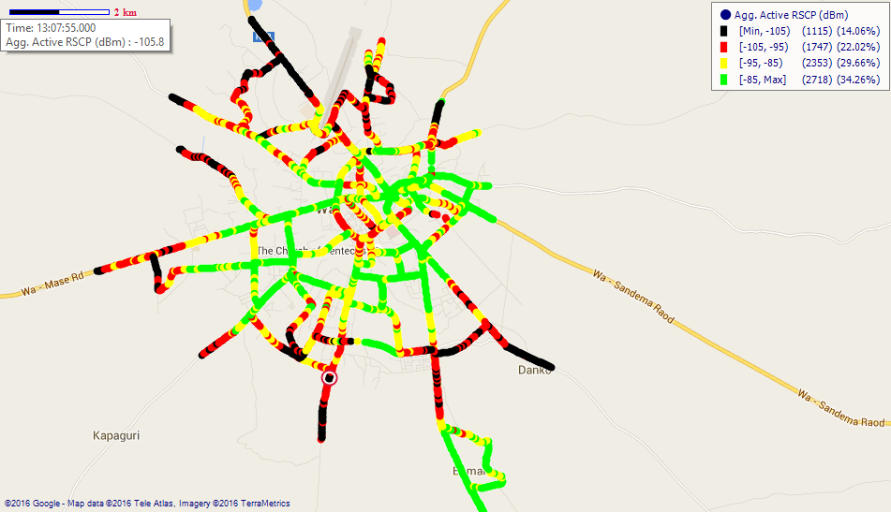
Remarks: Fair 3G network coverage in W. However, coverage at the outskirts of Wa is poor and require major improvement.
Fig. 27 - Glo 3G Coverage Map, Wa – May, 2016
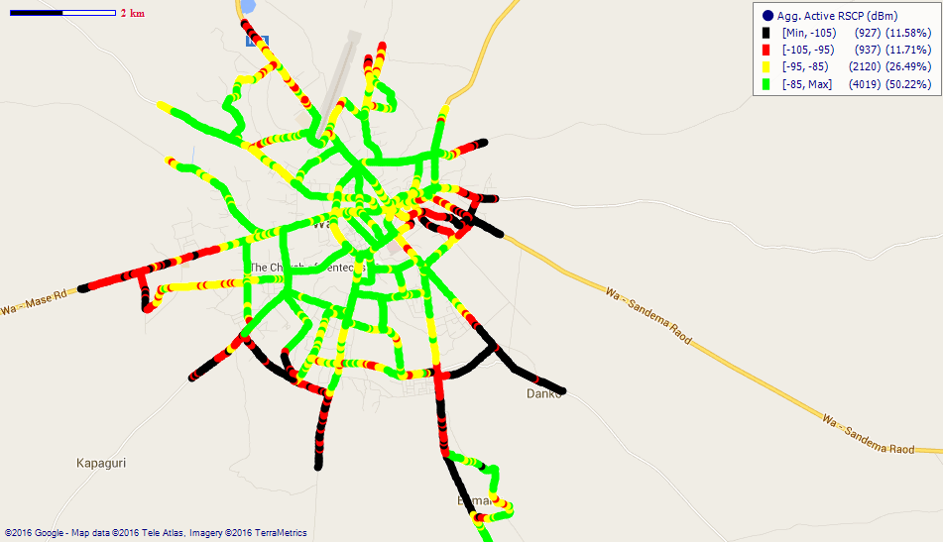
Remarks: Fair 3G coverage at Wa; however, 3G coverage at the outskirts of Wa is poor and requires major improvement.
COVERAGE AT WECHIAU
Fig. 28 - MTN 3G Coverage Map, Wechiau – May, 2016
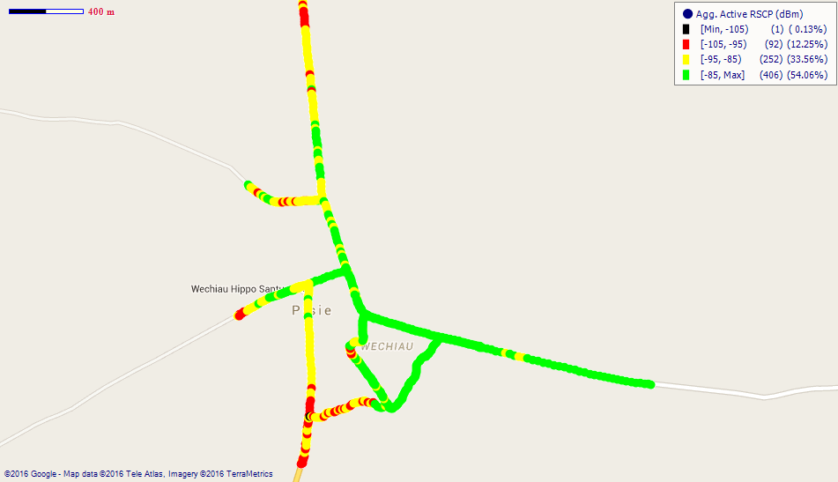
Remarks: Good 3G network coverage at Wechiau with fair coverage spots at the western side which requires improvement.
Fig. 29 - Vodafone 3G Coverage Map, Wechiau – May, 2016
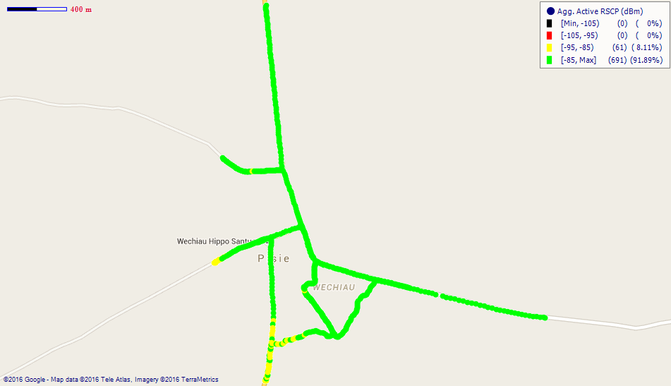
Remarks: Good 3G coverage at Wechiau.
Fig. 30 - Airtel 3G Coverage Map, Wechiau – May, 2016
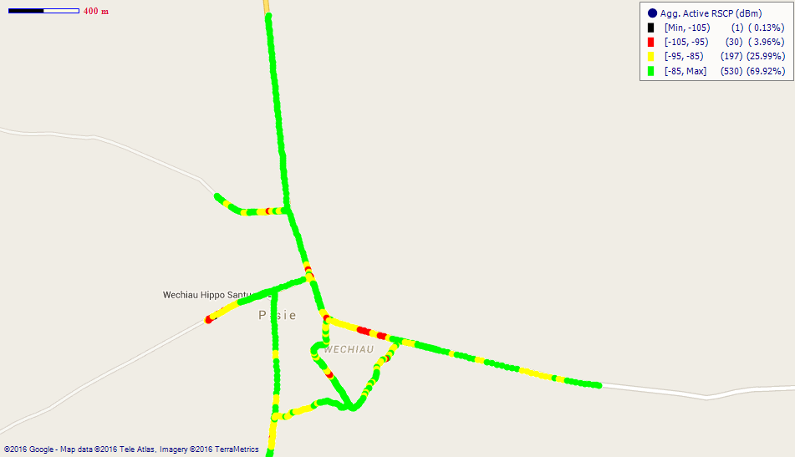
Remarks: Good 3G network coverage at Wechiau.
APPENDIX II
RSCP SAMPLING DISTRIBUTION
Fig. 31 - MTN 3G Coverage Samples Plot in the Upper West Region
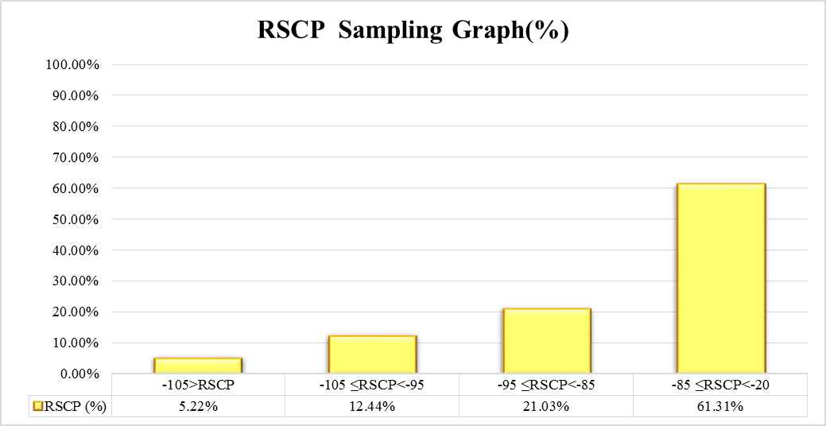
Remarks: MTN recorded its highest count of RSCP samples in the range –85 ≤RSCP < –20 dBm; representing “Good” 3G coverage across most of the District Capitals tested in the Upper West Region.
Fig. 32 - Vodafone 3G Coverage Samples Plot in the Upper West Region
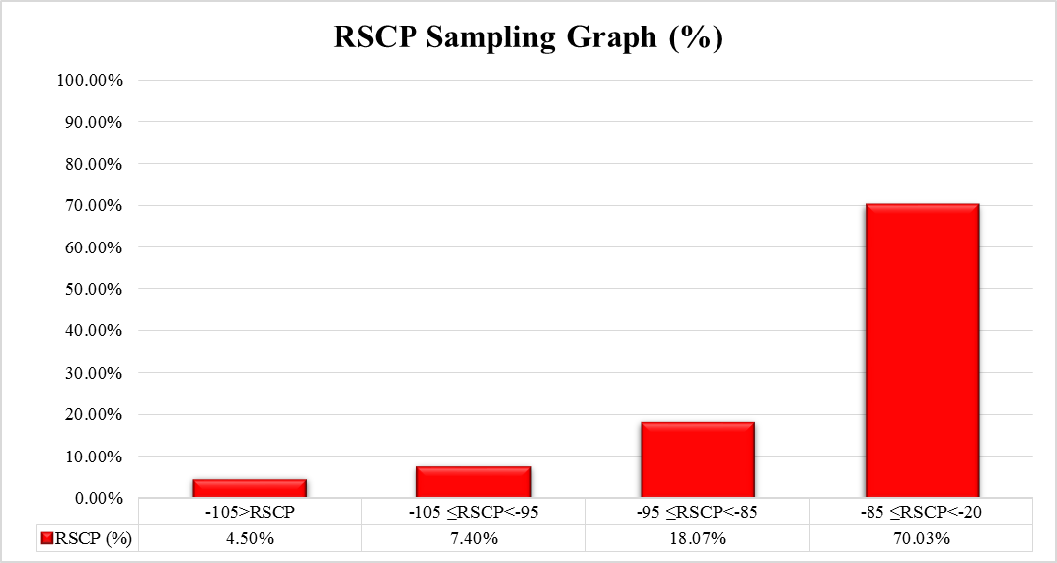
Remarks: Vodafone recorded its highest count of RSCP samples in the range –85 ≤RSCP < –20 dBm; representing “Good” 3G coverage across most of the District Capitals tested in the Upper West Region.
Fig. 33 - Tigo 3G Coverage Samples Plot in the Upper West Region
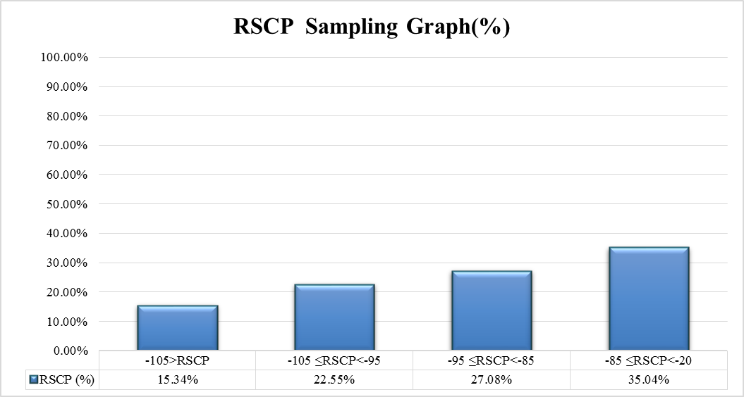
Remarks: Tigo recorded its highest count of RSCP samples in the range –85 ≤RSCP < –20 dBm; representing “Good” 3G coverage across most of the District Capitals tested in the Upper West Region.

Fig. 34 - Airtel 3G Coverage Samples Plot in the Upper West Region
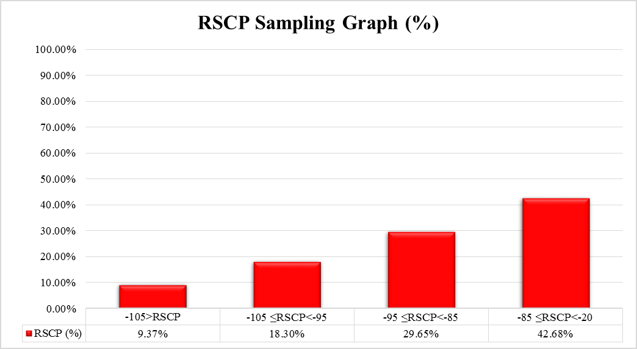
Remarks: Airtel recorded its highest count of RSCP samples in the range –85 ≤RSCP < –20 dBm; representing “Good” 3G coverage across most of the District Capitals tested in the Upper West Region.

Fig. 35 - Glo 3G Coverage Samples Plot in the Upper West Region
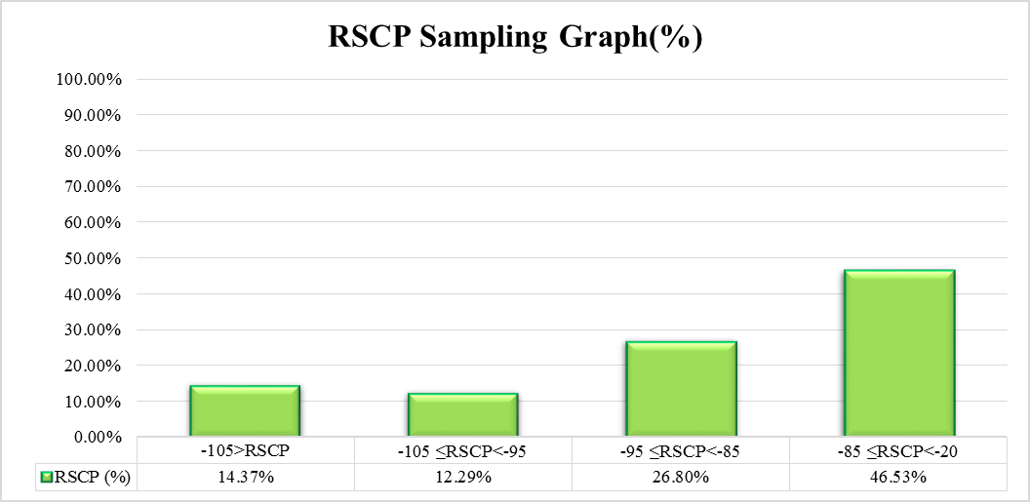
Remarks: Glo recorded its highest count of RSCP samples in the range –85 ≤RSCP < –20 dBm dBm; representing “Good” 3G coverage across most of the areas tested in Wa District Capital.

