3G Coverage Assessment of Cellular Mobile Services- Upper East Region
[May 2016]
[Communications for Development]


NATIONAL COMMUNICATIONS AUTHORITY

Table of Contents
1. Background 2
2. What we measure 2
3. Findings 2-3
4. Remedies 4
5. Coverage Signal Strength 4-25

Background
In pursuance of the 3G Cellular Mobile Licence obligations of Telecommunication Operators, the consumer experience of the 3G Coverage status is tested to ensure that Operators comply with the 3G Coverage obligations to the user.
The report is based on findings on 3G verification campaign in the Upper East Region from 12th to 16th May, 2016 for all Operators except for Expresso due to technical challenges.

What we measure
As per the 3G Cellular Mobile licence obligations, 3G-locked mode coverage samples are collected to obtain on the average, a signal strength measurement which is representative of the coverage situation in each of the District Capitals that was driven.
The 3G Signal Strength and their respective threshold for compliance considering the user’s perspective are categorised as follows;
Rating | 3G Signal Strength Range (dBm)
No 3G Coverage | -105>RSCP
Poor | –105≤ RSCP < -95
Fair | –95≤ RSCP< –85
Good | –85 ≤RSCP < –20

Findings
The results for the District Capitals within Upper East Region tested during the period are as below:
Table 1: Coverage Signal strength, May, 2016

DISTRICT CAPITAL | MTN | VODAFONE | TIGO | AIRTEL | GLO
Bawku | Fair | Good | Poor | Fair | No 3G Coverage
Bolgatanga | Fair | Fair | Fair | Fair | Poor
Bongo | Good | Good | No 3G Coverage | Fair | Fair
DISTRICT CAPITAL | MTN | VODAFONE | TIGO | AIRTEL | GLO
Garu | Good | Good | Fair | Fair | No 3G Coverage
Navrongo | Fair | Fair | Poor | Fair | No 3G Coverage
Paga | Good | Good | Fair | Fair | Poor
Sandema | Good | Good | Fair | Fair | No 3G Coverage
Tongo | Fair | Good | No 3G Coverage | Fair | No 3G Coverage
Zebilla | Good | Good | No 3G Coverage | Poor | No 3G Coverage
REMARKS:
- All Operators except Tigo and Glo met the 3G Coverage Obligation in all the District Capitals tested in the Upper East Region.
- MTN had good 3G coverage at Bongo, Garu, Paga, Sandema and Zebilla.
- MTN had fair 3G coverage at Bawku, Bolgatanga, Navrongo and Tongo.
- Vodafone had good 3G coverage in all the District Capitals tested except Bolgatanga and Navrongo which had “fair” 3G network coverage.
- Tigo had fair 3G network coverage at Bolgatanga, Garu, Paga and Sandema.
- Tigo had poor 3G coverage at Bawku and Navrongo.
- Tigo had no 3G coverage at Bongo, Tongo and Zebilla at the time of our test.
- Tigo indicated that, they experienced service outage at Zebilla at the period of our test.
- Airtel had fair 3G coverage in all the District Capitals tested except Zebilla which had poor 3G network coverage.
- Glo had no 3G coverage in all the tested District Capitals except Bongo, Bolgatanga and Paga.
- Glo had fair 3G coverage at Bongo and poor 3G network coverage at Bolgatanga and Paga.

Remedies
- The NCA has notified Operators of these findings and has directed all Operators to improve their 3G coverage in some localities by August 31, 2016.

- Tigo has been sanctioned for failing to maintain 3G coverage at Bongo, Tongo and Zebilla.
- Glo has been granted moratorium till December 31, 2016 to cover all the failed District Capitals in the Upper East Region.

APPENDICES
Coverage Signal Strength

The Maps below show the coverage levels in District Capitals of the Upper East Region where the monitoring exercise were performed. The coverage map is based on the 3G network signal strength when tested in an idle mode. In each plot is a legend to indicate the signal strength and quality range attained by Operators during measurement.
Coverage levels in green falls in the range of -85dBm and above, and are considered good. Those between -85 and -95dBm are considered average or fair and are indicated in yellow. The red samples represent worse or poor coverage in the range of -95 to -105dBm. The black samples represent areas with no 3G coverage.
Coverage Legend
Colour | Area Coverage Rating
 | Good Coverage Areas
 | Fair Coverage Areas
 | Poor Coverage Areas
 | Non-Existent Coverage Areas

APPENDIX I

COVERAGE AT BAWKU
Fig. 1 - MTN 3G Coverage Map, Bawku – May, 2016
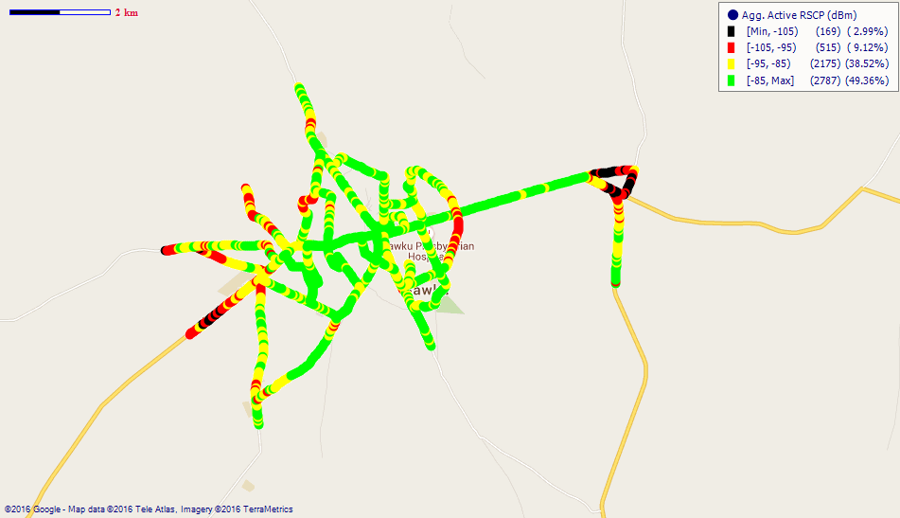
Remarks: Fair 3G coverage in Bawku which requires improvement.

Fig. 2 - Vodafone 3G Coverage Map, Bawku – May, 2016
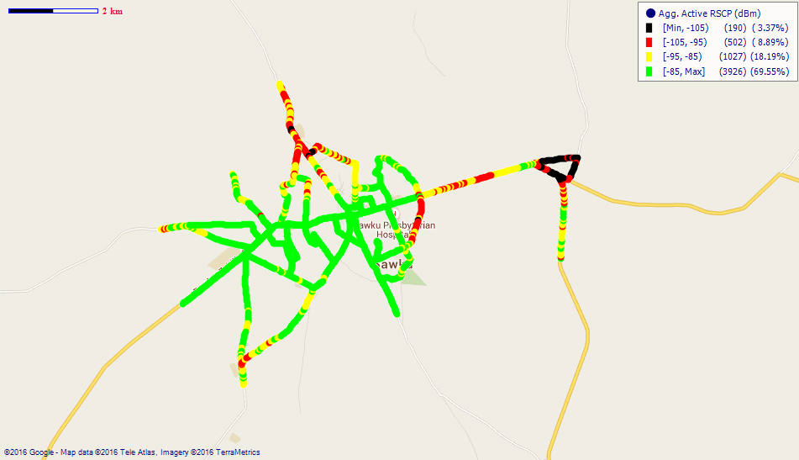
Remarks: Good 3G coverage in Bawku; however, 3G coverage along the Musiga Road and Bawkuzua areas is poor and requires improvement.
Fig. 3 – Tigo 3G Coverage Map, Bawku – May, 2016
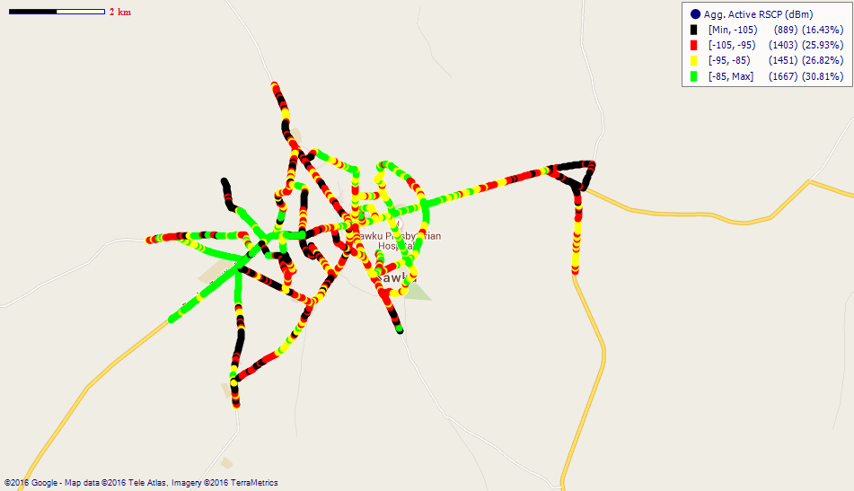
Remarks: Poor 3G coverage in Bawku, especially around the central parts. Major improvement is needed.
Fig. 4 - Airtel 3G Coverage Map, Bawku – May, 2016
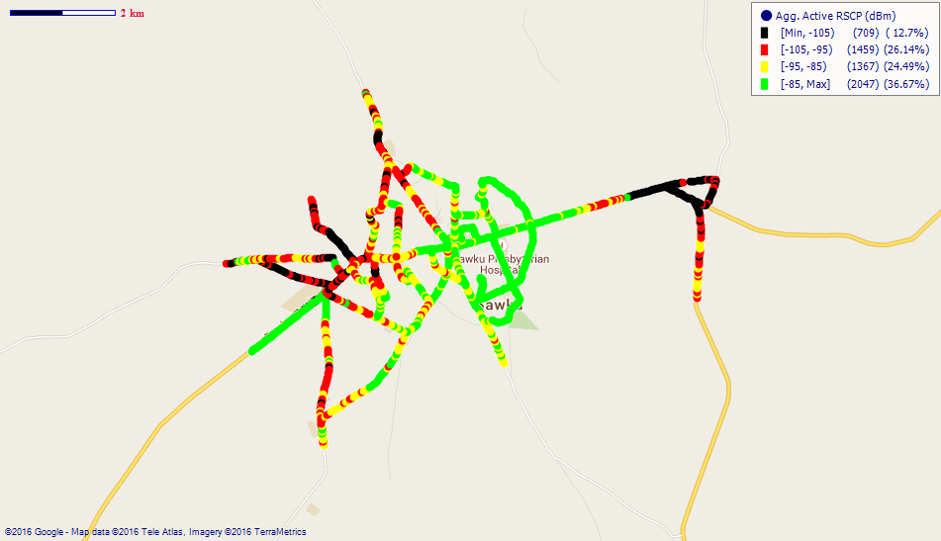
Remarks: Fair 3G coverage in Bawku. However, 3G network at the western side of the town and around the District Assembly Office is poor. Major improvement is required.

COVERAGE AT BOLGATANGA
Fig. 5 - MTN 3G Coverage Map, Bolgatanga –May, 2016
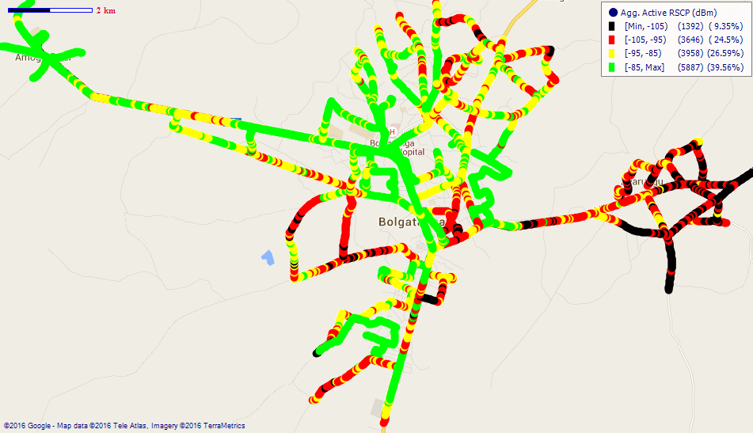
Remarks: Fair 3G coverage in Bolgatanga; however, coverage at Zuarungu, Zaare and Tanzui is poor and require major improvement.

Fig. 6- Vodafone 3G Coverage Map, Bolgatanga – May, 2016
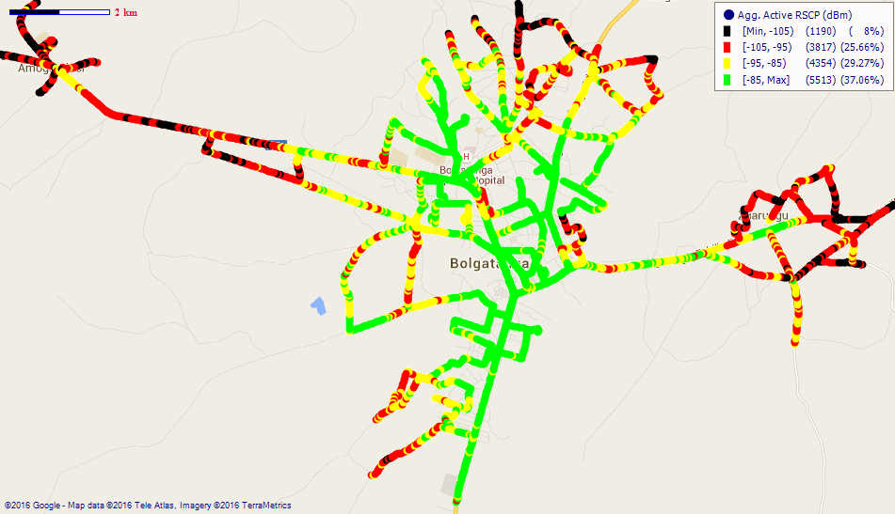
Remarks: Fair 3G coverage in Bolgatanga; however, 3G network at Sumbrungu, Yikene, Zaare and Zuarungu is poor. Major improvement is needed
Fig. 7 - Tigo 3G Coverage Map, Bolgatanga - May, 2016
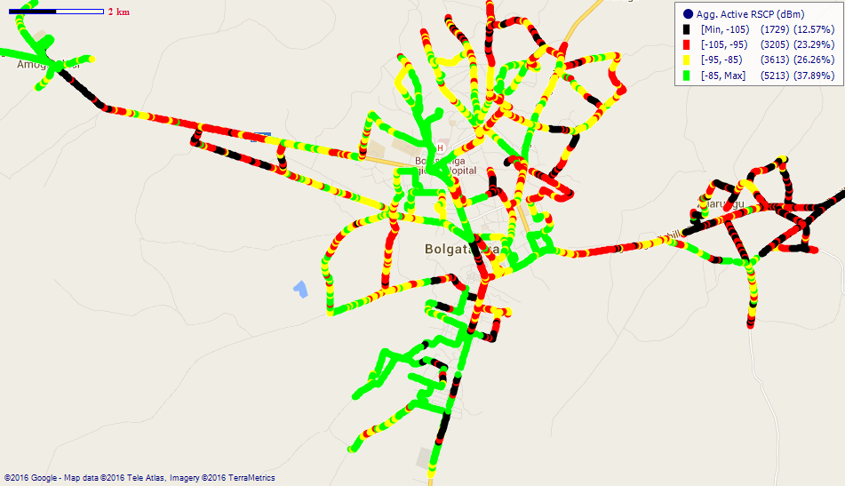
Remarks: Fair 3G network coverage across Bolgatanga with poor coverage spots at Sumbrungu, Tanzui, Zaare, Soe and Zuarungu. Major improvement is required.

Fig. 8 - Airtel 3G Coverage Map, Bolgatanga – May, 2016
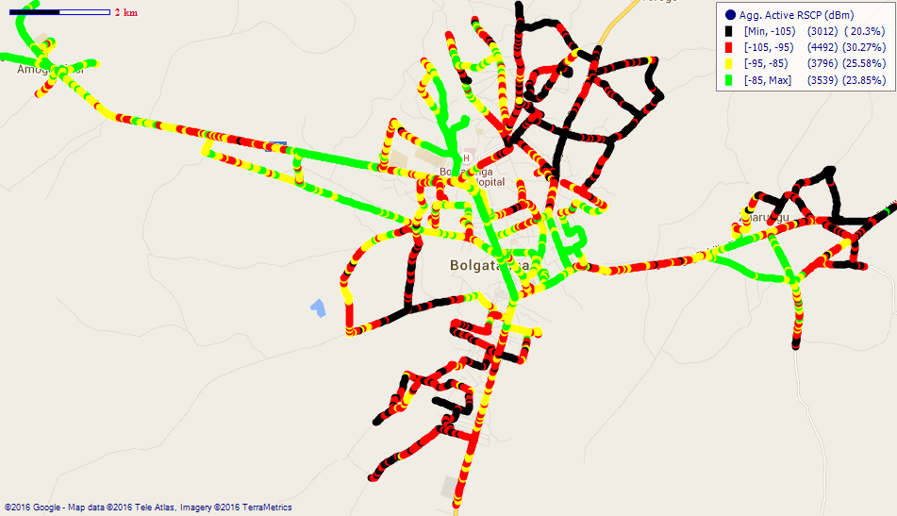
Remarks: Fair 3G coverage in Bolgatanga. However, 3G network at Zaare, Soe, Tanzui, SSNIT Estates and Zuarungu is poor. Major improvement is required.
Fig. 9 - Glo 3G Coverage Map, Bolgatanga – May, 2016

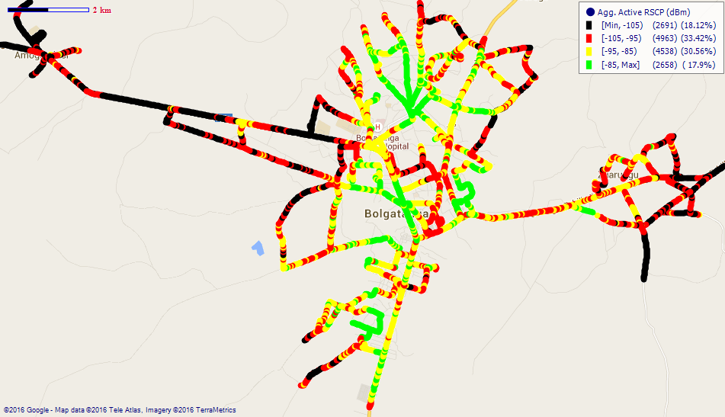
Remarks: Poor 3G coverage in and around the suburbs of Bolgatanga such as Zuarungu and Sumbrungu. Major improvement required.
COVERAGE AT BONGO
Fig. 10 – MTN 3G Coverage Map, Bongo – May, 2016
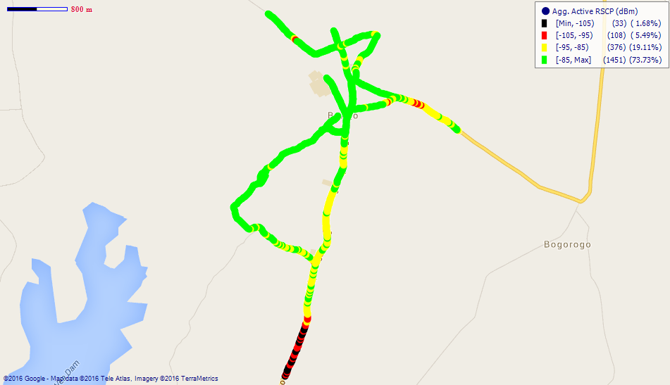
Remarks: Good 3G network coverage across Bongo.

Fig. 11 - Vodafone 3G Coverage Map, Bongo – May, 2016
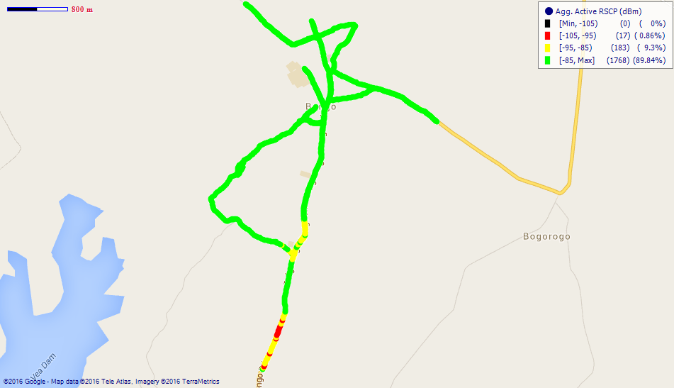
Remarks: Good 3G network coverage across Bongo.

Fig. 12 - Airtel 3G Coverage Map, Bongo – May, 2016
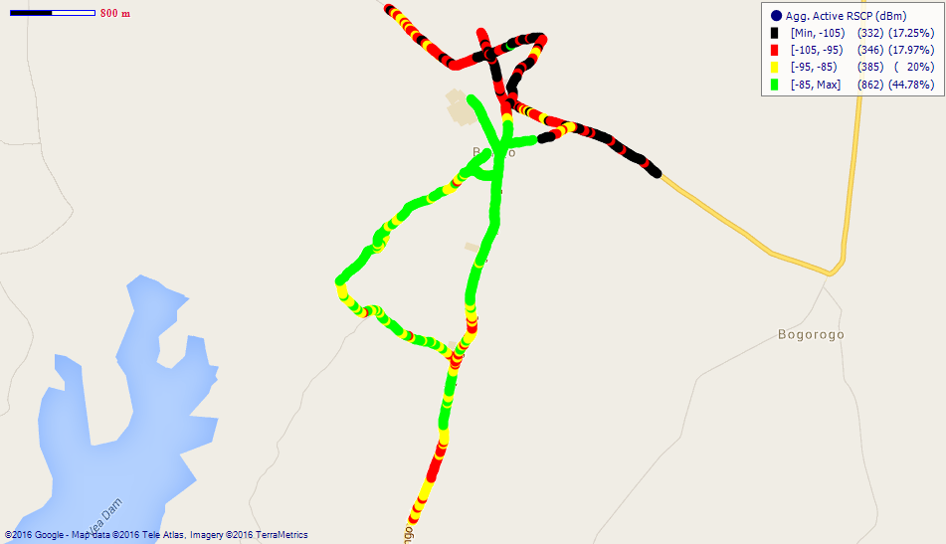
Remarks: Fair 3G network coverage in Bongo which requires major improvement.
Fig. 13 – Glo 3G Coverage Map, Bongo – May, 2016
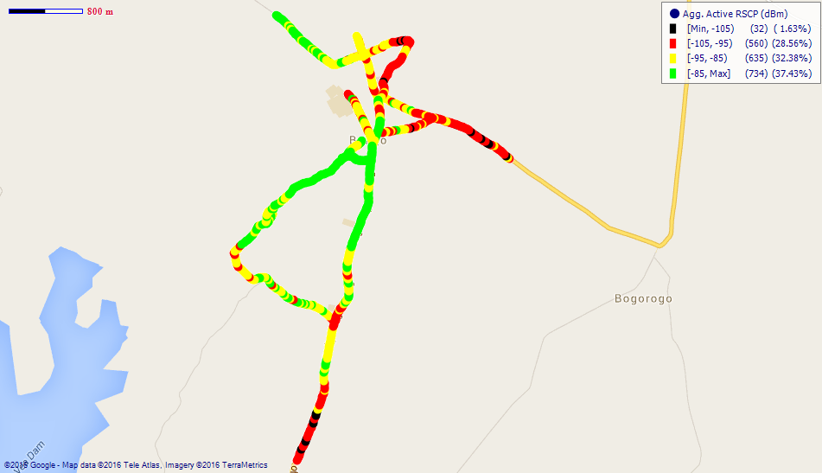
Remarks: Fair 3G coverage at Bongo. Major improvement is required.
COVERAGE AT GARU
Fig. 14 - MTN 3G Coverage Map, Garu – May, 2016
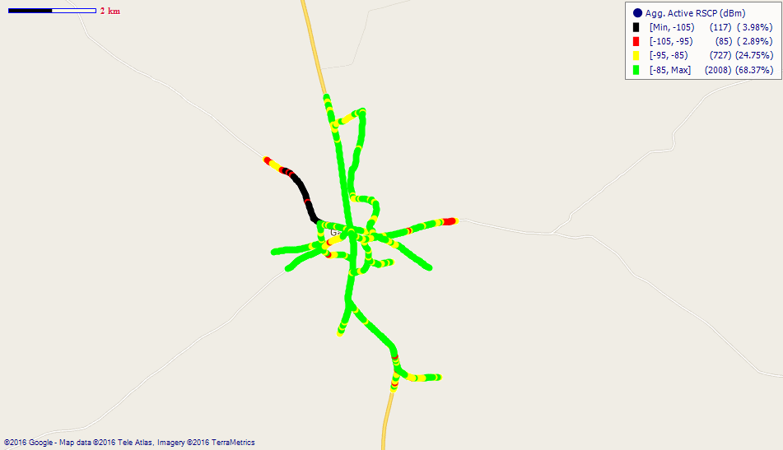
Remarks: Good 3G network coverage in Garu.
Fig. 15 - Vodafone 3G Coverage Map, Garu – May, 2016
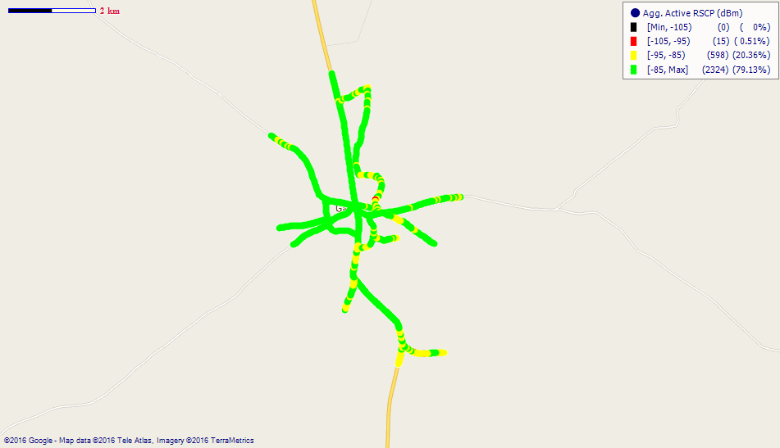
Remarks: Good 3G network coverage in and around Garu.

Fig. 16 - Tigo 3G Coverage Map, Garu – May, 2016

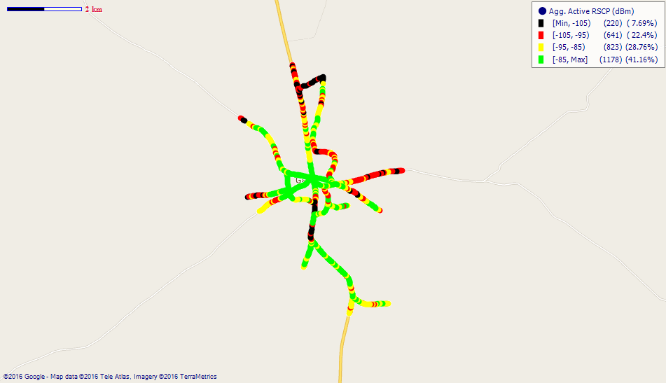

Remarks: Fair 3G coverage at Garu with poor coverage spots at the northern areas. Major improvement is required.
Fig. 17 - Airtel 3G Coverage Map, Garu – May, 2016
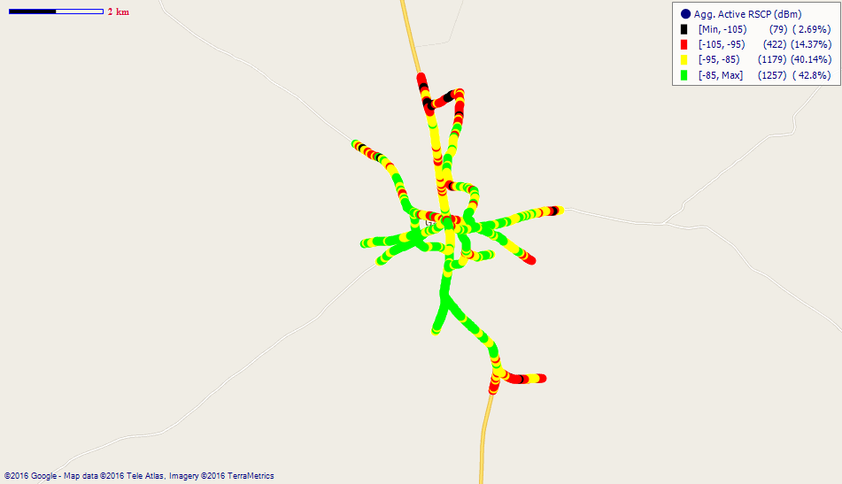
Remarks: Fair 3G network coverage in Garu. Major improvement required.
COVERAGE AT NAVRONGO

Fig. 18 - MTN 3G Coverage Map, Navrongo – May, 2016

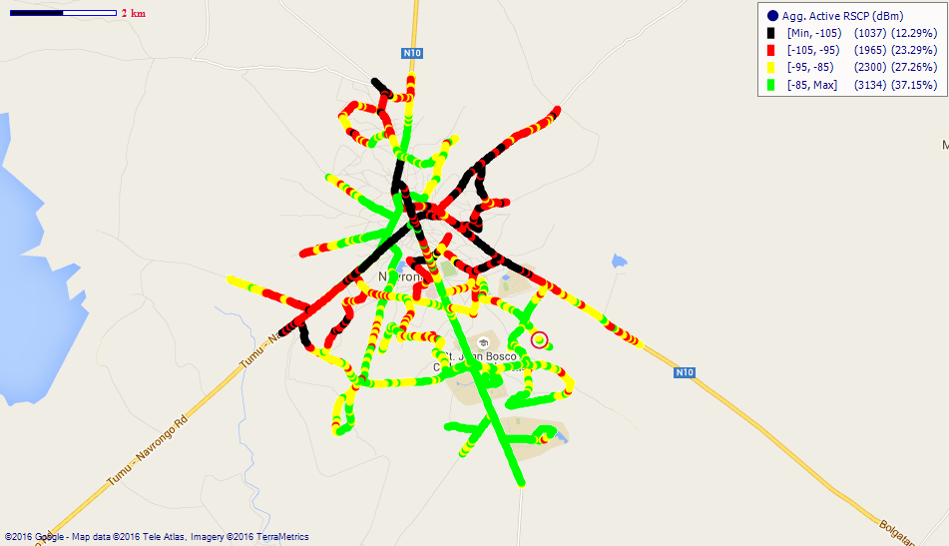

Remarks: Fair 3G coverage at Navrongo; however, 3G coverage at the central parts of Navrongo and along the Bolgatanga, Navro Pungu and Tumu Roads is poor. Major improvement is needed.
Fig. 19 - Vodafone 3G Coverage Map, Navrongo – May, 2016
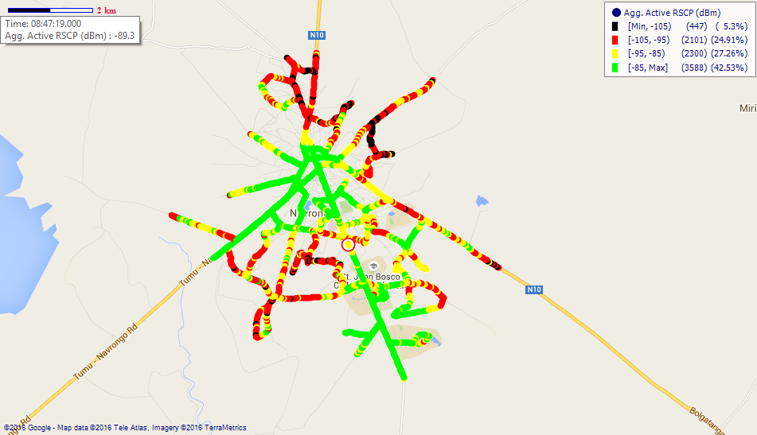
Remarks: Fair 3G coverage across Navrongo with poor coverage spots at Navro Pungu, Saboro and along the Bolgatanga road. Major improvement needed.

Fig. 20 - Tigo 3G Coverage Map, Navrongo – May, 2016
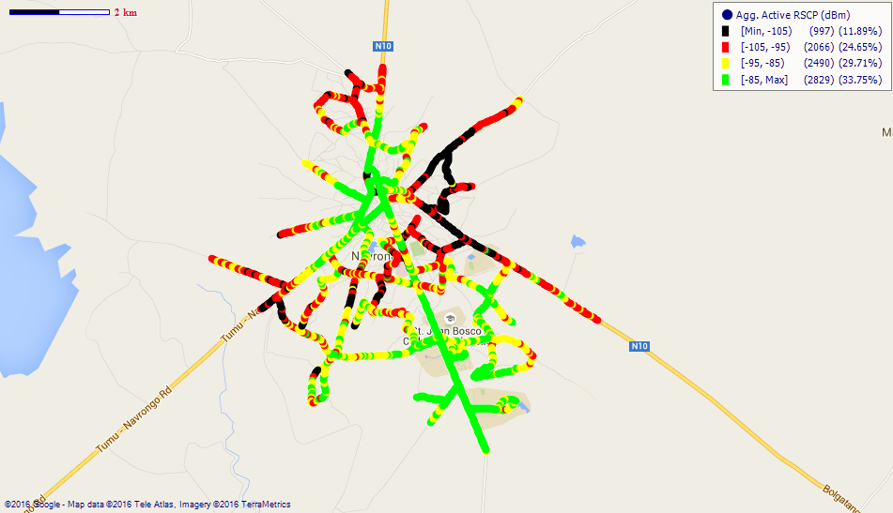
Remarks: Poor 3G coverage in and around Navrongo especially at the Commercial Area and along the Bolgatanga and Navro Pungu Road. Major improvement is required.
Fig. 21 - Airtel 3G Coverage Map, Navrongo – May, 2016
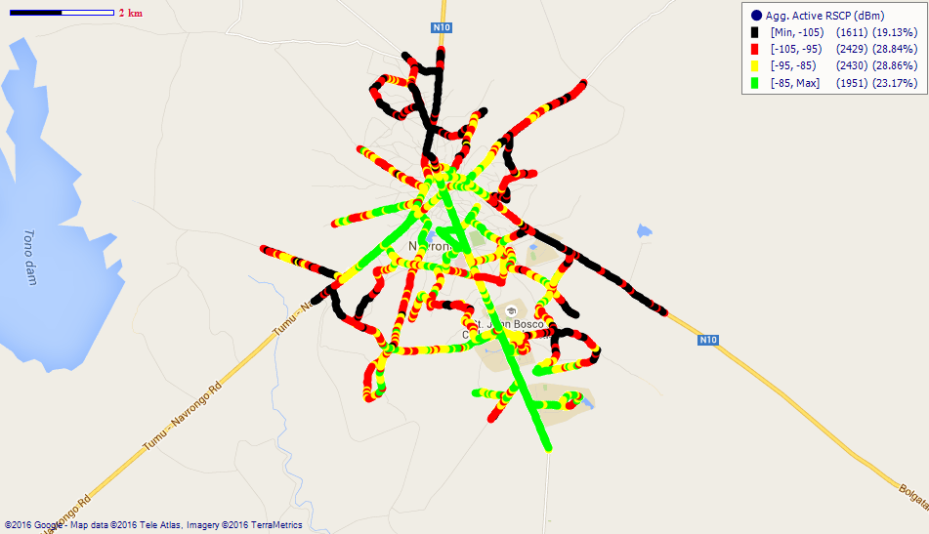

Remarks: Fair 3G network coverage in Navrongo. However, 3G coverage at areas to the north of Navrongo, around the District Assembly Office, Navro Pungu and along the Paga and Bolgatanga roads is poor. Major improvement is required.

COVERAGE AT PAGA
Fig. 22 - MTN 3G Coverage Map, Paga – May, 2016
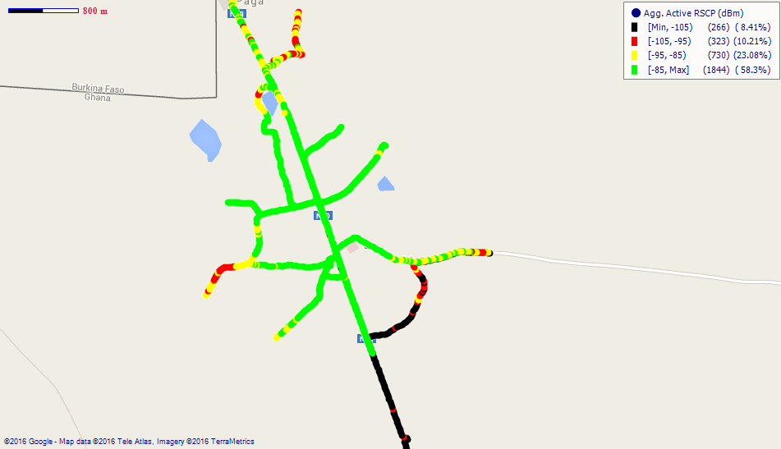
Remarks: Good 3G coverage at Paga.
Fig. 23 - Vodafone 3G Coverage Map, Paga – May, 2016
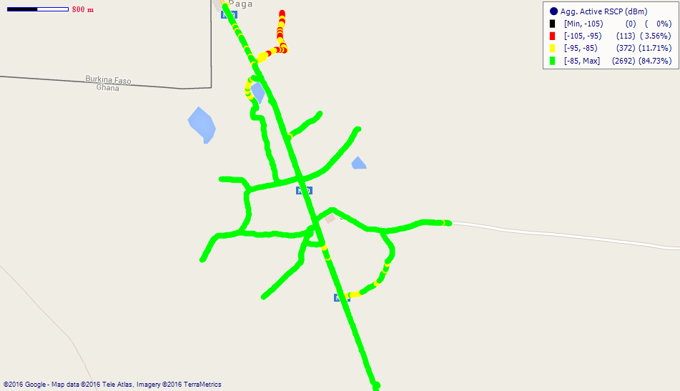
Remarks: Good 3G coverage at Paga.

Fig. 24 - Tigo 3G Coverage Map, Paga – May, 2016
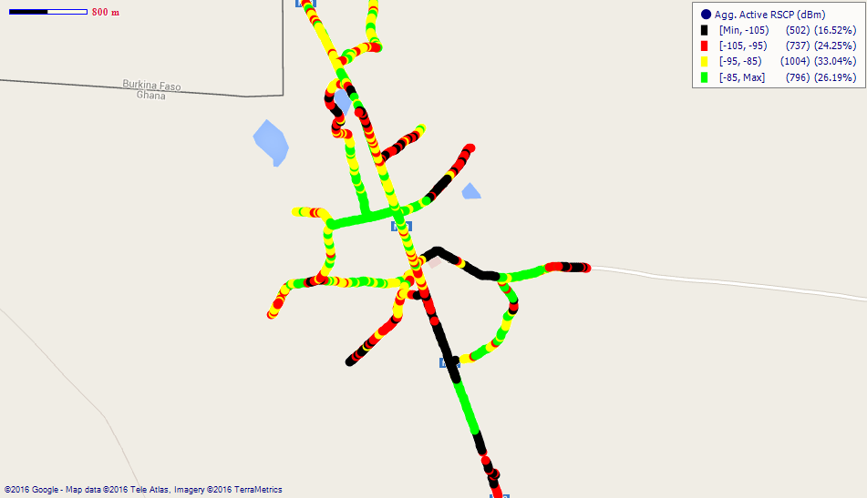
Remarks: Fair 3G coverage in and around Paga. Major improvement is needed.
Fig. 25 - Airtel 3G Coverage Map, Paga – May, 2016
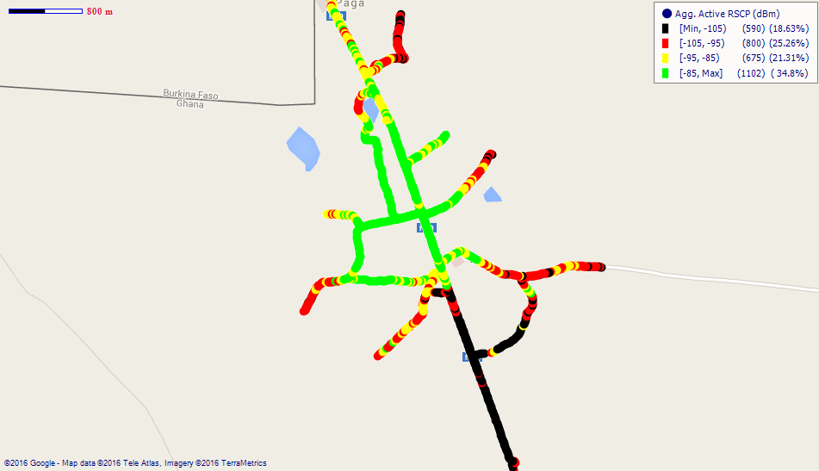
Remarks: Fair 3G network coverage in Paga with poor coverage spots along the Navrongo Road. Major improvement is required.
Fig. 26 - Glo 3G Coverage Map, Paga – May, 2016
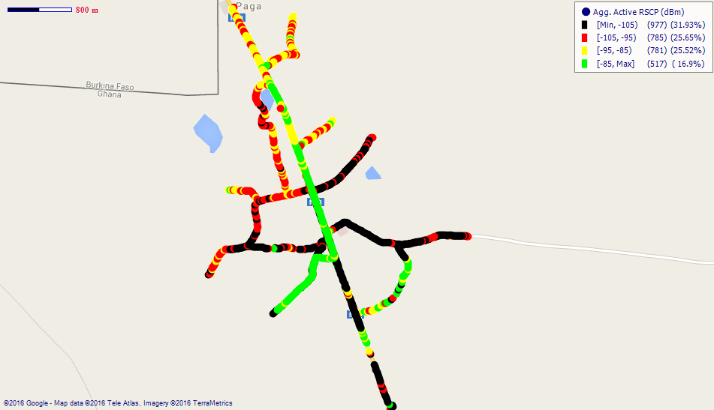
Remarks: Poor 3G coverage at Paga. Major improvement is needed.
COVERAGE AT SANDEMA
Fig. 27 - MTN 3G Coverage Map, Sandema – May, 2016
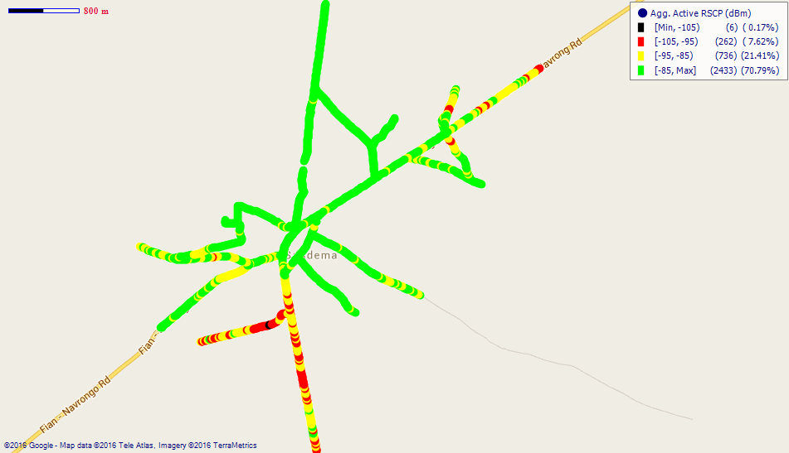
Remarks: Good 3G coverage at Sandema.

Fig. 28 - Vodafone 3G Coverage Map, Sandema – May, 2016
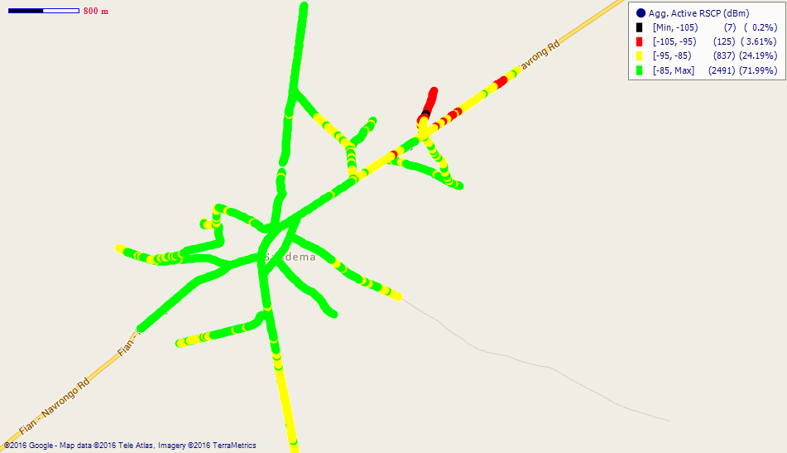
Remarks: Good 3G coverage at Sandema.
Fig. 29 - Tigo 3G Coverage Map, Sandema – May, 2016
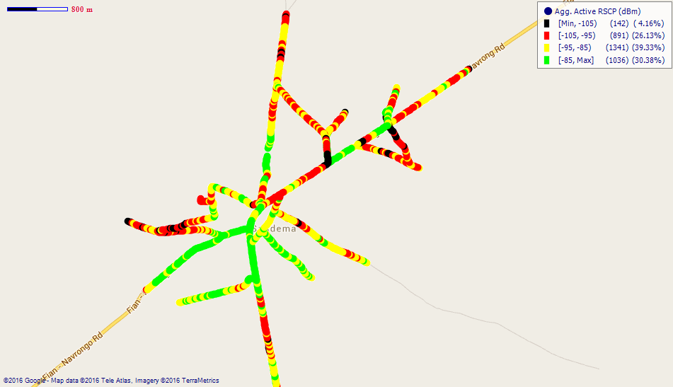
Remarks: Fair 3G network coverage at Sandema; however, 3G network at the outskirts of Sandema is poor and requires major improvement.
Fig. 30 - Airtel 3G Coverage Map, Sandema – May, 2016
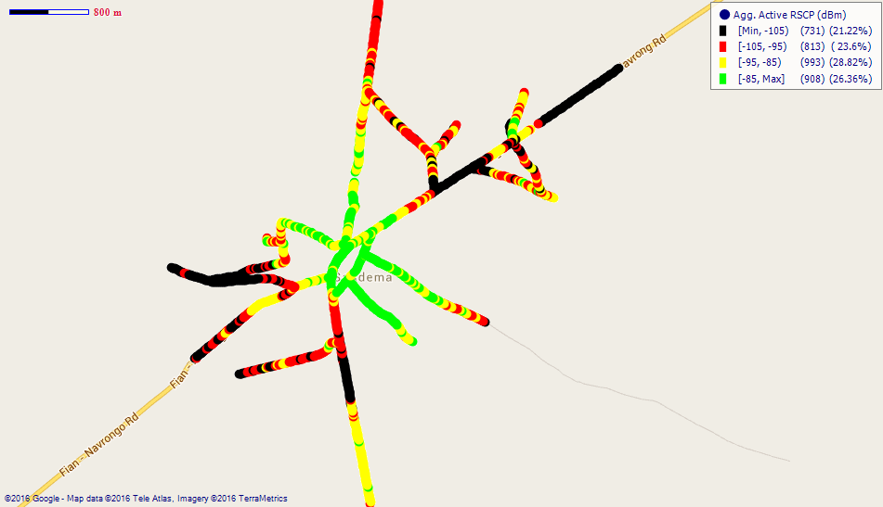
Remarks: Fair 3G network coverage at Sandema. 3G Coverage at the outskirts of Sandema is however poor. Major improvement is required.
COVERAGE AT TONGO
Fig. 31 - MTN 3G Coverage Map, Tongo – May, 2016
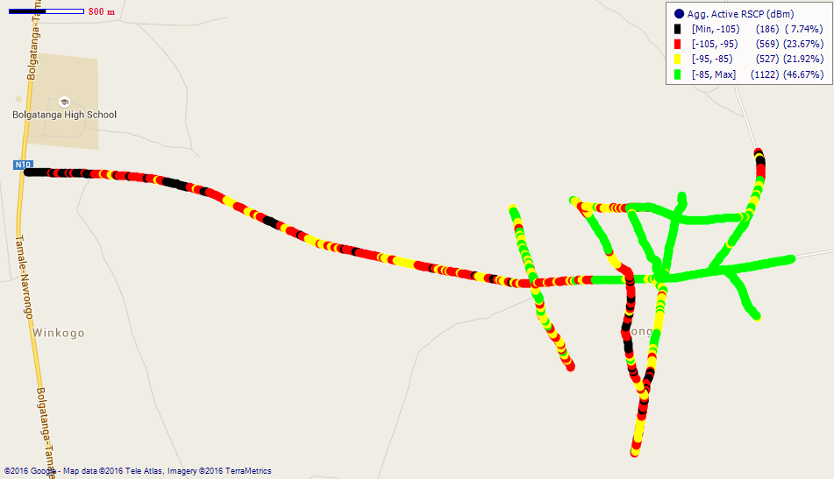
Remarks: Fair 3G coverage at Tongo; however, 3G coverage along the main road leading to the town is poor. Improvement is required.
Fig. 32 - Vodafone 3G Coverage Map, Tongo – May, 2016
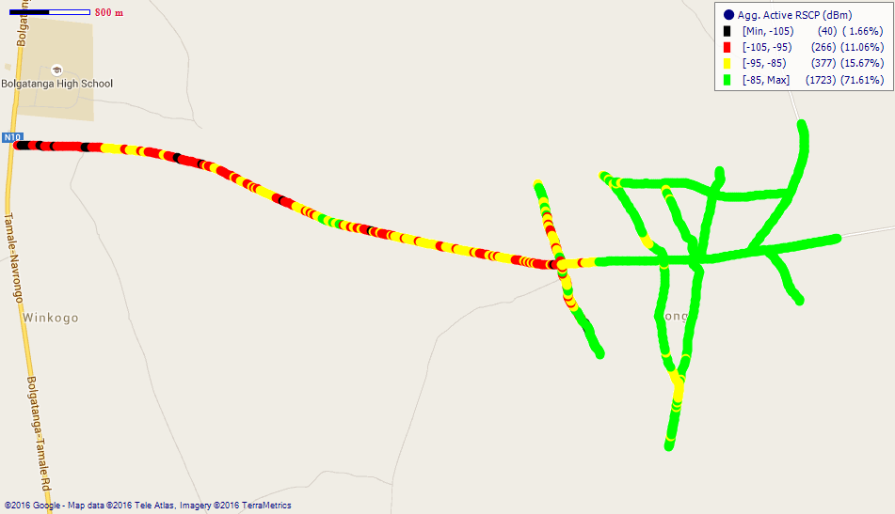
Remarks: Good 3G coverage at Tongo.
Fig. 33 - Airtel 3G Coverage Map, Tongo – May, 2016
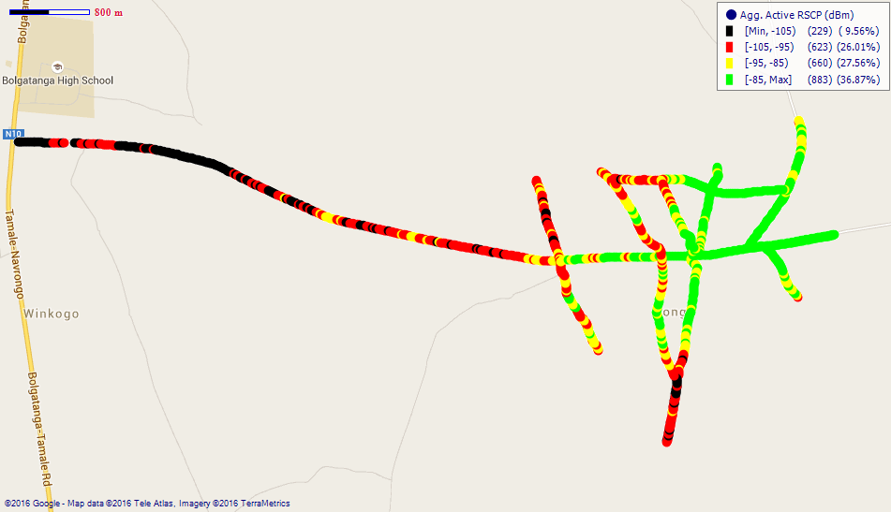
Remarks: Fair 3G network coverage in Tongo. Major improvement required along the main road leading to the town.
COVERAGE AT ZEBILLA
Fig. 34 - MTN 3G Coverage Map, Zebilla – May, 2016
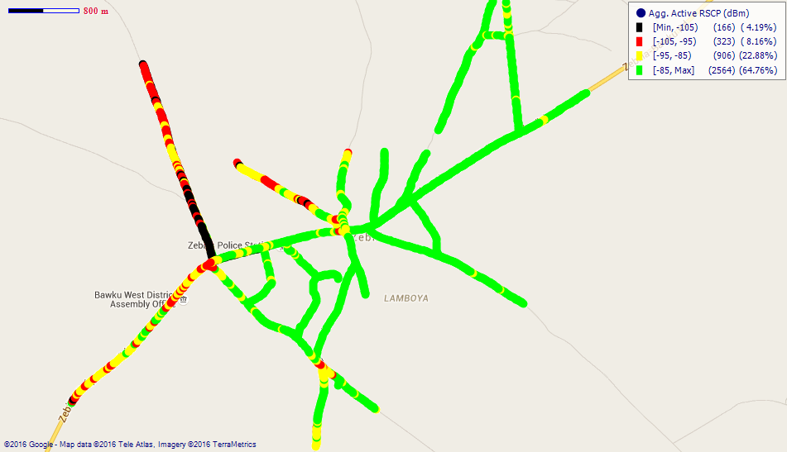
Remarks: Good 3G network coverage at Zebilla; however, coverage near the Customs Barrier and the District Assembly Office is fair and requires improvement.

Fig. 35 - Vodafone 3G Coverage Map, Zebilla – May, 2016
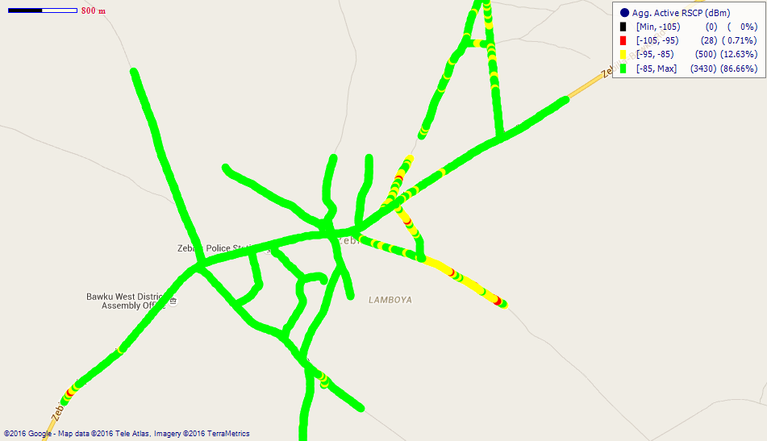
Remarks: Good 3G network coverage at Zebilla.
Fig. 36 - Airtel 3G Coverage Map, Zebilla – May, 2016
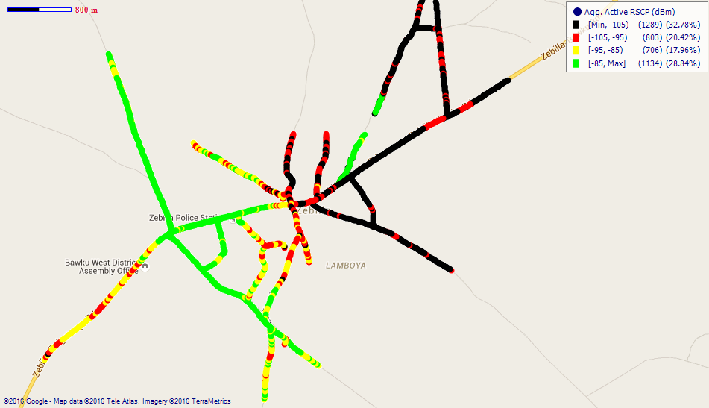
Remarks: Poor 3G network coverage in Zebilla, especially on the eastern side of the town. Major improvement is required.
APPENDIX II
RSCP SAMPLING DISTRIBUTION
Fig. 37 - MTN 3G Coverage Samples Plot in the Upper East Region
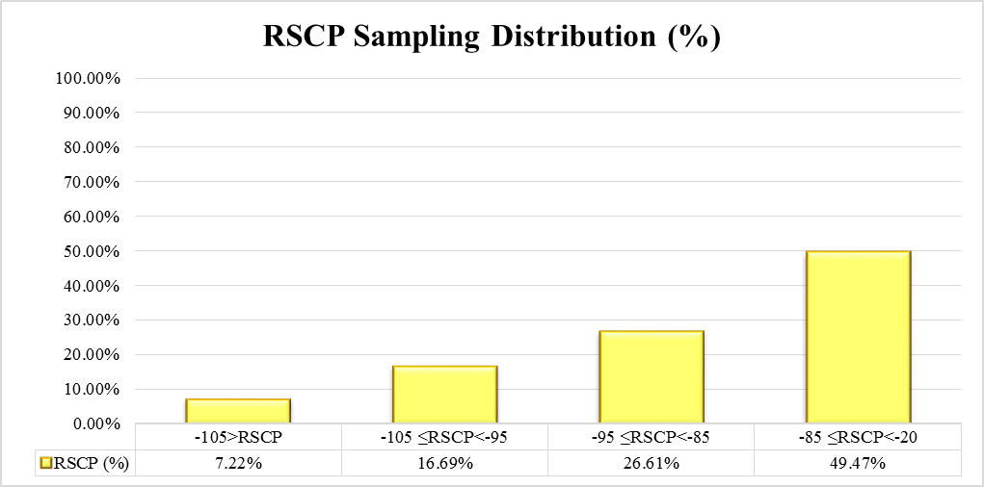
Remarks: MTN recorded its highest count of RSCP samples in the range –85 ≤RSCP < –20 dBm; representing “Good” 3G coverage across most of the District Capitals tested in the Upper East Region.
Fig. 38 - Vodafone 3G Coverage Samples Plot in the Upper East Region
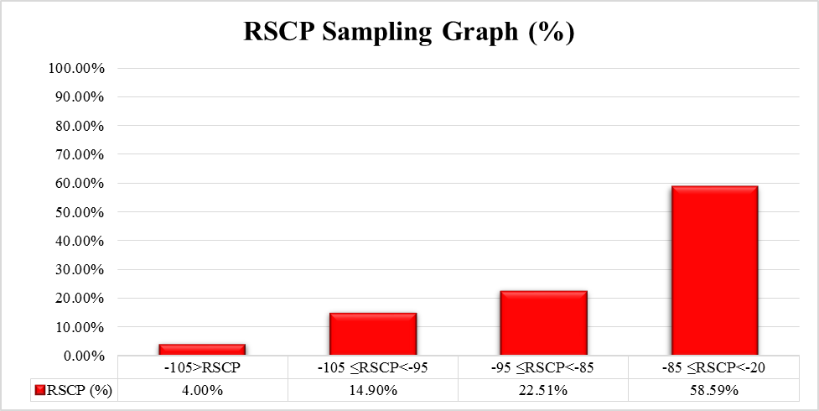
Remarks: Vodafone recorded its highest count of RSCP samples in the range –85 ≤RSCP < –20 dBm; representing “Good” 3G coverage across most of the District Capitals tested in the Upper East Region.
Fig. 39 - Tigo 3G Coverage Samples Plot in the Upper East Region
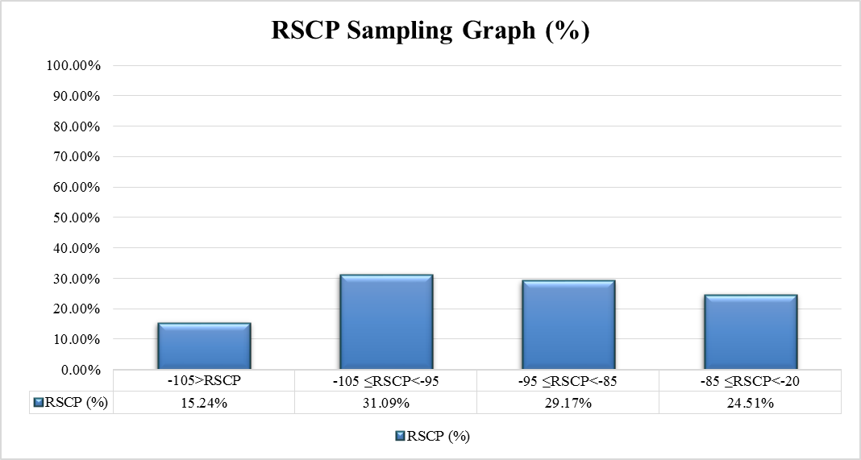
Remarks: Tigo recorded its highest count of RSCP samples in the range –105 ≤RSCP < –95 dBm; representing “Poor” 3G coverage across most of the District Capitals tested in the Upper East Region.

Fig. 40 - Airtel 3G Coverage Samples Plot in the Upper East Region
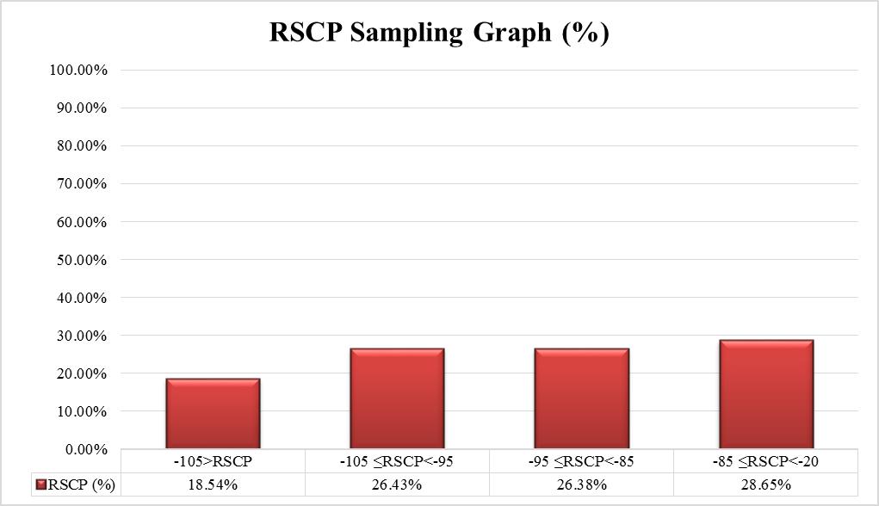
Remarks: Airtel recorded its highest count of RSCP samples in the range –85 ≤RSCP < –20 dBm; representing “Good” 3G coverage across most of the District Capitals tested in the Upper East Region.

Fig. 41 - Glo 3G Coverage Samples Plot in the Upper East Region
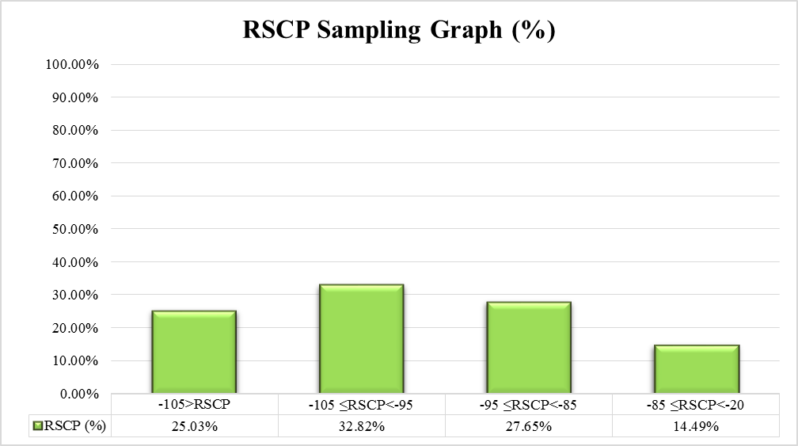
Remarks: Glo recorded its highest count of RSCP samples in the range –105 ≤RSCP < –95 dBm dBm; representing “Poor” 3G coverage across most of the District Capitals tested in the Upper East Region.

